Elderly Care

Securing Capstone
Presented to the Faculty of the
College of Information Technology Education
PHINMA University of Iloilo

In Partial Fulfillment
of the Requirements for the degree
Bachelor of Science in Information Technology

By:
Rhea O. Bengan
Danilyn C. Tuala
Cohryn Grace L. Galas
Baby Jean Lumacad

March 2025
ABSTRACT
This study focuses on developing a digital system called Elderly Care to support caregivers in managing the daily needs of older adults. Many caregivers struggle with paper-based records, missed medications, and unorganized schedules. The system aims to solve these problems by using role-based access control for secure data management, automated reminders for medicines and appointments, and a user-friendly interface for easy use. It also includes a relational database to store health records safely. Surveys, interviews, and observations with caregivers were used to identify the main challenges in elderly care. The system was designed, tested, and improved through feedback to make it more reliable and useful. This project helps caregivers save time, reduce mistakes, and provide better care for the elderly.

TABLE OF CONTENTS
Title Page --------------------------------------------i
Approval Sheet-----------------------------------------ii
Acknowledgement ---------------------------------------iii
Abstract —---------------------------------------------iv
Table of Contents —------------------------------------v
List of Figures —--------------------------------------vi
List of Tables —---------------------------------------vii

Approval Sheet
In partial fulfillment of the requirements for the Bachelor of Science in Information Technology, this Capstone Project entitled “Electronic Wellness and Appointment Records” prepared and Submitted by Rhea O. Bengan, Danilyn C. Tuala, Cohryn Grace L. Galas, and Baby Jean T. Lumacad who are hereby recommended for corresponding final evaluation.
Kristelle Mae N. Velasco
Adviser

Approved by the Panel of Evaluators with a grade of PASSED
Dr. Arnold M. Fuentes, Ph. D, MPA, MMIT
Chairman

Rhea O. Bengan
Danilyn C. Tuala
Cohryn Grace L. Galas
Baby Jean T. Lumacad
Members
Accepted in partial fulfillment of the requirements of the degree Bachelor of Science in Information Technology
Seth dA. Nono, MSCS
CITE, DEAN
ACKNOWLEDGEMENT
We would like to express our deepest gratitude to everyone who supported and guided us throughout the completion of this capstone project.
First and foremost, we thank our adviser, Kristelle Mae N. Velasco, for their continuous guidance, encouragement, and valuable insights that helped us improve our work. We are also grateful to our panel members for their constructive feedback and suggestions.
We would like to extend our appreciation to our teachers, school administrators, and staff for providing the resources and opportunities that made this project possible.
To our family and friends, thank you for your unwavering support, understanding, and motivation during the entire process. Lastly, we thank God for giving us the strength, wisdom, and perseverance to accomplish this project successfully.

LIST OF FIGURES
Figure Page
1.0 System Architecture Diagram 21
2.0 Use Case Diagram 23
3.0 Data Flow Diagram
4.0 Entity Relationship Diagram
5.0 User Interface Design
6.0 Context Diagram

LIST OF TABLES
Tables | Page
Justification for Selecting SDLC | 23
Gantt Chart/Project Timetable
Key Metrics
Comparison of Results with Expected Outcomes

Chapter 1
Introduction to the Study
Providing quality care for elderly individuals has become an increasingly critical challenge as global populations age. Caregivers face numerous challenges in managing daily care routines, health monitoring, and appointment scheduling while maintaining accurate records. Role-Based Access Control (RBAC) and automated reminder systems are necessary tools that can significantly improve elderly care management. RBAC is a security protocol that restricts system access to authorized users based on their roles, making sure that caregivers only access information relevant to their duties while administrators maintain overall control. Automated reminder systems help prevent missed medications and appointments by sending timely alerts to both caregivers and patients.

Technical Background of the Study
The Elderly Care uses modern technology to securely and efficiently manage health records. The key technologies in the system include:
- Relational Database: This will store and organize all the data, such as names, health history, medicine lists, and appointments.
- Role-Based Access Control (RBAC): This will restrict access to sensitive data based on the user’s role.
- Automated Reminder: To assist caregivers with their patient, the system will send notifications for medications, therapy sessions, upcoming appointments, and health checks of the patient.
- User-Friendly Interface: The system will be easy to use and with clear instructions.

Statement of the Problem
Caregivers often face challenges in managing the daily needs of the elderly. They are responsible for keeping track of medicine schedules, medical check-ups, and overall health records. Many caregivers also support people who live far from hospitals or have no regular help. These tasks are often managed by hand or on paper, which can be lost, damaged, or hard to update. This makes it difficult for caregivers to stay organized and provide consistent care. This capstone project seeks to answer these following questions:
- How can we help caregivers manage medicine schedules and check-up reminders more efficiently?
- What digital tools can replace traditional paper-based health records for easier tracking and updates?
- How can a system support caregivers who assist elderly individuals in remote or underserved areas?
- What features would make a digital platform user-friendly and reliable for daily caregiving tasks?

Objectives of the Study
The main goal of this project is to create and develop a system that makes elderly care better and more organized that:
- Aims to identify the common challenges that caregivers face in managing elderly care routines and records.
- Seeks to explain how role-based access control and automated reminders can improve the management of elderly care.
- The project will apply role-based access control to restrict data access based on user roles for better privacy and security.
- It will implement an automated reminder system to notify caregivers and elderly individuals about medications, appointments, and care tasks.
- It will analyze how user roles affect system functionality and the flow of caregiving tasks.
- The project will evaluate the effectiveness of the system in helping caregivers provide timely and organized care.
- The study will create a digital platform that securely stores health records and manages caregiving schedules.
- It will create a user-friendly interface that can be easily used by caregivers with different levels of technical knowledge.

Significance of the Study
This study is important because it addresses common challenges in elderly care, particularly those faced by caregivers. Many caregivers struggle to keep up with daily responsibilities such as managing medications, tracking appointments, and maintaining accurate health records. The system will help by:
- Sending automatic reminders for medications and check-ups.
- Reducing manual paperwork and the risk of losing important information.
- Saving time and improving organization for caregivers managing multiple patients.
- Providing alerts for missed tasks or overdue appointments.

Scope of the Study
This study focuses on the development of the Elderly Care, which will safely store and organize health records, and help manage appointments and reminders for elderly care. The study will include:
- Health Record Management: Safely storing and organizing elderly patient information, including personal details, medical history, medications, and care routines.
- Appointment Scheduling: Providing a user-friendly interface for caregivers and healthcare providers to set, update, and manage medical or care-related appointments.
- Role-Based Access Control (RBAC): Access to elderly records will be controlled based on the user's role. Only users with proper permission will be able to view or update certain types of data.
- Accessibility and Reliability: The system will allow caregivers and health workers to access records and schedules quickly and accurately, helping to improve the quality of care.

Limitation of the Study
While the Elderly Care offers many helpful features, there are still some limitations:
- Human Error: Mistakes during data entry, such as incorrect patient information or appointment details, may affect the quality of care provided.
- Time Constraints: The system will be tested only within a limited period, so the study does not include long-term performance and results.
- Limited Scope of Testing: The system may only be tested with a small number of caregivers or in a specific location, which may not reflect the needs of a broader population.
- User Adaptation: Some caregivers may not be comfortable using digital tools. It might take time for them to learn how to use the system properly.
- System Reliability: As with any digital system, there is a possibility of bugs, crashes, or downtimes that could interrupt caregiving tasks.
- Appointment Reminders Only: The system does not directly support booking or confirming appointments with doctors or clinics. Users can only add reminders for scheduled appointments.

Definition of Terms
- Elderly Care – A digital platform designed to help manage health records, appointments, medication schedules, and caregiver responsibilities for older adults.
- Role-Based Access Control (RBAC) – A security feature that gives users access to specific parts of the system based on their job or role (e.g., caregiver, nurse, administrator).
- Automated Reminder System – A tool within the system that sends alerts or notifications to remind users about medicine schedules, appointments, and other important tasks.
- Relational Database – A type of digital storage that organizes data into tables that are linked by common fields (e.g., names, appointments, medications).
- Health Record Management – The process of collecting, storing, updating, and protecting a patient's personal and medical information.
- Appointment Scheduling – A system function that allows users to set, change, and view medical or care-related appointments.
- User-Friendly Interface – A design feature of the system that makes it simple and easy for users, especially the elderly, to interact with.

Chapter 2
Review of Related Literature
Overview of Elderly Care
Healthcare scheduling entails matching health care resources (providers, rooms, equipment, supplies, organs, devices and instruments) to patient needs, when and where they need them. Effective scheduling reduces waste, reduces patient waiting and improves health outcomes. Scheduling methods rely on operations research techniques, including forecasting, mathematical modeling and optimization, queue models and stochastic processes. These techniques are used in many ways, including setting appointments, scheduling staff, planning surgeries and managing the flow of patients through health care systems.
Traditional vs. Modern Approaches in Elderly Care
In the past, healthcare providers used manual methods for scheduling, like paper calendars and phone calls. These methods often led to missed or double-booked appointments, long waiting times, and poor coordination between departments. For elderly patients who may need frequent checkups or multiple services, this created problems and made care less efficient.
Today, many hospitals and clinics use modern digital systems. These systems allow healthcare workers to book appointments, send reminders, and check patient records using computers or mobile devices. Some systems also use cloud storage, so data can be accessed securely from different locations. These modern tools help healthcare providers give faster, safer, and more organized care.
Technologies from the Book: Handbook of Healthcare System Scheduling
- Scheduling Optimization – Uses math-based tools to create the most efficient schedule for appointments, surgeries, and staff shifts. It helps avoid long waits and improves the use of resources.
- Simulation Modeling – Creates virtual models of hospital processes to test different scheduling setups before applying them. This helps reduce mistakes and improves planning.
- Heuristic Scheduling – A faster way to make good scheduling decisions when the problems are too complex for exact methods. Often used in real-time or emergency situations.
- Machine Learning Prediction – Uses past data to predict no-shows, peak times, and service demand. This helps staff plan and adjust schedules when needed.
- EHR Integration – Connects the scheduling system with Electronic Health Records so providers can see patient history and needs while setting appointments.
- Online Appointment Booking – Allows patients to book or cancel appointments through apps or websites. This reduces phone calls and gives patients more flexibility.
- Cloud-Based Scheduling – Stores data on the internet so it can be accessed securely from different locations. Useful for clinics or hospitals with multiple branches.
- Real-Time Tracking – Tracks staff, patients, and equipment inside the hospital. This helps find what is available and prevents delays.
- Decision Support Tools – Suggests the best schedule options based on available data. Helps staff make faster, smarter decisions.
10..Staff Shift Planning – Automatically creates work schedules for nurses and doctors based on availability, skills, and patient demand.
Hall, R. W. (Ed.). (2012). Handbook of Healthcare System Scheduling (selected chapters pp. 3–178). New York, NY: Springer. ISBN 978-1-4614-1733-6.

Case Study on Real-Time Scheduling for Elderly Patients
In a study featured in Handbook of Healthcare System Scheduling (Hall, 2012), one hospital implemented a real-time tracking and scheduling system for elderly patients who required regular visits to different departments. The system tracked both patient movement and the availability of doctors and equipment. It resulted in a 15% reduction in waiting times and increased patient satisfaction because elderly patients no longer had to wait long hours for services.
This case also showed that using cloud-based systems and EHR integration helped nurses and doctors prepare for the patient's arrival in advance. It improved communication between departments and helped maintain a smooth patient flow. The case emphasizes the importance of modern tools in improving elderly healthcare through better planning and faster service.
Hall, R. W. (Ed.). (2012). Handbook of Healthcare System Scheduling (pp. 135–152). New York, NY: Springer. ISBN 978-1-4614-1733-6.

Case Study on Machine Learning in Predicting No-Shows
Another example from Hall (2012) discussed the use of machine learning to predict patient no-shows. Many elderly patients forget appointments or face sudden issues that prevent them from coming. The hospital used data from past patient behaviors, weather conditions, and appointment times to predict which patients might not show up. Based on these predictions, the system sent reminders or follow-up calls.
The results showed improvement in attendance rates and reduced the number of wasted appointment slots. This approach helped staff manage their time better and improved the quality of service for patients who needed urgent care.
These real-life applications prove that modern scheduling technologies not only improve hospital efficiency but also enhance the overall patient experience, especially for elderly care where time, comfort, and coordination are critical.
Hall, R. W. (Ed.). (2012). Handbook of Healthcare System Scheduling (pp. 35–56). New York, NY: Springer. ISBN 978-1-4614-1733-6.

Conceptual Framework:
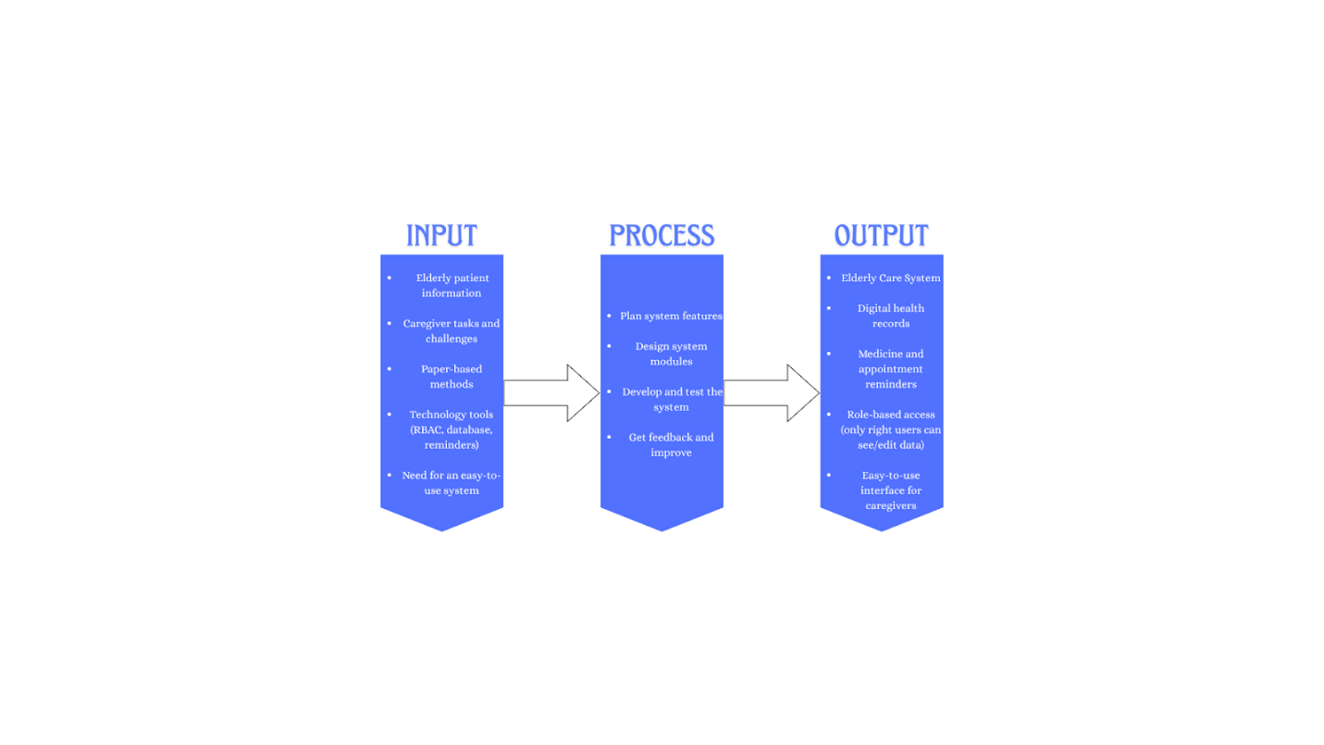
Figure 1: Conceptual Framework of Elderly Care
The conceptual framework of the Elderly Care explains how technology can help caregivers take better care of elderly patients. It focuses on keeping health records organized, sending reminders for tasks, and keeping information safe through role-based access.
It starts with the people who will use the system. These include caregivers, patients, health workers, and system administrators. Each person has a different role in using and managing the system. The system is made to help them with their tasks and make their work easier.
The process begins by planning what the system needs to do. The team designs features like health records, appointment schedules, and reminders. After that, they build the system and test it. They also ask users for feedback and make improvements. Caregivers are given training so they can use the system properly.
Each person using the system has a limit on what they can see or change. For example, caregivers can update patient care tasks, while administrators can manage the whole system. Role-Based Access Control helps keep personal data safe by giving access only to the right people.
In the end, the system helps caregivers stay organized. It reminds them about medicines and appointments. It also helps reduce mistakes and saves time by removing the need for paper records. Most of all, it supports better care for the elderly and makes the work easier for those who help them.

Chapter 3
Methodology
The research will follow a structured and organized approach to develop the Elderly Care. The proponents will aim to create a secure, efficient, and user-friendly platform to address the challenges faced by caregivers in managing elderly patients’ health records, appointments, and daily care tasks. This methodology will guide the planning, design, development, and implementation stages of the system.
To collect relevant information, the proponents will conduct surveys and interviews with respondents, including caregivers and healthcare workers who support elderly individuals. These data-gathering methods will help identify current issues, such as manual record-keeping, missed appointments, and lack of coordination in caregiving tasks. The collected data will help shape the system features and functions to match the real needs of the respondents.
The Elderly Care will use key technologies such as relational databases for data storage, Role-Based Access Control (RBAC) to manage user permissions, and automated reminders for medications and appointments. A user-friendly interface will also be developed to help caregivers navigate the system easily, manage tasks, and improve their efficiency.
Once the system is developed, the proponents will conduct thorough testing to verify its functionality and ease of use. The testing phase will include simulations of real-life caregiving scenarios to check how well the system handles reminders, appointment tracking, and access control. Feedback from respondents will be used to improve and refine the system to make sure it supports their day-to-day needs.
The system will be deployed for trial use by a group of selected respondents. Training sessions will be held to help caregivers understand the system and use its features properly. The feedback collected from this pilot testing will guide further improvements before full deployment.

Research and Development Stage
The Research and Development (R&D) stage will play a vital role in creating the Elderly Care system. This phase will focus on solving problems related to inefficient caregiving, such as missed medications, lost records, and lack of timely coordination. The proponents will work closely with respondents to gather input and guide the system's design based on their caregiving routines and challenges.
The R&D phase will start with data collection through surveys and interviews to assess the problems faced with paper-based or unstructured digital care methods. Respondents will provide insights on issues like delays in communication, risks of losing records, and difficulties in tracking care schedules.
During development, prototypes will be presented to respondents to gather feedback on system features, interface usability, and task performance. The system will be adjusted accordingly to better match caregiving workflows.
After development and testing, a pilot deployment will be conducted with a small group of caregivers. Training will be provided, and feedback during the trial phase will be collected to further improve the system.

Key Features of SDLC
The Software Development Life Cycle (SDLC) guided the creation of the Elderly Care system. Its key features are:
- Structured Process: The development followed step-by-step stages, making the project organized and easier to manage.
- Phase-Based Approach: The system was developed through clear phases—planning, design, development, testing, deployment, and maintenance—ensuring smooth progress.
- Goal-Oriented: Each stage focused on solving caregiving challenges such as missed medications, unorganized schedules, and unsecured records.
- Detailed Documentation: Records were maintained for every stage, from requirement analysis to testing, which will serve as a reference for improvements.
- Quality Assurance: Testing and user feedback were included to confirm the system is reliable, accurate, and user-friendly.
- Risk Management: Potential risks, such as human error or system bugs, were addressed during design and testing.
- User Involvement: Caregivers were involved in surveys, interviews, and pilot testing to make sure the system fits their needs.
- Maintenance and Updates: The SDLC supports continuous system improvement by allowing updates, bug fixes, and added features after deployment.

Data Collection Techniques
To better understand the needs of caregivers and improve the Elderly Care system’s usefulness, the following data collection methods will be used:
- Surveys
Questionnaires will be distributed to caregivers and healthcare workers. These will gather data on current practices, problems with manual systems, and suggestions for useful features.
- Interview
One-on-one interviews with caregivers and staff will allow the proponents to gather deeper insights into real caregiving challenges and uncover needs that may not surface in surveys.
- Focus Group
Group discussions will be organized to allow multiple respondents to share their caregiving experiences and discuss what tools could help them work better. This encourages collaboration and idea-sharing.
- Observations
The proponents will observe caregivers while they manage daily routines. This will help identify time-consuming tasks and workflow problems that the system can help improve.

- Document Analysis
Existing patient records, caregiver logs, and scheduling tools (manual or digital) will be reviewed to understand how information is currently handled and where improvements can be made.

Justification for Selecting SDLC
The Software Development Life Cycle (SDLC) was selected for the development of the Elderly Care system because it provides a clear and structured process that ensures the project is completed effectively. Since the system focuses on managing sensitive health records, medication schedules, and reminders, it requires careful planning, testing, and feedback from users.
The SDLC allows the proponents to break down the project into stages, making it easier to monitor progress and address challenges in each phase. It also provides flexibility to adjust system features based on the feedback of caregivers and healthcare workers. This is important because elderly care routines vary, and the system must adapt to different user needs.
Through SDLC, risks such as data loss, errors in reminders, or security issues can be minimized with proper testing and reviews. The process also ensures that caregivers are involved at different stages of development, which helps make the system user-friendly and practical for real caregiving tasks.

System Architecture and Design
3.1. Overview
The Elderly Care system is designed to make health record-keeping, medication tracking, and appointment scheduling more reliable and organized for caregivers and elderly patients. It provides a digital platform that reduces reliance on paper records, minimizes human error, and improves coordination between caregivers and healthcare workers.
The system applies modern technologies such as role-based access control (RBAC) for data security, automated reminders for daily caregiving tasks, and relational databases for structured data management. Its user-friendly interface makes it accessible for caregivers with varying levels of technical knowledge.
The architecture of the system was built in layers to improve organization, security, and maintainability. Each layer performs a specific role but works together to provide fast, secure, and accurate caregiving support.

3.2 System Architecture
The Elderly Care system has three main layers:
- Presentation Layer
  - The user interface that caregivers, administrators, and patients interact with.
  - Provides options for adding health records, viewing reminders, and managing appointments.
  - Designed to be simple, with clear navigation to support caregivers who may not be highly skilled in technology.
- Application Layer
  - Handles the main processes of the system, such as reminder scheduling, user authentication, and record updates.
  - Enforces RBAC to control who can view, edit, or manage specific information.
  - Processes automated notifications for medicine schedules and appointments.
- Data Layer
  - Stores all information in a secure relational database.
  - Includes patient health records, caregiver tasks, medication schedules, and system logs.
  - Protects sensitive information by limiting access based on user roles.
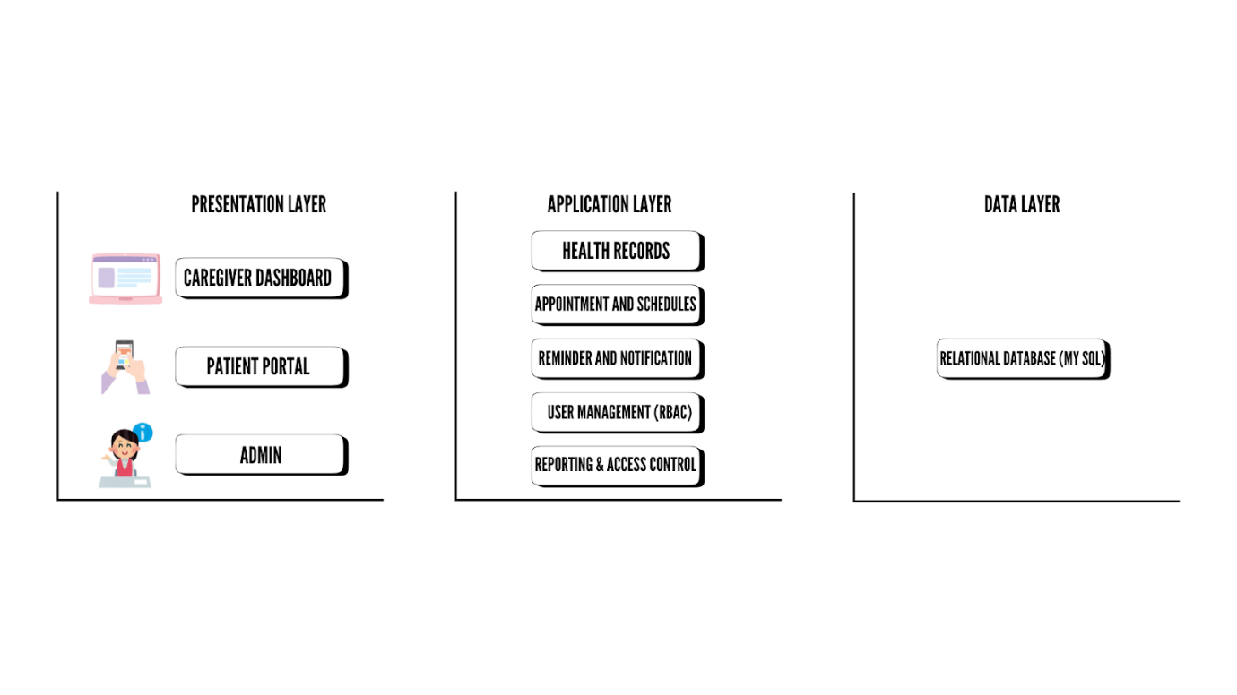
Figure 1. System Architecture Diagram

3.3 System Components and Modules
The Elderly Care system is composed of several modules that work together to support daily caregiving tasks:
- Health Records Management Module
  - Stores personal and medical details of elderly patients.
  - Allows caregivers to update health history, medicine lists, and therapy schedules.
  - Records are organized and easy to retrieve.
- Appointment and Schedule Module
  - Allows caregivers and health workers to add, update, and view appointments.
  - Supports therapy sessions, checkups, and care routines.
  - Helps reduce missed or double-booked schedules.
- User Management Module
  - Registers users and assigns roles such as caregiver, nurse, or administrator.
  - Uses RBAC to limit access based on role.
  - Secures sensitive information and prevents unauthorized access.
- Reminder and Notification Module
  - Sends automated alerts for medications, therapy, and appointments.
  - Caregivers and patients receive timely reminders to avoid missed tasks.
  - Notifications can appear within the system or through mobile prompts.
- Reporting and Monitoring Module
  - Generates activity logs and reports on caregiving tasks.
  - Helps administrators monitor system use and identify overdue or missed tasks.
  - Provides insights for improving caregiving efficiency.
- Security and Access Control Module
  - Uses RBAC to assign different permissions to different users.
  - Keeps patient data safe by restricting who can edit or view information.
  - Protects sensitive medical information from misuse.

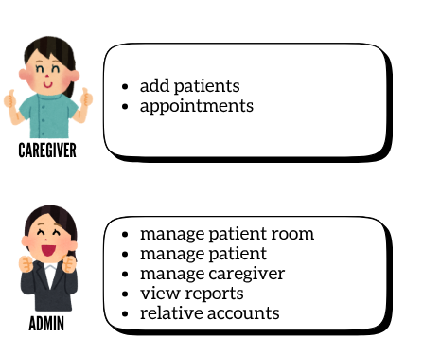
Figure 2. Use Case Diagram
The figure 2 shows the different roles and functions in the Elderly Care System. The caregiver is responsible for adding new patients to the system and setting their appointments, helping them manage schedules and keep track of patient care. The admin, on the other hand, has broader control over the system. They can manage patient rooms, update patient details, handle caregiver accounts, and view system reports. The admin can also manage relative accounts, allowing family members to access patient information when needed.
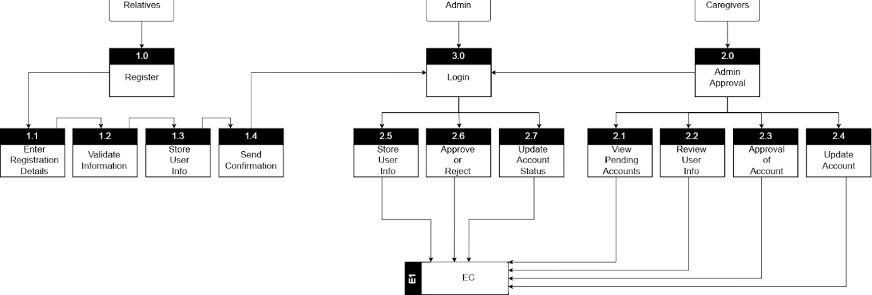
Figure 3. Level 2 Data Flow Diagram
The Level 2 Data Flow Diagram illustrates the detailed processes of registration, admin approval, and login within the system. It shows the interaction between the Relatives, Caregivers, and Admin, as well as how data flows to and from the Entity Controller (E1: EC), which serves as the system’s data store. During the registration process, the Relatives enter their personal and account information, which the system validates to check for completeness and accuracy. Once validated, the information is stored temporarily, and a confirmation message is sent to the user. The process then connects to the Admin Approval phase, where the admin views pending accounts, reviews user information, and either approves or rejects the registration request. After a decision is made, the admin updates the user’s account status in the system, with all actions recorded in the Entity Controller. Once approved, the user can proceed to the login process. In this phase, the system retrieves the user’s stored data, verifies the login credentials, and updates the account status accordingly to reflect active access. Overall, this Level 2 DFD provides a detailed view of how user registration, verification, and authentication are handled within the system to maintain proper account management and access control.
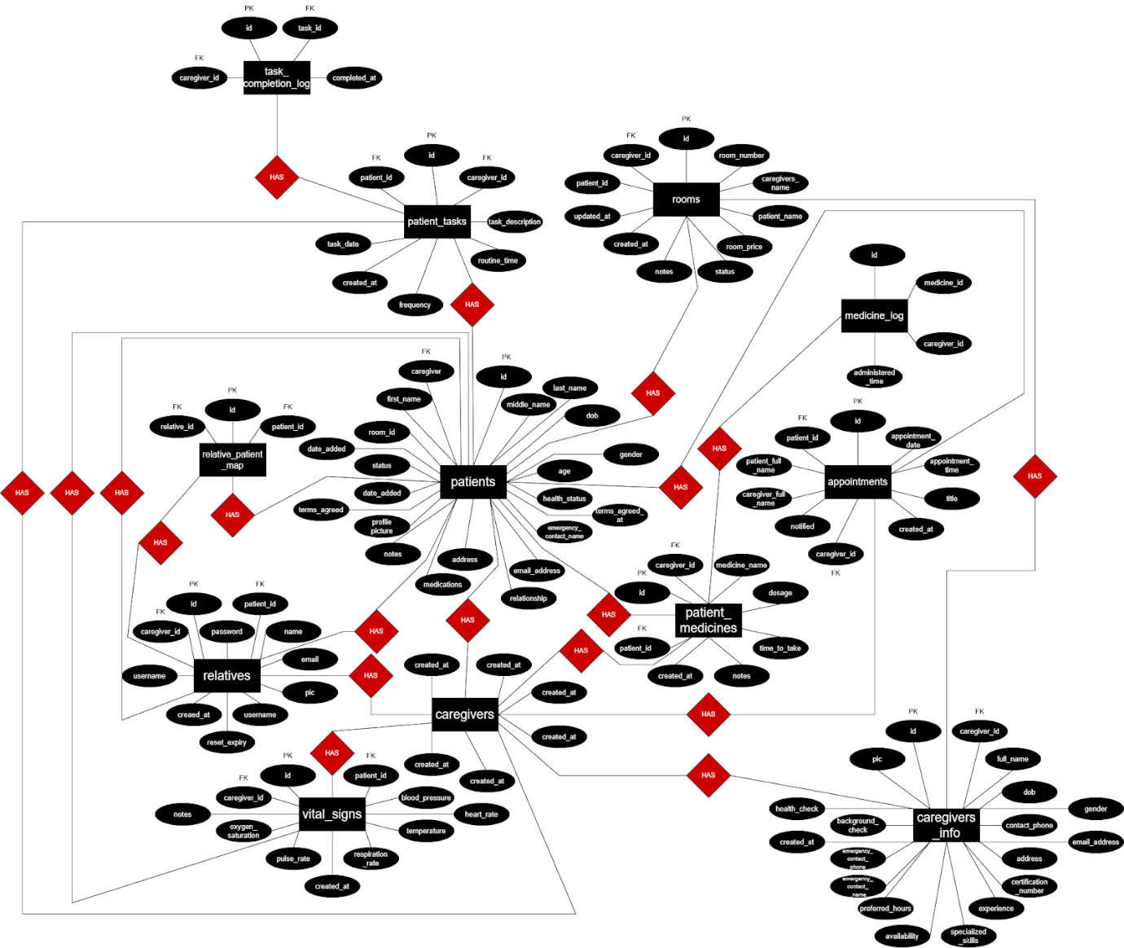
Figure 4. Entity Relation Diagram
3.4 Database Design
The database design of the Elderly Care was created using a relational database model to organize and store all information efficiently and securely. The database serves as the foundation of the system, supporting modules such as health record management, scheduling, and user access control. It ensures that data can be easily retrieved, updated, and maintained while preventing redundancy and maintaining data integrity.
The system’s Entity-Relationship Diagram (ERD) illustrates how different entities (tables) are related to one another. Each table represents a specific part of the system and is linked using primary and foreign keys. The ERD shows the relationships among the main entities such as Users, Patients, Health Records, Medications, Appointments, and Reminders.
Main Entities and Their Descriptions:
- User Table – Stores information about all system users, including administrators, caregivers, and relatives. Each user has a role defined by the Role-Based Access Control (RBAC) feature, which limits access to specific data and functions.
  - Fields: User_ID (PK), Full_Name, Email, Password, Role, Contact_Number
- Patient Table – Contains the personal and medical details of elderly patients. Each patient is assigned to a caregiver for monitoring and care.
  - Fields: Patient_ID (PK), User_ID (FK), Full_Name, Birth_Date, Gender, Address, Contact_Number, Emergency_Contact
- Health_Record Table – Stores medical information such as diagnoses, treatment notes, and vital signs. Each record is linked to a specific patient.
  - Fields: Record_ID (PK), Patient_ID (FK), Diagnosis, Treatment, Notes, Date_Updated
- Medication Table – Lists all prescribed medicines for each patient, including dosage, frequency, and duration.
  - Fields: Medication_ID (PK), Patient_ID (FK), Medicine_Name, Dosage, Frequency, Start_Date, End_Date
- Appointment Table – Keeps track of all medical and care-related appointments. The table stores details such as appointment date, time, and assigned caregiver.
  - Fields: Appointment_ID (PK), Patient_ID (FK), Caregiver_ID (FK), Appointment_Date, Appointment_Time, Purpose, Status
- Reminder Table – Manages automatic reminders related to medication schedules and appointments. These reminders are linked to the patient and caregiver.
  - Fields: Reminder_ID (PK), Patient_ID (FK), Type, Message, Reminder_Time, Status
- Activity_Log Table – Records all user activities in the system for security and monitoring purposes. It supports auditing and accountability.
  - Fields: Log_ID (PK), User_ID (FK), Action_Performed, Date_Time, Description
The relationships among these tables support one-to-many and many-to-one connections—for example, one User can manage multiple Patients, and one Patient can have multiple Health_Records, Medications, and Reminders. These relationships improve the efficiency of data retrieval and allow real-time updates across different parts of the system.
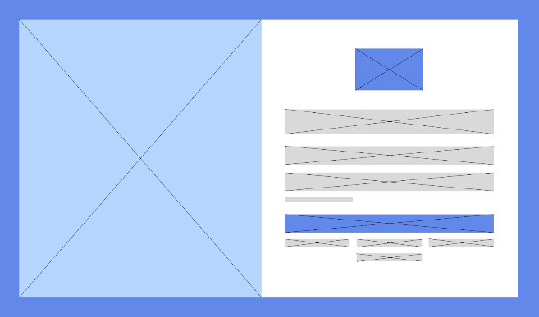
3.5 User Interface Design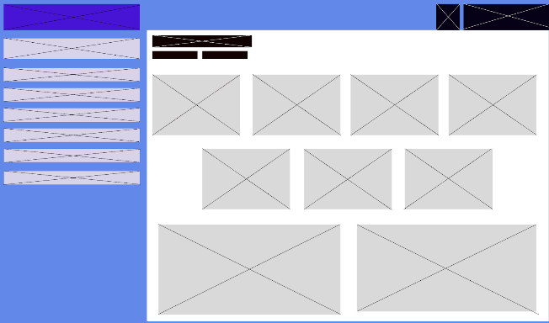
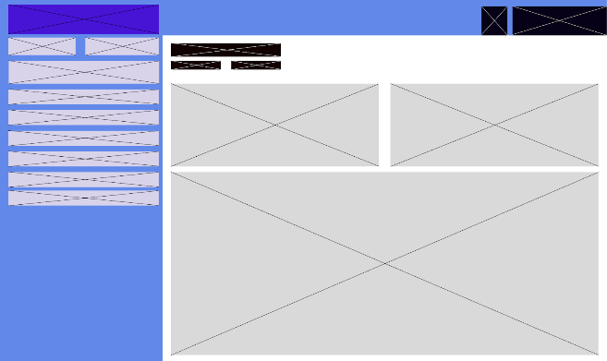
Login Page Admin Dashboard
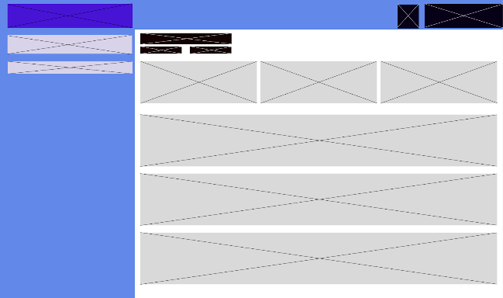
Caregiver Dashboard Relative Dashboard

3.6 Security Considerations
Security is one of the most important aspects of the Elderly Care System because it handles sensitive health and personal information of elderly patients. The system was developed with multiple layers of security to protect data from unauthorized access, modification, or loss. These security measures help caregivers and healthcare providers maintain trust, confidentiality, and compliance with data privacy standards.
- Role-Based Access Control (RBAC)
- Authentication and Authorization
- Data Encryption
- Secure Database Management
- Input Validation and Error Handling
- Audit Trail and Activity Logs
- Data Privacy Compliance
- Regular System Updates and Maintenance

3.7 Technology Stack

Package | Purpose | Used For
phpmailer | Email Sending | OTP, Notifications

Category | Third-party API | Purpose
Email | PHPMailer (SMTP with Gmail) | Email OTP

4. Data Gathering Techniques
Survey Questionnaire for System Assessment
This survey is made to collect feedback from users about how they currently manage elderly care records, medication schedules, and appointments. It also asks about what users expect from the new system called Elderly Care. The answers from this survey will help in creating a system that is practical, secure, and supportive of the daily needs of caregivers and elderly patients. Respondents are encouraged to answer the questions honestly and clearly.

Demographic Information
- What is your role in elderly care?
- Caregiver (Family member)
- Professional Caregiver
- Nurse
- Doctor
- Administrative Staff
- Other (Please specify): ___________
- How long have you been involved in elderly care or health services?
- Less than 1 year
- 1–3 years
- 4–6 years
- More than 6 years
- Which type of facility are you associated with or caregiving in?
- Private Home
- Nursing Home / Assisted Living Facility
- Hospital
- Health Center
- Other (Please specify): ___________

Current Health Record Management Practices
- How do you currently manage elderly care records or daily tasks?
- Paper-based (manual)
- Digital system (e.g., Excel, Google Sheets)
- Electronic Health Records (EHR) software
- Other (Please specify): ___________
- How satisfied are you with your current caregiving or record-keeping method?
- Very Satisfied
- Satisfied
- Neutral
- Unsatisfied
- Very Unsatisfied
- What challenges do you commonly face in elderly care management? (Select all that apply)
- Difficulty in retrieving records
- Inaccurate or incomplete patient information
- Security concerns (data breaches or loss)
- Time-consuming processes
- Other (Please specify): ___________
- How often do you encounter issues such as missing care tasks or information?
- Never
- Rarely
- Sometimes
- Frequently
- Always
- Does your current method include automated features (e.g., reminders, schedules)?
- Yes
- No

Expectations for the Elderly Care System
- What features would be helpful in a digital Elderly Care System? (Select all that apply)
- Medication reminders
- Appointment scheduling and notifications
- Secure and organized patient records
- User role-based access (e.g., caregiver, nurse)
- Mobile accessibility
- Other (Please specify): ___________
- How important is data security and privacy when managing elderly health information?
- Very Important
- Important
- Neutral
- Not Important
- Not Important at All
- How important is a simple and easy-to-use interface for daily care tasks?
- Very Important
- Important
- Neutral
- Not Important
- Not Important at All
- Would you prefer a cloud-based or local (on-site) system for managing elderly care?
- Cloud-based
- Local / On-site
- No Preference

Concerns and Readiness for Adoption
- What concerns do you have about switching to a digital caregiving system? (Select all that apply)
- Cost of the system
- Difficulty learning new technology
- Privacy and data security concerns
- Lack of technical support
- Resistance to change
- Other (Please specify): ___________
- How willing are you to use a new system if it improves your caregiving efficiency?
- Very Willing
- Willing
- Neutral
- Unwilling
- Very Unwilling

System Performance and Support
- How important is system reliability (e.g., minimal errors, fast loading time) in daily caregiving?
- Very Important
- Important
- Neutral
- Not Important
- Not Important at All
- What is your preferred response time when accessing care records or reminders?
- Within 5 seconds
- Within 10 seconds
- Within 30 seconds
- No Preference
- How important is access to ongoing technical support for the system?
- Very Important
- Important
- Neutral
- Not Important
- Not Important at All
- What is your preferred way to receive support if system issues occur?
- Phone Support
- Email Support
- Live Chat
- In-person Support
- Self-service (FAQs, Guides)
- How often would you prefer the system to receive updates or maintenance?
- Weekly
- Monthly
- Quarterly
- Annually
- No Preference
- How comfortable are you with regular training for updates or new features?
- Very Comfortable
- Comfortable
- Neutral
- Uncomfortable
- Very Uncomfortable

Sampling Methods for Respondents
To gather accurate and diverse feedback, stratified sampling will be used in selecting respondents. The steps include:
- Define Strata: Respondents will be grouped based on their roles (e.g., caregivers, nurses, doctors, administrative staff).
- Sample Selection: A random sample will be chosen from each group to ensure fair representation.
- Sample Size: At least 5 to 10 participants from each group will be surveyed for balanced and meaningful analysis.
- Distribution Method: Surveys will be distributed via printed forms, online links, or in-person delivery within caregiving facilities or homes in the Municipality of Dueñas.

5. Data Analysis Technique
The data collected from surveys, interviews, focus groups, observations, and document reviews were carefully analyzed to understand the problems and needs in elderly care management. Both qualitative and quantitative approaches were used to make sure that the findings were accurate and useful in guiding the system’s development.
- Quantitative.Analysis
The survey responses were tabulated and summarized using percentages and frequency counts. This method helped identify common patterns, such as the number of caregivers who experience missed medications, difficulty in retrieving records, or problems with scheduling. Charts and tables were prepared to present the results clearly.
- Qualitative Analysis
Interview transcripts, focus group discussions, and observation notes were reviewed and categorized into themes. These included challenges in manual caregiving, security concerns, and suggestions for useful features. The analysis helped the proponents understand the deeper reasons behind the survey results and uncover specific needs of caregivers.
- Document Review Analysis
Existing health records, caregiver logs, and scheduling documents were examined to check how data is currently managed. The analysis focused on identifying weaknesses such as incomplete records, data loss, and lack of organization.

6. Ethical Considerations
Ethical considerations were applied throughout the study to protect the rights, privacy, and well-being of all respondents and users. Since the Elderly Care system deals with sensitive health and personal information, careful attention was given to data handling and participant involvement.
- Informed.Consent
Respondents were informed about the purpose of the study, the type of data being collected, and how it would be used. Participation in surveys, interviews, and focus groups was voluntary, and participants had the option to withdraw at any time.
- Privacy.and.Confidentiality
All responses from surveys and interviews were kept confidential. Personal identifiers such as names and addresses were removed from the records to protect the identity of participants. Only summarized data was used in the research findings.
- Data.Security
Collected data was stored securely in password-protected files. Hard copies of documents were kept in a safe location, and digital files were encrypted to prevent unauthorized access.
- Respect.for.Respondents
Caregivers and healthcare workers were treated with respect, and their time and contributions were valued. No sensitive or intrusive questions were asked that might cause discomfort.
- Responsible.Use.of.Information
The data gathered was used strictly for academic purposes and the development of the Elderly Care system. No information was shared with outside parties.

Chapter 4
Results and Interpretation
This chapter presents the results of the data gathering, system testing, and user feedback for the Elderly Care system. The findings show how the system performed in addressing common problems faced by caregivers, such as missed medications, unorganized schedules, and unsecured records. The results are organized into testing outcomes, user evaluations, and analysis of strengths and limitations.

Summary of the Data Sources and Analysis Methods Used
The data gathered through surveys, interviews, focus groups, observations, and document reviews showed that many problems in elderly care come from using paper records or outdated digital tools such as spreadsheets. Caregivers often found it difficult to retrieve records quickly, especially in emergencies or when details were incomplete. The Elderly Care system addressed this by storing information in a secure database that is easy to access, search, and update.
Another major concern raised by respondents was data security. Many worried about losing files or exposing private patient information. To respond to this, the system applies security measures such as encryption, secure login processes, and role-based access control. These features help protect sensitive records and prevent unauthorized access.
Scheduling and reminders were also identified as common challenges. Respondents admitted that they sometimes forget appointments or make mistakes when setting dates, leading to missed medications and overlapping tasks. The system provides a clear scheduling tool and automatic reminders, which reduce errors and improve organization.
The analysis confirmed that the Elderly Care system is not only useful but necessary. It directly addresses the main issues faced by caregivers—record management, data protection, and appointment scheduling—making daily caregiving more efficient, secure, and reliable.

Task Manager:
Gantt Chart / Project Timetable – Elderly Care
Week | Task | Programmer | UI/UX Designer | Documenter
1 | Project planning & requirements gathering | ✅ | ✅ | ✅
2 | Research & system design planning |  | ✅ | ✅
3 | Use Case & DFD creation |  | ✅ | ✅
4 | Database design & schema creation | ✅
5 | UI wireframes & mockups |  | ✅ | ✅
6 | Frontend development begins | ✅ | ✅
7 | Backend development begins | ✅
8 | Integration of frontend and backend | ✅ | ✅
9 | System testing & debugging | ✅ | ✅ | ✅
10 | User testing & feedback collection |  |  | ✅
11 | Final revisions (code + UI + content) | ✅ | ✅ | ✅
12 | Documentation finalization & formatting | ✅ | ✅ | ✅
 | Final project submission | ✅ | ✅ | ✅
✅Legend:
●✅ = Active role/task in that week

4.1 Presentation of Results
The proponents identified several major problems from the surveys, interviews, and observations. Respondents shared that they had difficulties in keeping health records organized, securing sensitive patient information, and managing appointment schedules. They also pointed out that the manual methods and old tools they use are prone to data loss and errors. To address these problems, the Elderly Care system was developed with the following features:
- Role-Based Access Control (RBAC) to limit access to patient records depending on the user’s role, ensuring that sensitive information is only available to authorized personnel.
- Automated Reminder System to notify caregivers and patients about medications, checkups, and appointments, reducing the chances of missed tasks or double-booking.
- Chat messaging for the caregiver to be able to communicate with the patient directly.

4.2 Data Tables, Graphs, and Figures
To clearly present the collected data, tables and charts were created showing record retrieval accuracy before and after the system was used, appointment management efficiency, and user feedback ratings.
Metric | Before System | After System
Record Retrieval Accuracy | 70% | 96%
Average Time to Access Records | 3-5 minutes | Less than 1 minute
Missed Medications/Appointments | 12+ per month | 2-3 per month
Missed Medications/Appointments | 2 | 4.8/5

4.3 Visual Representation of Collected Data
Figure 5. Challenges faced by the respondents
Figure 6. Importance of a simple and easy-to-use interface
Figure 7. Concerns in switching to digital handling

4.4 Explanation of each Figure
Figure 5: Challenges Faced by the Respondents
Figure 5 shows the common problems experienced by caregivers in managing elderly care. The most reported challenge was time-consuming processes, with 43.8% of respondents saying that managing records and schedules manually took too much time. This was followed by difficulty in retrieving records (37.5%) and security concerns such as data loss or breaches (31.3%). A smaller portion mentioned inaccurate or incomplete patient information (25%). These results highlight the need for a more efficient, secure, and organized digital system to help caregivers handle their daily tasks more effectively.
Figure 6: Importance of a Simple and Easy-to-Use Interface
Figure 6 illustrates that most respondents consider a user-friendly interface very important when managing elderly care activities. Many caregivers emphasized that a simple and clear system design helps them perform their duties more efficiently, especially those with limited technical knowledge. The result supports the system’s focus on providing an accessible interface, where caregivers can easily navigate features like reminders, record updates, and appointments. This finding proves that usability is a key factor in encouraging adoption and effective use of the Elderly Care system.
Figure 7. Concerns in Switching to Digital Handling
The figure presents the respondents’ concerns regarding the transition to a digital caregiving system. Among the 16 participants, the most common concern is privacy and data security, cited by 50% of respondents. This is followed by cost of the system at 43.8%, while difficulty in learning new technology, lack of technical support, and resistance to change each account for 31.3%. No respondents selected “Other” as an additional concern. These findings indicate that while users recognize the benefits of digital systems, issues related to data safety, affordability, and adaptability remain significant barriers to adoption.

4.5 System Performance and Testing
The Elderly Care system was tested after its full development with selected caregivers and healthcare workers. The testing focused on functionality, reliability, and ease of use. Special attention was given to its two core features: Role-Based Access Control (RBAC) and the Automated Reminder System.
Results showed that RBAC worked as expected. Users were only able to access the information assigned to their roles, preventing unauthorized access to sensitive patient records. Caregivers could update and view daily tasks, while administrators had full control of the system. No cases of data leakage or improper access were observed during the tests.
The automated reminder features also performed well. Caregivers and patients received timely notifications for scheduled medications and appointments. During the testing phase, the reminders consistently appeared at the correct time and helped reduce missed tasks. Respondents confirmed that this feature made daily caregiving more reliable and less prone to error.

4.5.1 Evaluation of Software Performance
- Response Time: Average 1.8-2.5 seconds when accessing records and reminders.
- Error Rate: Maintained at 1.2%, mostly from minor input errors.
- System Uptime: Reached 99.4%, showing stable performance.

4.6 User Feedback, Testing Results, Accuracy Rates
During the testing and pilot deployment of the Elderly Care system, caregivers and healthcare workers were invited to evaluate its performance. A total of 16 respondents participated in the user testing, consisting of family caregivers, professional caregivers, and healthcare staff. Their feedback was collected through surveys, interviews, and observation of actual system use.
4.6.1 Key Findings
- Record retrieval accuracy improved from 70% (manual) to 96% (system-based).
- Access time was reduced from 3–5 minutes to less than one minute.
- Missed medications and appointments decreased from 12+ per month to 2–3 per month.
- Users rated the system 4.8/5 in overall satisfaction.
- RBAC prevented unauthorized access and protected sensitive patient data.
- Automated reminders proved effective in reducing errors in daily caregiving tasks.
Caregivers reported reduced workload and better organization of schedules.
- Initial training was necessary, but once familiar, users found the system easy to navigate.

4.7 Summary of Significant Results
The results of the Elderly Care system testing confirmed that it successfully addressed the major problems faced by caregivers, particularly in managing health records, scheduling, and daily reminders. The system improved record retrieval accuracy reduced missed medications and appointments, and ensured that sensitive information was protected through Role-Based Access Control (RBAC). Automated reminders were found to be reliable and timely, which eased the burden of remembering schedules and minimized errors in caregiving routines. Caregivers expressed high satisfaction with the system’s performance, highlighting its ease of use and positive impact on their efficiency. Despite initial adjustments to the digital interface, users quickly adapted and appreciated the convenience and security the system provided. Overall, the Elderly Care system significantly enhanced the organization, reliability, and quality of elderly care services.

4.7.1 Comparison of Results with Expected Outcomes
Expected Outcome | Actual Result
Improved record management and faster retrieval | Records accessed in less than 1 minute with 96% accuracy
Reduced missed medications and appointments | Missed tasks dropped from 12+ per month to 2–3 per month
Increased data security and privacy | RBAC successfully restricted access, no unauthorized access reported
Enhanced caregiver efficiency | Workload reduced, tasks became more organized and manageable
High user satisfaction with the system | Rated 4.8/5 overall satisfaction

4.8 Analysis and Interpretation
The analysis of the testing results shows that the Elderly Care system effectively improved the accuracy, efficiency, and reliability of caregiving tasks. The shift from manual paper-based records to a secure digital platform significantly reduced errors, with record retrieval accuracy increasing to 96% and access time dropping to less than one minute. These findings indicate that the system not only improved the speed of information access but also minimized the risk of losing or misplacing important records. The Automated Reminder System proved essential in reducing missed medications and appointments, addressing one of the most common concerns raised during data gathering. Similarly, the implementation of Role-Based Access Control (RBAC) strengthened security by limiting access to sensitive data, which increased user trust in the system.
User feedback reinforced the system’s effectiveness, with caregivers highlighting reduced workloads and improved organization of daily routines. While some users initially had trouble adapting to the digital interface, their satisfaction ratings suggest that the system’s user-friendly design and functionality outweighed these challenges. The consistency of results across different respondents confirms the system’s practicality and reliability in real caregiving settings. Overall, the interpretation of these outcomes shows that the Elderly Care system achieved its objectives by supporting caregivers in providing timely, accurate, and secure care to elderly individuals.

4.9 Explanation of Trends, Patterns, or Anomalies
The results of the system testing revealed clear trends that highlight the strengths of the Elderly Care system. One notable trend was the consistent improvement in task accuracy and efficiency across all users, regardless of their role or background. Record retrieval times and accuracy rates followed a positive pattern, showing significant gains compared to manual methods. Another trend observed was the strong reliability of the Automated Reminder System, which consistently reduced missed medications and appointments. This demonstrates that timely digital reminders are highly effective in supporting caregivers with daily responsibilities.
In terms of patterns, feedback showed that most users reported a reduction in workload and stress after using the system. This was consistent across both family caregivers and healthcare staff, suggesting that the system addressed shared challenges in caregiving. User satisfaction ratings also displayed a pattern of steady approval, with most respondents giving high scores to ease of use, reliability, and security features.
However, a few anomalies were noted. Some participants mentioned initial difficulty in navigating the system due to lack of familiarity with digital tools. While this did not significantly affect overall satisfaction, it suggests that proper user orientation and training are necessary for smoother adoption. Another minor anomaly was occasional delays in notification delivery when internet connectivity was unstable, which indicates that performance may vary slightly depending on network conditions. Despite these anomalies, the general trend points to the system’s effectiveness in improving caregiving practices and meeting its intended objectives.

4.10 Identification of Strength and Limitations
Strengths
- Record retrieval accuracy improved from 70% (manual) to 96% (system-based).
- Access time was reduced from 3–5 minutes to less than one minute.
- Missed medications and appointments dropped from 12+ per month to only 2–3 per month.
- Role-Based Access Control (RBAC) enhanced data security and prevented unauthorized access.
- Automated reminders consistently supported daily caregiving tasks and minimized human errors.
- Caregivers and healthcare staff experienced reduced workload and better organization of schedules.
- High user satisfaction rating of 4.8/5, reflecting ease of use and overall reliability of the system.

Limitations
- Some caregivers required initial training to fully adapt to the system interface.
- Occasional notification delays occurred when internet connectivity was unstable.
- Users with limited technical knowledge needed additional guidance and support during the early stages of system use.

Impact on the Information Technology Field
The Elderly Care system demonstrates how information technology can directly address real-world challenges in healthcare and caregiving. By integrating secure databases, Role-Based Access Control (RBAC), and automated notification systems, the project showcases the value of IT solutions in improving accuracy, efficiency, and data protection. Its success highlights the growing importance of digital platforms in replacing traditional manual methods, especially in sensitive fields like elderly care where reliability and timeliness are critical. The project contributes to the IT field by showing how user-centered system design can empower both professional and non-professional caregivers, bridging the gap between healthcare and technology. Furthermore, it emphasizes the role of IT in enhancing service delivery, data security, and operational efficiency, which can be replicated in other healthcare-related systems.
Contribution to Technological Advancement
This study contributes to technological advancement by developing a system that integrates modern IT practices into the caregiving process. The inclusion of RBAC strengthens data security, aligning the system with current standards for privacy and confidentiality in digital healthcare. The Automated Reminder System illustrates how technology can directly support daily routines, reduce human error and improving adherence to medical schedules. By combining these features into a user-friendly platform, the project advances the concept of technology-assisted caregiving, offering a model that can be further enhanced with future innovations such as mobile applications, cloud integration, and AI-driven analytics. In this way, the Elderly Care system not only improves current caregiving practices but also paves the way for more advanced IT-driven healthcare solutions in the future.

Code Impression Management
process.php

<?php
session_start();
include 'conn.php';

if (isset($_POST['login'])) {
$email = $_POST['email'];
$password = $_POST['password'];

// Check if the email exists
$query = "SELECT id, password, fullname FROM admins WHERE email = ?";
$stmt = mysqli_prepare($conn, $query);
mysqli_stmt_bind_param($stmt, "s", $email);
mysqli_stmt_execute($stmt);
mysqli_stmt_bind_result($stmt, $admin_id, $stored_password, $full_name);

if (mysqli_stmt_fetch($stmt)) {
mysqli_stmt_close($stmt);
// Email exists, check password
if ($password === $stored_password) {
$_SESSION['admin_id'] = $admin_id;
$_SESSION['message'] = "Logged in successfully! Welcome back, Admin " . $full_name . "!";
header("Location: /elderlycare/templates/admin/AdminDashboard.php");
exit;
} else {
$_SESSION['message'] = "Incorrect password. Please try again!";
header("Location: /elderlycare/templates/admin/adminLogin.php");
exit;
}
} else {
mysqli_stmt_close($stmt);
// Email not found
$_SESSION['message'] = "No account found with that email.";
header("Location: /elderlycare/templates/admin/adminLogin.php");
exit;
}
}

if (isset($_POST['addAdmin'])) {

$adminId = isset($_POST['admin_id']) ? (int)$_POST['admin_id'] : 0;
$fullname = mysqli_real_escape_string($conn, $_POST['fullName']);
$position = mysqli_real_escape_string($conn, $_POST['position']);
$phone = mysqli_real_escape_string($conn, $_POST['phone']);
$address = mysqli_real_escape_string($conn, $_POST['address']);
$email = mysqli_real_escape_string($conn, $_POST['email']);

$imageName = '';
if (!empty($_FILES['admin_picture']['name'])) {
$imageName = time() . "_" . basename($_FILES['admin_picture']['name']);
$targetDir = "uploads/admin/";
$targetFile = $targetDir . $imageName;

if ($_FILES['admin_picture']['error'] === UPLOAD_ERR_OK) {

if (!is_dir($targetDir)) {
mkdir($targetDir, 0777, true);
}

if (!move_uploaded_file($_FILES['admin_picture']['tmp_name'], $targetFile)) {
echo "Error: Could not move the uploaded file.";
exit;
}
} else {
echo "File upload error: " . $_FILES['admin_picture']['error'];
exit;
}
} else {

$result = mysqli_query($conn, "SELECT admin_picture FROM admins WHERE id = $adminId LIMIT 1");
if ($result) {
$row = mysqli_fetch_assoc($result);
$imageName = $row ? $row['admin_picture'] : '';
}
}

$sql = "UPDATE admins
SET admin_picture = ?,
fullname = ?,
position = ?,
phone_num = ?,
email = ?,
address = ?
WHERE id = ?";

$stmt = mysqli_prepare($conn, $sql);
if ($stmt) {
mysqli_stmt_bind_param($stmt, 'ssssssi', $imageName, $fullname, $position, $phone, $email, $address, $adminId);
if (mysqli_stmt_execute($stmt)) {
header("Location: admin_profile.php?updated=1");
exit();
} else {
echo "Error updating database: " . mysqli_error($conn);
}

mysqli_stmt_close($stmt);
} else {
echo "Error preparing statement: " . mysqli_error($conn);
}
}

if (isset($_POST['changePass']) && isset($_SESSION['admin_id'])) {
$admin_id = $_SESSION['admin_id'];

$currentPassword = $_POST['password'];
$newPassword = $_POST['newpassword'];
$renewPassword = $_POST['renewpassword'];

if ($newPassword !== $renewPassword) {
echo "<script>alert('New passwords do not match.'); history.back();</script>";
exit;
}

$stmt = $conn->prepare("SELECT password FROM admins WHERE id = ?");
$stmt->bind_param("i", $admin_id);
$stmt->execute();
$stmt->bind_result($dbPassword);
$stmt->fetch();
$stmt->close();

$validPassword = password_verify($currentPassword, $dbPassword) || $currentPassword === $dbPassword;

if ($validPassword) {

$hashedNewPassword = password_hash($newPassword, PASSWORD_DEFAULT);

$update = $conn->prepare("UPDATE admins SET password = ? WHERE id = ?");
$update->bind_param("si", $hashedNewPassword, $admin_id);

if ($update->execute()) {
echo "<script>alert('Password updated successfully.'); window.location.href = 'admin_profile.php';</script>";
} else {
echo "<script>alert('Error updating password.'); history.back();</script>";
}

$update->close();
} else {
echo "<script>alert('Current password is incorrect.'); history.back();</script>";
}

$conn->close();
}

if (isset($_POST['action'], $_POST['request_id'])) {
$action = $_POST['action'];
$request_id = intval($_POST['request_id']);

if ($action === 'approve' || $action === 'reject') {
$status = ($action === 'approve') ? 'Approved' : 'Rejected';

$stmt = $conn->prepare("UPDATE caregivers SET status = ? WHERE id = ?");
if ($stmt) {
$stmt->bind_param("si", $status, $request_id);
if ($stmt->execute()) {
echo "<script>
alert('Caregiver successfully {$status}!');
window.location.href = 'manage_caregivers.php';
</script>";
} else {
echo "<script>
alert('Failed to update caregiver: {$stmt->error}');
window.location.href = 'manage_caregivers.php';
</script>";
}
$stmt->close();
} else {
echo "<script>
alert('Statement preparation failed: {$conn->error}');
window.location.href = 'manage_caregivers.php';
</script>";
}
} else {
echo "<script>
alert('Invalid action provided!');
window.location.href = 'manage_caregivers.php';
</script>";
}
}

//to remove the caregiver
if ($_SERVER['REQUEST_METHOD'] === 'POST') {
if (isset($_POST['action']) && $_POST['action'] === 'delete_caregiver' && isset($_POST['id'])) {
$caregiver_id = $_POST['id'];

// 1. Delete all patients under this caregiver
$deletePatientsSQL = "DELETE FROM patients WHERE caregiver_id = ?";
$stmtPatients = $conn->prepare($deletePatientsSQL);
if ($stmtPatients) {
$stmtPatients->bind_param("i", $caregiver_id);
$stmtPatients->execute();
$stmtPatients->close();
}

// 2. Delete the caregiver
$deleteCaregiverSQL = "DELETE FROM caregivers WHERE id = ?";
$stmtCaregiver = $conn->prepare($deleteCaregiverSQL);
if ($stmtCaregiver) {
$stmtCaregiver->bind_param("i", $caregiver_id);
if ($stmtCaregiver->execute()) {
$stmtCaregiver->close();
header("Location: manage_caregivers.php?delete=success");
exit();
} else {
$stmtCaregiver->close();
header("Location: manage_caregivers.php?delete=error");
exit();
}
} else {
echo "Error preparing the SQL statement.";
exit();
}
}
}

function getCaregiverIdByPatientId($patientId) {
global $conn;
$query = "SELECT caregiver_id FROM patients WHERE id = ?";
$stmt = mysqli_prepare($conn, $query);
mysqli_stmt_bind_param($stmt, 'i', $patientId);
mysqli_stmt_execute($stmt);
mysqli_stmt_bind_result($stmt, $caregiverId);
mysqli_stmt_fetch($stmt);
mysqli_stmt_close($stmt);
return $caregiverId;
}

function getPatientNameById($patientId) {
global $conn;
$query = "SELECT first_name, middle_name, last_name FROM patients WHERE id = ?";
$stmt = mysqli_prepare($conn, $query);
mysqli_stmt_bind_param($stmt, 'i', $patientId);
mysqli_stmt_execute($stmt);
mysqli_stmt_bind_result($stmt, $firstName, $middleName, $lastName);
mysqli_stmt_fetch($stmt);
mysqli_stmt_close($stmt);

$fullName = $firstName;
if (!empty($middleName)) {
$fullName .= ' ' . $middleName;
}
$fullName .= ' ' . $lastName;

return $fullName;
}

require __DIR__ . '/../../vendor/autoload.php';
$dotenv = Dotenv\Dotenv::createImmutable(__DIR__ . '/../../');
$dotenv->load();

use PHPMailer\PHPMailer\PHPMailer;
use PHPMailer\PHPMailer\Exception;

if ($_SERVER['REQUEST_METHOD'] === 'POST' && isset($_POST['action'])) {
$action = $_POST['action'];

if ($action === 'approve' || $action === 'reject') {
$request_patient = isset($_POST['request_patient']) ? intval($_POST['request_patient']) : 0;

if ($request_patient > 0) {
$status = ($action === 'approve') ? 'approved' : 'rejected';

$stmt = mysqli_prepare($conn, "UPDATE patients SET status = ? WHERE id = ?");
if ($stmt) {
mysqli_stmt_bind_param($stmt, 'si', $status, $request_patient);
if (mysqli_stmt_execute($stmt)) {

if ($action === 'approve') {

$patientInfoQuery = "SELECT room_id, caregiver_id FROM patients WHERE id = ?";
$patientInfoStmt = mysqli_prepare($conn, $patientInfoQuery);
mysqli_stmt_bind_param($patientInfoStmt, 'i', $request_patient);
mysqli_stmt_execute($patientInfoStmt);
$resultInfo = mysqli_stmt_get_result($patientInfoStmt);
$patientInfo = mysqli_fetch_assoc($resultInfo);
mysqli_stmt_close($patientInfoStmt);

if ($patientInfo && !empty($patientInfo['room_id'])) {
$room_id = $patientInfo['room_id'];
$caregiver_id = $patientInfo['caregiver_id'];

$patientName = getPatientNameById($request_patient);

$cg_q = mysqli_query($conn, "SELECT full_name FROM caregivers_info WHERE caregiver_id = $caregiver_id");
$cg_data = mysqli_fetch_assoc($cg_q);
$caregiver_name = $cg_data['full_name'] ?? '';

$updateRoomSql = "UPDATE rooms SET status = 'Occupied', patient_id = ?, patient_name = ?, caregiver_id = ?, caregivers_name = ? WHERE id = ?";
$updateRoomStmt = mysqli_prepare($conn, $updateRoomSql);
if (!$updateRoomStmt) {
error_log("Failed to prepare room update query: " . mysqli_error($conn));
} else {
mysqli_stmt_bind_param($updateRoomStmt, 'isisi', $request_patient, $patientName, $caregiver_id, $caregiver_name, $room_id);
if (!mysqli_stmt_execute($updateRoomStmt)) {
error_log("Failed to execute room update: " . mysqli_stmt_error($updateRoomStmt));
}
mysqli_stmt_close($updateRoomStmt);
}
}
}

$caregiverId = getCaregiverIdByPatientId($request_patient);
$patientName = getPatientNameById($request_patient);
$message = ($action === 'approve')
? "Your request to add patient {$patientName} has been approved."
: "Your request to add patient {$patientName} has been rejected.";

$notifQuery = "INSERT INTO admin_notifications (type, reference_id, message, is_read, created_at, user_type, user_id)
VALUES ('new_patient', ?, ?, 0, NOW(), 'admin', ?)";
$notifStmt = mysqli_prepare($conn, $notifQuery);
mysqli_stmt_bind_param($notifStmt, 'isi', $request_patient, $message, $caregiverId);
mysqli_stmt_execute($notifStmt);
mysqli_stmt_close($notifStmt);

$infoQuery = "SELECT emergency_contact_name, email_address FROM patients WHERE id = ?";
$infoStmt = mysqli_prepare($conn, $infoQuery);
mysqli_stmt_bind_param($infoStmt, 'i', $request_patient);
mysqli_stmt_execute($infoStmt);
$result = mysqli_stmt_get_result($infoStmt);
$patientData = mysqli_fetch_assoc($result);
mysqli_stmt_close($infoStmt);

if ($patientData) {
$relative_name = $patientData['emergency_contact_name'];
$relative_email = $patientData['email_address'];

if (empty($relative_email)) {
error_log("⚠️ Relative email is empty for patient ID: $request_patient");
echo "<script>alert('Error: Relative email is empty.');</script>";
} else {
$mail = new PHPMailer(true);
try {
$mail->isSMTP();
$mail->Host = 'smtp.gmail.com';
$mail->SMTPAuth = true;
$mail->Username = $_ENV['EMAIL_USER'];
$mail->Password = $_ENV['EMAIL_PASS'];
$mail->SMTPSecure = PHPMailer::ENCRYPTION_STARTTLS;
$mail->Port = 587;

$mail->setFrom($_ENV['EMAIL_USER'], 'ElderlyCare System');
$mail->addAddress($relative_email, $relative_name);
$mail->isHTML(true);

if ($action === 'approve') {
$base_username = preg_replace('/[^a-z0-9]/', '', strtolower($relative_name));
$generated_username = $base_username . rand(100, 999);
$generated_password = bin2hex(random_bytes(4));
$hashed_password = password_hash($generated_password, PASSWORD_DEFAULT);

$insertRel = mysqli_prepare($conn, "INSERT INTO relatives (username, password, name, email, patient_id, caregiver_id)
VALUES (?, ?, ?, ?, ?, ?)");
mysqli_stmt_bind_param($insertRel, 'ssssii', $generated_username, $hashed_password, $relative_name, $relative_email, $request_patient, $caregiverId);
mysqli_stmt_execute($insertRel);
mysqli_stmt_close($insertRel);

$mail->Subject = 'Account Created for Patient Access';
$mail->Body = "
<p>Dear $relative_name,</p>
<p>Your patient request has been approved. Here are your login credentials:</p>
<ul>
<li><strong>Username:</strong> $generated_username</li>
<li><strong>Password:</strong> $generated_password</li>
</ul>
<p>Please log in and change your password immediately.</p>
<p>— ElderlyCare System</p>
";
} else {
$mail->Subject = 'Patient Request Rejected';
$mail->Body = "
<p>Dear $relative_name,</p>
<p>We're sorry to inform you that the request to add your patient to the ElderlyCare system has been <strong>rejected</strong>.</p>
<p>If you believe this was a mistake, please contact your caregiver or try resubmitting the request with complete details.</p>
<p>— ElderlyCare System</p>
";
}

$mail->send();
error_log("✅ Email successfully sent to: $relative_email");

if ($action === 'approve') {
echo "<script>
alert('Patient successfully approved and email sent to $relative_email.');
window.location.href = 'manage_patients.php';
</script>";
} else {
echo "<script>
alert('Patient request has been rejected and email sent to $relative_email.');
window.location.href = 'manage_patients.php';
</script>";
}
exit;

} catch (Exception $e) {
error_log("❌ Mailer Error: {$mail->ErrorInfo}");
echo "<script>alert('Mailer Error: " . addslashes($mail->ErrorInfo) . "');</script>";
}
}
} else {
error_log("❌ No patient data found for ID: $request_patient");
echo "<script>alert('Error: No patient data found.');</script>";
}

} else {
echo "Error executing patient status update: " . mysqli_error($conn);
}
mysqli_stmt_close($stmt);
} else {
echo "Error preparing patient status update query: " . mysqli_error($conn);
}
}
}
}

if (isset($_POST['submitRoom'])) {
// Fetch all room numbers in ascending order
$result = $conn->query("SELECT room_number FROM rooms ORDER BY id ASC");

$usedNumbers = [];
while ($row = $result->fetch_assoc()) {
$usedNumbers[] = (int) str_replace('Room ', '', $row['room_number']);
}

// Find the smallest available number
$newNum = 1;
while (in_array($newNum, $usedNumbers)) {
$newNum++;
}

$room_number = "Room " . $newNum;

$caregiver_id = $_SESSION['user_id'];
$patient_name = '';
$room_price = 5000.00;
$status = 'Available';

$query = "INSERT INTO rooms (room_number, caregiver_id, patient_name, room_price, status) VALUES (?, ?, ?, ?, ?)";
$stmt = mysqli_prepare($conn, $query);
if (!$stmt) {
$_SESSION['message'] = 'Prepare failed: ' . mysqli_error($conn);
header("Location: manage_rooms.php");
exit;
}

mysqli_stmt_bind_param($stmt, 'sisss', $room_number, $caregiver_id, $patient_name, $room_price, $status);

if (mysqli_stmt_execute($stmt)) {
$_SESSION['message'] = 'New room added successfully!';
header("Location: manage_rooms.php");
exit;
} else {
$_SESSION['message'] = 'Failed to add room.';
header("Location: manage_rooms.php");
exit;
}
}

if (isset($_POST['deleteRoom'])) {
$roomId = $_POST['deleteRoom'];

$check = $conn->prepare("SELECT status FROM rooms WHERE id = ?");
$check->bind_param("i", $roomId);
$check->execute();
$result = $check->get_result();
$room = $result->fetch_assoc();

if ($room && $room['status'] === 'Available') {
$stmt = $conn->prepare("DELETE FROM rooms WHERE id = ?");
$stmt->bind_param("i", $roomId);
$stmt->execute();

$_SESSION['message'] = "Room deleted successfully.";
header("Location: manage_rooms.php");
exit;
} else {
// Room cannot be deleted if Occupied or Under Maintenance
$_SESSION['message'] = "Cannot delete room. It is currently {$room['status']}.";
header("Location: manage_rooms.php");
exit;
}
}

if (isset($_POST['updateRoom'])) {
$room_id = $_POST['id'];
$room_price = $_POST['room_price'];
$status = $_POST['status'] ?? null;

if (!is_numeric($room_price) || $room_price < 0) {
$_SESSION['message'] = "Invalid room price.";
header("Location: manage_rooms.php");
exit;
}

// Fetch current room number for the message
$roomQuery = $conn->prepare("SELECT room_number FROM rooms WHERE id = ?");
$roomQuery->bind_param("i", $room_id);
$roomQuery->execute();
$roomResult = $roomQuery->get_result();
$room = $roomResult->fetch_assoc();
$room_number = $room['room_number'] ?? 'Room';

if ($status === 'Occupied') {
$query = "UPDATE rooms SET room_price = ? WHERE id = ?";
$stmt = mysqli_prepare($conn, $query);
mysqli_stmt_bind_param($stmt, "di", $room_price, $room_id);
} else {
$query = "UPDATE rooms SET room_price = ?, status = ? WHERE id = ?";
$stmt = mysqli_prepare($conn, $query);
mysqli_stmt_bind_param($stmt, "dsi", $room_price, $status, $room_id);
}

if ($stmt->execute()) {
mysqli_stmt_close($stmt);

$message = "Room {$room_number} updated successfully. Price: ₱" . number_format($room_price, 2);
if ($status === 'Available' || $status === 'Under Maintenance' || $status === 'Occupied') {
$message .= "<br>Status: {$status}.";
}

$_SESSION['message'] = $message;
header("Location: manage_rooms.php");
exit;
} else {
mysqli_stmt_close($stmt);
$_SESSION['message'] = "Failed to update room.";
header("Location: manage_rooms.php");
exit;
}
}

mysqli_close($conn);

?>

caregiver_proces.php

<?php
session_start();

include 'caregiver_dbconnection.php';

if (isset($_POST['add'])) {

$caregiver_id = $_SESSION['user_id'];

$count_query = "SELECT COUNT(*) AS patient_count FROM patients WHERE caregiver_id = ? AND status = 'approved'";
$stmt_count = mysqli_prepare($conn, $count_query);
mysqli_stmt_bind_param($stmt_count, 'i', $caregiver_id);
mysqli_stmt_execute($stmt_count);
$result_count = mysqli_stmt_get_result($stmt_count);
$count_data = mysqli_fetch_assoc($result_count);
mysqli_stmt_close($stmt_count);

if ($count_data['patient_count'] >= 5) {
echo "<script>alert('You have reached the maximum limit of 5 approved patients.'); window.location.href = 'patients_list.php';</script>";
exit;
}

// Get room_id from form
$room_id = $_POST['room_id'];

// Proceed with file upload and data insert
$patient_upload_dir = 'uploads/patients/';
$patient_file = $_FILES['patient_image'];
$patient_filename = time() . "_" . uniqid() . "_" . basename($patient_file['name']);
$patient_target_file = $patient_upload_dir . $patient_filename;
$patient_file_type = strtolower(pathinfo($patient_target_file, PATHINFO_EXTENSION));

if ($patient_file['error'] === UPLOAD_ERR_OK) {
if (in_array($patient_file_type, ['jpg', 'jpeg', 'png', 'gif'])) {
if ($patient_file['size'] <= 5 * 1024 * 1024) {

if (!file_exists($patient_upload_dir)) {
mkdir($patient_upload_dir, 0777, true);
}

if (move_uploaded_file($patient_file['tmp_name'], $patient_target_file)) {
$first_name = $_POST['first_name'];
$middle_name = $_POST['middle_name'];
$last_name = $_POST['last_name'];
$dob = $_POST['dob'];
$age = $_POST['age'];
$gender = $_POST['gender'];
$health_status = $_POST['health_status'];
$emergency_contact_name = $_POST['emergency_contact_name'];
$emergency_contact_number = $_POST['emergency_contact_number'];
$email_address = $_POST['email_address'];
$relationship = $_POST['relationship'];
$address = $_POST['address'];
$medications = $_POST['medications'];
$notes = $_POST['notes'];
$profile_picture = $patient_filename;

// Check if patient exists
$query_check = "SELECT * FROM patients WHERE first_name = ? AND last_name = ? AND dob = ?";
$stmt_check = mysqli_prepare($conn, $query_check);
mysqli_stmt_bind_param($stmt_check, 'sss', $first_name, $last_name, $dob);
mysqli_stmt_execute($stmt_check);
$result_check = mysqli_stmt_get_result($stmt_check);

if (mysqli_num_rows($result_check) > 0) {
echo "<script>alert('Patient already exists.'); window.location.href = 'add_patient.php';</script>";
exit;
}
mysqli_stmt_close($stmt_check);

$query = "INSERT INTO patients
(caregiver_id, first_name, middle_name, last_name, dob, age, gender, health_status, emergency_contact_name, emergency_contact_number, email_address, relationship, address, medications, notes, profile_picture, date_added, terms_agreed, terms_agreed_at, room_id)
VALUES (?, ?, ?, ?, ?, ?, ?, ?, ?, ?, ?, ?, ?, ?, ?, ?, CURRENT_DATE, ?, ?, ?)";

$stmt = mysqli_prepare($conn, $query);
if (!$stmt) {
die('Prepare failed: ' . mysqli_error($conn));
}

// Checkbox for terms
$terms_agreed = isset($_POST['agree']) ? 1 : 0;
$terms_agreed_at = $terms_agreed ? date('Y-m-d H:i:s') : null;

mysqli_stmt_bind_param(
$stmt,
'issssissssssssssisi',
$caregiver_id,
$first_name,
$middle_name,
$last_name,
$dob,
$age,
$gender,
$health_status,
$emergency_contact_name,
$emergency_contact_number,
$email_address,
$relationship,
$address,
$medications,
$notes,
$profile_picture,
$terms_agreed,
$terms_agreed_at,
$room_id // <-- your room_id here
);

if (mysqli_stmt_execute($stmt)) {
$patient_id = mysqli_insert_id($conn);

$query_patient_name = "SELECT CONCAT(first_name, ' ', IFNULL(middle_name, ''), ' ', last_name) AS full_name FROM patients WHERE id = ?";
$stmt_patient = mysqli_prepare($conn, $query_patient_name);
mysqli_stmt_bind_param($stmt_patient, 'i', $patient_id);
mysqli_stmt_execute($stmt_patient);
$result_patient = mysqli_stmt_get_result($stmt_patient);
$patient_data = mysqli_fetch_assoc($result_patient);
mysqli_stmt_close($stmt_patient);

$patient_name = $patient_data['full_name'] ?? '';

// Fetch caregiver full name
$cg_q = mysqli_query($conn, "SELECT full_name FROM caregivers_info WHERE caregiver_id = $caregiver_id");
$cg_data = mysqli_fetch_assoc($cg_q);
$caregiver_name = $cg_data['full_name'] ?? '';

$cg_q = mysqli_query($conn, "SELECT full_name FROM caregivers_info WHERE caregiver_id = $caregiver_id");
$cg_data = mysqli_fetch_assoc($cg_q);
$caregiver_name = $cg_data['full_name'];

$notif_message = "New patient \"$first_name $last_name\" added by caregiver $caregiver_name that needs your approval";
$notif_user_type = 'caregiver';
$notif_query = "INSERT INTO admin_notifications (type, reference_id, message, user_type)
VALUES ('new_patient', ?, ?, ?)";
$notif_stmt = mysqli_prepare($conn, $notif_query);
mysqli_stmt_bind_param($notif_stmt, "iss", $patient_id, $notif_message, $notif_user_type);
mysqli_stmt_execute($notif_stmt);
mysqli_stmt_close($notif_stmt);

echo "<script>
alert('New Patient request submitted successfully, waiting for admin\'s approval');
window.location.href = 'patients_list.php';
</script>";
} else {
echo "<script>alert('Error submitting new patient request.'); window.location.href = 'add_patient.php';</script>";
}
mysqli_stmt_close($stmt);
} else {
echo "<script>alert('Failed uploading the patient image.'); window.location.href = 'add_patient.php';</script>";
}
} else {
echo "<script>alert('File is too large. Maximum allowed size is 5MB.'); window.location.href = 'add_patient.php';</script>";
}
} else {
echo "<script>alert('Only image files (jpg, jpeg, png, gif) are allowed.'); window.location.href = 'add_patient.php';</script>";
}
} else {
echo "<script>alert('Error uploading file. Error code: " . $patient_file['error'] . "'); window.location.href = 'add_patient.php';</script>";
}
}

if (isset($_POST['mark_as_read'])) {

mysqli_query($conn, "UPDATE admin_notifications SET is_read = 1 WHERE is_read = 0");
}

if (isset($_POST['submit'])) {
$email = $_POST['email'];
$password = $_POST['password'];

$query = "SELECT * FROM caregivers WHERE email = ?";
$stmt = mysqli_prepare($conn, $query);
mysqli_stmt_bind_param($stmt, "s", $email);
mysqli_stmt_execute($stmt);
$result = mysqli_stmt_get_result($stmt);

if (mysqli_num_rows($result) > 0) {
$user = mysqli_fetch_assoc($result);

if ($user['status'] !== 'Approved') {
$_SESSION['message'] = "Your account is not yet approved. Please wait for admin approval.";
header("Location: /elderlycare/templates/caregiver/userLogin.php");
exit;
}

if (password_verify($password, $user['password'])) {
$_SESSION['user_id'] = $user['id'];
$_SESSION['email'] = $user['email'];
$_SESSION['message'] = "Logged in successfully!";
header("Location: /elderlycare/templates/caregiver/CaregiverDashboard.php");
exit;
} else {
$_SESSION['message'] = "Incorrect password. Please try again.";
header("Location: /elderlycare/templates/caregiver/userLogin.php");
exit;
}
} else {
$_SESSION['message'] = "No account found with that email.";
header("Location: /elderlycare/templates/caregiver/userLogin.php");
exit;
}
}

if (isset($_POST['update_patient'])) {
$id = $_POST['patient_id'];
$first_name = $_POST['first_name'];
$middle_name = $_POST['middle_name'];
$last_name = $_POST['last_name'];
$dob = $_POST['dob'];
$health_status = $_POST['health_status'];
$emergency_contact_name = $_POST['emergency_contact_name'];
$address = $_POST['address'];
$medications = $_POST['medications'];
$notes = $_POST['notes'];

if (isset($_FILES['profile_picture']) && $_FILES['profile_picture']['error'] === UPLOAD_ERR_OK) {
$upload_dir = 'uploads/patients/';
$original_name = basename($_FILES['profile_picture']['name']);
$new_filename = time() . '_' . $original_name;
$target_file = $upload_dir . $new_filename;

if (move_uploaded_file($_FILES['profile_picture']['tmp_name'], $target_file)) {
$query = "UPDATE patients
SET first_name = ?, middle_name = ?, last_name = ?, dob = ?, health_status = ?,
emergency_contact_name = ?, address = ?, medications = ?, notes = ?, profile_picture = ?
WHERE id = ?";
$stmt = mysqli_prepare($conn, $query);
mysqli_stmt_bind_param($stmt, 'ssssssssssi', $first_name, $middle_name, $last_name, $dob, $health_status, $emergency_contact_name, $address, $medications, $notes, $new_filename, $id);
} else {
echo "Failed to upload profile picture.";
exit;
}
} else {

$query = "UPDATE patients
SET first_name = ?, middle_name = ?, last_name = ?, dob = ?, health_status = ?,
emergency_contact_name = ?, address = ?, medications = ?, notes = ?
WHERE id = ?";
$stmt = mysqli_prepare($conn, $query);
mysqli_stmt_bind_param($stmt, 'sssssssssi', $first_name, $middle_name, $last_name, $dob, $health_status, $emergency_contact_name, $address, $medications, $notes, $id);
}

if (mysqli_stmt_execute($stmt)) {
header("Location: patients_list.php?updated=1");
exit;
} else {
echo "Error updating patient: " . mysqli_error($conn);
}
}
if (isset($_GET['id']) && !isset($_POST['submitvital'])) {
$patient_id = $_GET['id'];

// First find the room(s) linked to this patient
$roomQuery = "SELECT id FROM rooms WHERE patient_id = ?";
if ($roomStmt = $conn->prepare($roomQuery)) {
$roomStmt->bind_param("i", $patient_id);
$roomStmt->execute();
$roomResult = $roomStmt->get_result();

// Store all affected room ids
$roomIds = [];
while ($roomRow = $roomResult->fetch_assoc()) {
$roomIds[] = $roomRow['id'];
}
$roomStmt->close();
}

// Delete patient record
$query = "DELETE FROM patients WHERE id = ?";
if ($stmt = $conn->prepare($query)) {
$stmt->bind_param("i", $patient_id);
$stmt->execute();

if ($stmt->affected_rows > 0) {
// Update all rooms related to this patient
$updateRoomQuery = "UPDATE rooms SET status = 'Available', caregiver_id = NULL, caregivers_name = NULL, patient_name = NULL, patient_id = NULL WHERE id = ?";
if ($updateRoomStmt = $conn->prepare($updateRoomQuery)) {
foreach ($roomIds as $roomId) {
$updateRoomStmt->bind_param("i", $roomId);
$updateRoomStmt->execute();
}
$updateRoomStmt->close();
}

$caregiver_id = $_SESSION['user_id'];

// Get caregiver name
$caregiver_name = "Unknown";
$caregiverQuery = "SELECT full_name FROM caregivers_info WHERE caregiver_id = ?";
if ($caregiverStmt = $conn->prepare($caregiverQuery)) {
$caregiverStmt->bind_param("i", $caregiver_id);
$caregiverStmt->execute();
$caregiverResult = $caregiverStmt->get_result();
if ($caregiverRow = $caregiverResult->fetch_assoc()) {
$caregiver_name = $caregiverRow['full_name'];
}
$caregiverStmt->close();
}

// Notification details
$notifMessage = "Caregiver '$caregiver_name' deleted a patient record (Patient ID: $patient_id).";
$notifType = "deleted_patient";
$reference_id = $patient_id;

$notifQuery = "INSERT INTO admin_notifications (message, type, reference_id, is_read, created_at)
VALUES (?, ?, ?, 0, NOW())";
if ($notifStmt = $conn->prepare($notifQuery)) {
$notifStmt->bind_param("ssi", $notifMessage, $notifType, $reference_id);
$notifStmt->execute();
$notifStmt->close();
}

header("Location: patients_list.php");
exit;
} else {
echo "Error: Patient could not be deleted.";
}

$stmt->close();
} else {
echo "Error preparing statement.";
}
}

//edit vitals signs

if (isset($_POST['update_vital'])) {

$id = $_POST['id'];
$blood_pressure = $_POST['blood_pressure'];
$heart_rate = $_POST['heart_rate'];
$temperature = $_POST['temperature'];
$respiration_rate = $_POST['respiration_rate'];
$pulse_rate = $_POST['pulse_rate'];
$oxygen_saturation = $_POST['oxygen_saturation'];
$notes = $_POST['notes'];

$query = "UPDATE vital_signs SET blood_pressure = ?, heart_rate = ?, temperature = ?, respiration_rate = ?, pulse_rate = ?, oxygen_saturation = ?, notes = ? WHERE id = ?";
$stmt = $conn->prepare($query);
$stmt->bind_param("sssssssi", $blood_pressure, $heart_rate, $temperature, $respiration_rate, $pulse_rate, $oxygen_saturation, $notes, $id);

if ($stmt->execute()) {
echo "<script>
alert('Vital signs updated successfully!');
window.location.href = 'vital_signs.php';
</script>";
exit;
} else {
echo "<script>
alert('Error updating record: " . addslashes($conn->error) . "');
window.history.back();
</script>";
exit;
}
}

if (isset($_POST['deleteVital'])) {
$id = intval($_POST['deleteVital']);

$stmt = $conn->prepare("DELETE FROM vital_signs WHERE id = ?");
$stmt->bind_param("i", $id);

if ($stmt->execute()) {
echo "<script>
alert('Record deleted successfully!');
window.location.href = 'vital_signs.php';
</script>";
exit;
} else {
echo "<script>
alert('Error deleting record: " . addslashes($conn->error) . "');
window.history.back();
</script>";
exit;
}
}

use PHPMailer\PHPMailer\PHPMailer;
use PHPMailer\PHPMailer\Exception;

function sendEmailToRelative($relative_email, $subject, $message) {
require_once __DIR__ . '/../../vendor/autoload.php';

if (!isset($_ENV['EMAIL_USER'])) {
$dotenv = Dotenv\Dotenv::createImmutable(__DIR__ . '/../../');
$dotenv->load();
}

$mail = new PHPMailer(true);

try {
$mail->isSMTP();
$mail->Host = 'smtp.gmail.com';
$mail->SMTPAuth = true;
$mail->Username = $_ENV['EMAIL_USER'];
$mail->Password = $_ENV['EMAIL_PASS'];
$mail->SMTPSecure = PHPMailer::ENCRYPTION_STARTTLS;
$mail->Port = 587;

$mail->setFrom($_ENV['EMAIL_USER'], 'Elderly Care System');
$mail->addAddress($relative_email);
$mail->Subject = $subject;
$mail->Body = $message;

$mail->send();
} catch (Exception $e) {
error_log("Email failed to send: " . $mail->ErrorInfo);
}
}

if ($_SERVER['REQUEST_METHOD'] === 'POST' && isset($_POST['submitvital'])) {

if (!empty($_POST['patient_id'])) {
$patient_id = $_POST['patient_id'];
$blood_pressure = $_POST['blood_pressure'];
$heart_rate = $_POST['heart_rate'];
$temperature = $_POST['temperature'];
$respiration_rate = $_POST['respiration_rate'];
$pulse_rate = $_POST['pulse_rate'];
$oxygen_saturation = $_POST['oxygen_saturation'];
$notes = isset($_POST['notes']) ? $_POST['notes'] : '';

$caregiver_id = $_SESSION['user_id'];

$query = "SELECT * FROM patients WHERE id = ? AND caregiver_id = ?";
$stmt = $conn->prepare($query);
$stmt->bind_param("ii", $patient_id, $caregiver_id);
$stmt->execute();
$result = $stmt->get_result();

if ($result->num_rows > 0) {

$insertQuery = "INSERT INTO vital_signs
(patient_id, caregiver_id, blood_pressure, heart_rate, temperature, respiration_rate, pulse_rate, oxygen_saturation, notes)
VALUES (?, ?, ?, ?, ?, ?, ?, ?, ?)";

$stmt = $conn->prepare($insertQuery);
$stmt->bind_param("iisssssss", $patient_id, $caregiver_id, $blood_pressure, $heart_rate, $temperature, $respiration_rate, $pulse_rate, $oxygen_saturation, $notes);

if ($stmt->execute()) {

$notif_message = "New vital signs recorded for your relative.";
$notif_type = "vital";
$date_now = date('Y-m-d H:i:s');

$relative_query = "SELECT id FROM relatives WHERE patient_id = ?";
$relative_stmt = $conn->prepare($relative_query);
$relative_stmt->bind_param("i", $patient_id);
$relative_stmt->execute();
$relative_result = $relative_stmt->get_result();

if ($relative_result->num_rows > 0) {
$relative_row = $relative_result->fetch_assoc();
$relative_id = $relative_row['id'];

$insert_notif = $conn->prepare("INSERT INTO relative_notification (relative_id, patient_id, message, date) VALUES (?, ?, ?, NOW())");
$insert_notif->bind_param("iis", $relative_id, $patient_id, $notif_message);
$insert_notif->execute();

$relative_email_query = $conn->prepare("SELECT email FROM relatives WHERE id = ?");
$relative_email_query->bind_param("i", $relative_id);
$relative_email_query->execute();
$email_result = $relative_email_query->get_result();

if ($email_result->num_rows > 0) {
$email_row = $email_result->fetch_assoc();
$email = $email_row['email'];

$subject = "Vital Signs Update";
$body = "New vital signs recorded for your relative:\n\n
Blood Pressure: $blood_pressure\nHeart Rate: $heart_rate\nTemperature: $temperature\nRespiration Rate: $respiration_rate\nPulse Rate: $pulse_rate\nOxygen Saturation: $oxygen_saturation\n\nNotes: $notes";

sendEmailToRelative($email, $subject, $body);
}
}

echo "<script>
alert('Vital signs saved successfully!');
window.location.href = 'vital_signs.php';
</script>";
} else {
echo "<script>alert('Error inserting vital signs.');</script>";
}

} else {
echo "<script>alert('Caregiver is not assigned to this patient.');</script>";
}
} else {
echo "<script>alert('Missing patient ID.');</script>";
}
}

if (isset($_SESSION['user_id']) && isset($_POST['add_appointment'])) {
$user_id = $_SESSION['user_id'];
$patient_id = $_POST['patient_id'];
$appointment_date = $_POST['appointment_date'];
$appointment_time = $_POST['appointment_time'];
$appointment_purpose = $_POST['appointment_purpose'];

$stmt = $conn->prepare("SELECT full_name FROM caregivers_info WHERE caregiver_id = ?");
$stmt->bind_param("i", $user_id);
$stmt->execute();
$caregiver_full_name = $stmt->get_result()->fetch_assoc()['full_name'] ?? '';

$stmt = $conn->prepare("SELECT first_name, middle_name, last_name FROM patients WHERE id = ?");
$stmt->bind_param("i", $patient_id);
$stmt->execute();
$p = $stmt->get_result()->fetch_assoc();
$patient_full_name = $p['first_name'] . ' ' . $p['middle_name'] . ' ' . $p['last_name'];

$stmt = $conn->prepare("INSERT INTO appointments (caregiver_id, patient_id, appointment_date, appointment_time, title, caregiver_full_name, patient_full_name) VALUES (?, ?, ?, ?, ?, ?, ?)");
$stmt->bind_param("iisssss", $user_id, $patient_id, $appointment_date, $appointment_time, $appointment_purpose, $caregiver_full_name, $patient_full_name);

if ($stmt->execute()) {
$notif_message = "A new appointment \"$appointment_purpose\" has been scheduled for $patient_full_name on $appointment_date at $appointment_time.";

$relatives = $conn->prepare("SELECT id, email FROM relatives WHERE patient_id = ?");
$relatives->bind_param("i", $patient_id);
$relatives->execute();
$result = $relatives->get_result();

$notif_stmt = $conn->prepare("INSERT INTO relative_notification (relative_id, patient_id, message, is_read, created_at, date) VALUES (?, ?, ?, 0, NOW(), NOW())");

while ($rel = $result->fetch_assoc()) {
$relative_id = $rel['id'];
$email = $rel['email'];

$notif_stmt->bind_param("iis", $relative_id, $patient_id, $notif_message);
$notif_stmt->execute();

$subject = "New Appointment Scheduled";
$body = $notif_message;
sendEmailToRelative($email, $subject, $body);
}

echo "<script>
alert('Appointment successfully added!');
window.location.href = 'CaregiverDashboard.php';
</script>";
} else {
echo "Error: " . $stmt->error;
}
exit;
}

//for task
if (!isset($_SESSION['user_id'])) {
header('Location: /elderlycare/templates/caregiver/userLogin.php');
exit;
}

if (isset($_POST['submitTask'])) {
$caregiver_id = $_SESSION['user_id'];
$patient_id = $_POST['patient_id'] ?? null;
$task_description = $_POST['task_description'] ?? '';
$routine_time = !empty($_POST['routine_time']) ? $_POST['routine_time'] : null;
$frequency = $_POST['frequency'] ?? 'Daily';
$task_date = date('Y-m-d');

if (!$patient_id || !$task_description) {
header('Location: task_and_notes.php?error=missing_fields');
exit;
}

$stmt = $conn->prepare("INSERT INTO patient_tasks (caregiver_id, patient_id, task_description, routine_time, frequency, task_date) VALUES (?, ?, ?, ?, ?, ?)");
$stmt->bind_param("iissss", $caregiver_id, $patient_id, $task_description, $routine_time, $frequency, $task_date);

if ($stmt->execute()) {
// Get patient name
$stmt = $conn->prepare("SELECT first_name, middle_name, last_name FROM patients WHERE id = ?");
$stmt->bind_param("i", $patient_id);
$stmt->execute();
$p = $stmt->get_result()->fetch_assoc();
$full_name = $p['first_name'] . ' ' . $p['middle_name'] . ' ' . $p['last_name'];

$notif_message = "A new task \"$task_description\" has been assigned to $full_name. Routine: $routine_time | Frequency: $frequency";

// Fetch relatives
$rel_stmt = $conn->prepare("SELECT id, email FROM relatives WHERE patient_id = ?");
$rel_stmt->bind_param("i", $patient_id);
$rel_stmt->execute();
$relatives = $rel_stmt->get_result();

$notif_stmt = $conn->prepare("INSERT INTO relative_notification (relative_id, patient_id, message, is_read, created_at, date) VALUES (?, ?, ?, 0, NOW(), NOW())");

while ($r = $relatives->fetch_assoc()) {
$relative_id = $r['id'];
$email = $r['email'];

$notif_stmt->bind_param("iis", $relative_id, $patient_id, $notif_message);
$notif_stmt->execute();

$subject = "New Task Assigned";
$body = $notif_message;
sendEmailToRelative($email, $subject, $body);

}

header('Location: task_and_notes.php?success=task_added');
exit;
}
}

//edit task
if (isset($_POST['updateTask'])) {
$task_id = isset($_POST['task_id']) ? intval($_POST['task_id']) : 0;
$task_description = isset($_POST['task_description']) ? trim($_POST['task_description']) : '';
$routine_time = isset($_POST['routine_time']) && $_POST['routine_time'] !== '' ? $_POST['routine_time'] : null;
$frequency = isset($_POST['frequency']) ? $_POST['frequency'] : 'Daily';

if ($task_id > 0) {
$stmt = $conn->prepare("
UPDATE patient_tasks
SET task_description = ?, routine_time = ?, frequency = ?
WHERE id = ?
");
if ($stmt) {
$stmt->bind_param("sssi", $task_description, $routine_time, $frequency, $task_id);
$stmt->execute();
$stmt->close();

header("Location: task_and_notes.php");
exit;
} else {
echo "Failed to prepare statement: " . $conn->error;
}
} else {
echo "Invalid task ID.";
}
}

//delete task

if (isset($_POST['deleteTask'])) {
$task_id = isset($_POST['task_id']) ? intval($_POST['task_id']) : 0;
if ($task_id > 0) {
$stmt = $conn->prepare("DELETE FROM patient_tasks WHERE id = ?");
if ($stmt) {
$stmt->bind_param("i", $task_id);
$stmt->execute();
$stmt->close();

header("Location: task_and_notes.php");
exit;
} else {
echo "Failed to prepare delete statement: " . $conn->error;
}
} else {
echo "Invalid task ID for deletion.";
}
}

//for Medicines
if (!isset($_SESSION['user_id'])) {
header('Location: /elderlycare/templates/caregiver/userLogin.php');
exit;
}
if (isset($_POST['submitMedicine'])) {
$caregiver_id = $_SESSION['user_id'];
$patient_id = $_POST['patient_id'] ?? null;
$medicine_name = $_POST['medicine_name'] ?? '';
$dosage = $_POST['dosage'] ?? '';
$time_to_take = $_POST['time_to_take'] ?? null;
$notes = $_POST['notes'] ?? null;

if (!$patient_id || !$medicine_name || !$dosage) {
header('Location: task_and_notes.php?error=missing_fields');
exit;
}

$query = "INSERT INTO patient_medicines (caregiver_id, patient_id, medicine_name, dosage, time_to_take, notes)
VALUES (?, ?, ?, ?, ?, ?)";
$stmt = mysqli_prepare($conn, $query);
mysqli_stmt_bind_param($stmt, "iissss", $caregiver_id, $patient_id, $medicine_name, $dosage, $time_to_take, $notes);

if (mysqli_stmt_execute($stmt)) {

$notif_msg = "New medicine added: $medicine_name ($dosage) for patient ID $patient_id";

$notif_insert = $conn->prepare("INSERT INTO admin_notifications (user_id, type, reference_id, message, user_type, is_read, created_at) VALUES (?, 'medicine', ?, ?, 'caregiver', 0, NOW())");
$notif_insert->bind_param("iis", $caregiver_id, $patient_id, $notif_msg);
$notif_insert->execute();
$notif_insert->close();

$rel_stmt = $conn->prepare("SELECT id FROM relatives WHERE patient_id = ?");
$rel_stmt->bind_param("i", $patient_id);
$rel_stmt->execute();
$rel_stmt->bind_result($relative_id);
if ($rel_stmt->fetch()) {
$rel_stmt->close();

$notif_msg_rel = "New medicine added for your loved one: Med Name: $medicine_name Dosage:($dosage)";
$notif_stmt = $conn->prepare("INSERT INTO relative_notification (relative_id, message, is_read, created_at) VALUES (?, ?, 0, NOW())");
$notif_stmt->bind_param("is", $relative_id, $notif_msg_rel);
$notif_stmt->execute();
$notif_stmt->close();

$email_stmt = $conn->prepare("SELECT email FROM relatives WHERE id = ?");
$email_stmt->bind_param("i", $relative_id);
$email_stmt->execute();
$email_stmt->bind_result($relative_email);
if ($email_stmt->fetch()) {
sendEmailToRelative($relative_email, "New Medicine Added for Your Loved One", $notif_msg_rel);
}
$email_stmt->close();
}

header('Location: task_and_notes.php?success=medicine_added');
exit;
} else {
header('Location: task_and_notes.php?error=db_error');
exit;
}
}

//to edit medicines
if (isset($_POST['update_medicine'])) {
$id = isset($_POST['id']) ? intval($_POST['id']) : 0;
$medicine_name = isset($_POST['medicine_name']) ? trim($_POST['medicine_name']) : '';
$dosage = isset($_POST['dosage']) ? trim($_POST['dosage']) : '';
$time_to_take = isset($_POST['time_to_take']) && $_POST['time_to_take'] !== '' ? $_POST['time_to_take'] : null;
$notes = isset($_POST['notes']) ? trim($_POST['notes']) : '';

if ($id > 0 && $medicine_name !== '') {
$stmt = $conn->prepare("UPDATE patient_medicines SET medicine_name = ?, dosage = ?, time_to_take = ?, notes = ? WHERE id = ?");
if ($stmt) {
$stmt->bind_param("ssssi", $medicine_name, $dosage, $time_to_take, $notes, $id);
$stmt->execute();

if ($stmt->affected_rows > 0) {
$stmt->close();
header("Location: task_and_notes.php");
exit;
} else {
echo "No changes made or invalid medicine ID.";
}
} else {
echo "Prepare failed: " . $conn->error;
}
} else {
echo "Invalid medicine ID or medicine name.";
}
}

//delete medicine
if (isset($_POST['delete_medicine'])) {
$medicine_id = isset($_POST['medicine_id']) ? intval($_POST['medicine_id']) : 0;

if ($medicine_id > 0) {
$stmt = $conn->prepare("DELETE FROM patient_medicines WHERE id = ?");
if ($stmt) {
$stmt->bind_param("i", $medicine_id);
$stmt->execute();

if ($stmt->affected_rows > 0) {
$stmt->close();
header("Location: task_and_notes.php");
exit;
} else {
echo "Medicine not found or already deleted.";
}
} else {
echo "Failed to prepare delete statement: " . $conn->error;
}
} else {
echo "Invalid medicine ID.";
}
}

///Caregiver///

if (isset($_POST['updateCaregiverprofile'])) {
$caregiver_id = $_POST['caregiver_id'];
$full_name = trim($_POST['full_name']);
$contact_phone = trim($_POST['contact_phone']);
$address = trim($_POST['address']);
$email = trim($_POST['email']);
$removeImage = isset($_POST['remove_image']) && $_POST['remove_image'] == '1';

$getImageQuery = mysqli_query($conn, "SELECT pic FROM caregivers_info WHERE caregiver_id = $caregiver_id");
$current = mysqli_fetch_assoc($getImageQuery);
$currentPic = $current['pic'] ?? '';
$newPic = $currentPic;

if ($removeImage) {
if (!empty($currentPic) && file_exists("uploads/caregivers/$currentPic")) {
unlink("uploads/caregivers/$currentPic");
}
$newPic = '';
}

if (isset($_FILES['caregiver_pic']) && $_FILES['caregiver_pic']['error'] === UPLOAD_ERR_OK) {
$fileTmpPath = $_FILES['caregiver_pic']['tmp_name'];
$fileName = $_FILES['caregiver_pic']['name'];
$fileExt = pathinfo($fileName, PATHINFO_EXTENSION);
$allowedExts = ['jpg', 'jpeg', 'png', 'gif', 'webp'];

if (in_array(strtolower($fileExt), $allowedExts)) {
$newPicName = uniqid('cg_', true) . '.' . $fileExt;
$uploadDir = 'uploads/caregivers/';
move_uploaded_file($fileTmpPath, $uploadDir . $newPicName);

if (!empty($currentPic) && file_exists($uploadDir . $currentPic)) {
unlink($uploadDir . $currentPic);
}

$newPic = $newPicName;
} else {
echo "<script>alert('Invalid image file type.'); window.location.href = 'caregiver_profile.php';</script>";
exit;
}
}

$infoUpdate = "UPDATE caregivers_info
SET full_name = ?, contact_phone = ?, address = ?, pic = ?
WHERE caregiver_id = ?";
$stmtInfo = mysqli_prepare($conn, $infoUpdate);
mysqli_stmt_bind_param($stmtInfo, 'ssssi', $full_name, $contact_phone, $address, $newPic, $caregiver_id);
$infoSuccess = mysqli_stmt_execute($stmtInfo);

$emailUpdate = "UPDATE caregivers SET email = ? WHERE id = ?";
$stmtEmail = mysqli_prepare($conn, $emailUpdate);
mysqli_stmt_bind_param($stmtEmail, 'si', $email, $caregiver_id);
$emailSuccess = mysqli_stmt_execute($stmtEmail);

if ($infoSuccess && $emailSuccess) {
echo "<script>
alert('Profile updated successfully.');
window.location.href = 'caregiver_profile.php';
</script>";
} else {
echo "<script>
alert('Error updating profile.');
window.location.href = 'caregiver_profile.php';
</script>";
}

mysqli_stmt_close($stmtInfo);
mysqli_stmt_close($stmtEmail);
mysqli_close($conn);
}

else if (isset($_POST['changeCaregiverPassword'])) {
$caregiver_id = $_POST['caregiver_id'];
$currentpassword = $_POST['currentpassword'];
$newpassword = $_POST['newpassword'];
$confirmpassword = $_POST['confirmpassword'];

$stmt = $conn->prepare("SELECT password FROM caregivers WHERE id = ?");
$stmt->bind_param("i", $caregiver_id);
$stmt->execute();
$result = $stmt->get_result();

if ($result && $result->num_rows === 1) {
$row = $result->fetch_assoc();
$hashedPassword = $row['password'];

if (password_verify($currentpassword, $hashedPassword)) {
if ($newpassword === $confirmpassword) {

$newHashed = password_hash($newpassword, PASSWORD_BCRYPT);

$updateStmt = $conn->prepare("UPDATE caregivers SET password = ? WHERE id = ?");
$updateStmt->bind_param("si", $newHashed, $caregiver_id);

if ($updateStmt->execute()) {
session_unset();
session_destroy();
echo "<script>alert('Password changed successfully. Please Login again!'); window.location.href='userLogin.php';</script>";
exit;
} else {
echo "<script>alert('Failed to update password'); window.location.href='caregiver_profile.php';</script>";
exit;
}
} else {
echo "<script>alert('New passwords do not match'); window.location.href='caregiver_profile.php';</script>";
exit;
}
} else {
echo "<script>alert('Current password is incorrect'); window.location.href='caregiver_profile.php';</script>";
exit;
}
} else {
echo "<script>alert('Caregiver not found'); window.location.href='caregiver_profile.php';</script>";
exit;
}
}

if (isset($_POST['action']) && $_POST['action'] === 'verify_sensitive_panel_password') {

if (!isset($_SESSION['user_id'])) {
echo json_encode(['success' => false, 'message' => 'Not logged in']);
exit;
}

$user_id = $_SESSION['user_id'];
$password = $_POST['password'] ?? '';

$query = "SELECT password FROM caregivers WHERE id = ?";
$stmt = mysqli_prepare($conn, $query);
mysqli_stmt_bind_param($stmt, 'i', $user_id);
mysqli_stmt_execute($stmt);
$result = mysqli_stmt_get_result($stmt);
$row = mysqli_fetch_assoc($result);

if ($row && password_verify($password, $row['password'])) {
echo json_encode(['success' => true]);
} else {
echo json_encode(['success' => false, 'message' => 'Invalid password']);
}
exit;
}

?>

relative_process.php

<?php
session_start();

include 'conn.php';
if (isset($_POST['relative_login'])) {
$username = trim($_POST['username']);
$password = trim($_POST['password']);

$username = mysqli_real_escape_string($conn, $username);
$password = mysqli_real_escape_string($conn, $password);

if (empty($username) || empty($password)) {
$_SESSION['message'] = "Please enter your username and password.";
header("Location: relatives_login.php");
exit;
}

$query = "SELECT id, username, password, name FROM relatives WHERE username = ?";
$stmt = mysqli_prepare($conn, $query);
mysqli_stmt_bind_param($stmt, "s", $username);
mysqli_stmt_execute($stmt);
$result = mysqli_stmt_get_result($stmt);

if ($result && mysqli_num_rows($result) === 1) {
$row = mysqli_fetch_assoc($result);

if (password_verify($password, $row['password'])) {
$_SESSION['relative_id'] = $row['id'];
$_SESSION['username'] = $row['username'];
$_SESSION['user_type'] = 'relative';
$_SESSION['message'] = "Login successful! Welcome back, " . $row['name'] . "!";

header("Location: relatives_dashboard.php");
exit;
} else {
$_SESSION['message'] = "Incorrect password. Please try again.";
header("Location: relatives_login.php");
exit;
}
} else {
$_SESSION['message'] = "Username not found.";
header("Location: relatives_login.php");
exit;
}
}

if (isset($_POST['relative_login'])) {
$username = trim($_POST['username']);
$password = trim($_POST['password']);

$username = mysqli_real_escape_string($conn, $username);
$password = mysqli_real_escape_string($conn, $password);

if (empty($username) || empty($password)) {
echo "<script>
alert('Please enter your username and password.');
window.location.href = 'relatives_login.php';
</script>";
exit;
}

$query = "SELECT id, username, password FROM relatives WHERE username = ?";
$stmt = mysqli_prepare($conn, $query);
mysqli_stmt_bind_param($stmt, "s", $username);
mysqli_stmt_execute($stmt);
$result = mysqli_stmt_get_result($stmt);

if ($result && mysqli_num_rows($result) === 1) {
$row = mysqli_fetch_assoc($result);

if (password_verify($password, $row['password'])) {
$_SESSION['relative_id'] = $row['id'];
$_SESSION['username'] = $row['username'];

echo "<script>
alert('Login successful!');
window.location.href = 'relatives_dashboard.php';
</script>";
exit;
} else {
echo "<script>
alert('Invalid username or password.');
window.location.href = 'relatives_login.php';
</script>";
exit;
}
} else {
echo "<script>
alert('Username not found.');
window.location.href = 'relatives_login.php';
</script>";
exit;
}
}

if (isset($_POST['updateRelative'])) {
$relative_id = $_POST['relative_id'];
$username = trim($_POST['username']);
$name = trim($_POST['name']);
$email = trim($_POST['email']);
$removeImage = isset($_POST['remove_image']) && $_POST['remove_image'] == '1';

$username = mysqli_real_escape_string($conn, $username);
$name = mysqli_real_escape_string($conn, $name);
$email = mysqli_real_escape_string($conn, $email);

$query = mysqli_query($conn, "SELECT pic FROM relatives WHERE id = $relative_id");
$row = mysqli_fetch_assoc($query);
$currentImage = $row['pic'];
$profileImageName = $currentImage;

if (isset($_FILES['relative_pic']) && $_FILES['relative_pic']['error'] === UPLOAD_ERR_OK) {
$fileTmp = $_FILES['relative_pic']['tmp_name'];
$fileName = basename($_FILES['relative_pic']['name']);
$fileExt = pathinfo($fileName, PATHINFO_EXTENSION);
$allowedExt = ['jpg', 'jpeg', 'png', 'gif'];

if (in_array(strtolower($fileExt), $allowedExt)) {
$newFileName = 'relative_' . time() . '.' . $fileExt;
$destination = 'uploads/relatives/' . $newFileName;

if (!is_dir('uploads/relatives')) {
mkdir('uploads/relatives', 0777, true);
}

if (move_uploaded_file($fileTmp, $destination)) {
// Delete old file
if (!empty($currentImage) && file_exists("uploads/relatives/$currentImage")) {
unlink("uploads/relatives/$currentImage");
}
$profileImageName = $newFileName;
} else {
$_SESSION['error'] = "Failed to upload image.";
header("Location: relatives_profile.php");
exit();
}
}
}

if ($removeImage) {
if (!empty($currentImage) && file_exists("uploads/relatives/$currentImage")) {
unlink("uploads/relatives/$currentImage");
}
$profileImageName = '';
}

$sql = "UPDATE relatives SET username = ?, name = ?, email = ?, pic = ? WHERE id = ?";
$stmt = mysqli_prepare($conn, $sql);
mysqli_stmt_bind_param($stmt, "ssssi", $username, $name, $email, $profileImageName, $relative_id);

if (mysqli_stmt_execute($stmt)) {
echo "<script>
alert('Profile updated successfully.');
window.location.href = 'relatives_profile.php';
</script>";
} else {
echo "<script>
alert('Failed to update profile.');
window.location.href = 'relatives_profile.php';
</script>";
}
mysqli_stmt_close($stmt);
exit();

}

if (isset($_POST['changeRelativePassword'])) {

$relative_id = $_POST['relative_id'];
$current_password = $_POST['current_password'];
$new_password = $_POST['new_password'];
$confirm_password = $_POST['confirm_password'];

if ($new_password !== $confirm_password) {
echo "<script>
alert('New password and confirm password do not match.');
window.location.href = 'relatives_profile.php';
</script>";
exit;
}

$stmt = $conn->prepare("SELECT password FROM relatives WHERE id = ?");
$stmt->bind_param("i", $relative_id);
$stmt->execute();
$stmt->bind_result($hashed_password);
$stmt->fetch();
$stmt->close();

if (!password_verify($current_password, $hashed_password)) {
echo "<script>
alert('Current password is incorrect.');
window.location.href = 'relatives_profile.php';
</script>";
exit;
}

$new_hashed = password_hash($new_password, PASSWORD_DEFAULT);
$stmt = $conn->prepare("UPDATE relatives SET password = ? WHERE id = ?");
$stmt->bind_param("si", $new_hashed, $relative_id);

if ($stmt->execute()) {
session_unset();
session_destroy();
echo "<script>
alert('Password changed successfully. Please log in again.');
window.location.href = 'relatives_login.php';
</script>";
} else {
echo "<script>
alert('Failed to update password.');
window.location.href = 'relatives_profile.php';
</script>";
}

$stmt->close();
exit;
}

?>

rcp_process.php

<?php
require __DIR__ . '/../../vendor/autoload.php';

use PHPMailer\PHPMailer\PHPMailer;
use PHPMailer\PHPMailer\Exception;

$dotenv = Dotenv\Dotenv::createImmutable(__DIR__ . '/../../');
$dotenv->load();

include('conn.php');
session_start();

if (isset($_POST['sendCode'])) {
$email = trim($_POST['email']);

$stmt = $conn->prepare("SELECT * FROM relatives WHERE email = ?");
$stmt->bind_param("s", $email);
$stmt->execute();
$result = $stmt->get_result();

if ($result && $result->num_rows === 1) {
$code = strval(rand(100000, 999999));
$expiry = date('Y-m-d H:i:s', strtotime('+15 minutes'));

$update = $conn->prepare("UPDATE relatives SET reset_code = ?, reset_expiry = ? WHERE email = ?");
$update->bind_param("sss", $code, $expiry, $email);
$update->execute();

$mail = new PHPMailer(true);
try {
$mail->isSMTP();
$mail->Host = 'smtp.gmail.com';
$mail->SMTPAuth = true;
$mail->Username = $_ENV['EMAIL_USER'];
$mail->Password = $_ENV['EMAIL_PASS'];
$mail->SMTPSecure = 'tls';
$mail->Port = 587;

$mail->setFrom($_ENV['EMAIL_USER'], 'ElderlyCare System');
$mail->addAddress($email);

$mail->isHTML(true);
$mail->Subject = 'Your Password Reset Code';
$mail->Body = "
<p>Hello,</p>
<p>You requested a password reset. Your verification code is:</p>
<h2>$code</h2>
<p>This code will expire in 15 minutes.</p>
<br><p>– ElderlyCare System</p>
";

$mail->send();

echo "<script>
alert('Reset code sent to your email.');
window.location.href = '/elderlycare/templates/relatives/verify_code.php?email=" . urlencode($email) . "';
</script>";
exit();

} catch (Exception $e) {
echo "<script>
alert('Mailer Error: " . $mail->ErrorInfo . "');
window.location.href = '/elderlycare/templates/relatives/forgot_password.php';
</script>";
exit();
}
} else {
echo "<script>
alert('No relative account found with that email.');
window.location.href = '/elderlycare/templates/relatives/forgot_password.php';
</script>";
exit();
}
}

if ($_SERVER['REQUEST_METHOD'] === 'POST' && isset($_POST['reset_code'])) {
$code = trim($_POST['reset_code']);

$stmt = $conn->prepare("SELECT email, reset_expiry FROM relatives WHERE reset_code = ?");
$stmt->bind_param("s", $code);
$stmt->execute();
$result = $stmt->get_result();

if ($result && $result->num_rows === 1) {
$row = $result->fetch_assoc();

if (strtotime($row['reset_expiry']) < time()) {
echo "<script>
alert('Reset code has expired.');
window.location.href = '/elderlycare/templates/relatives/verify_code.php';
</script>";
exit();
}

$_SESSION['reset_email'] = $row['email'];
echo "<script>
alert('Code verified successfully.');
window.location.href = '/elderlycare/templates/relatives/change_password.php?email=" . urlencode($row['email']) . "';
</script>";
exit();
} else {
echo "<script>
alert('Invalid or expired code.');
window.location.href = '/elderlycare/templates/relatives/verify_code.php';
</script>";
exit();
}
}

if (isset($_POST['submitPass'])) {
$newpassword = $_POST['new_password'];
$confirmpassword = $_POST['confirm_password'];

$email = isset($_GET['email']) ? $_GET['email'] : (isset($_SESSION['reset_email']) ? $_SESSION['reset_email'] : '');

if (empty($email)) {
echo "<script>alert('Email not found'); window.location.href='forgot_password.php';</script>";
exit;
}

if ($newpassword !== $confirmpassword) {
echo "<script>alert('Passwords do not match'); window.location.href='change_password.php?email=" . urlencode($email) . "';</script>";
exit;
}

$newHashed = password_hash($newpassword, PASSWORD_BCRYPT);

$stmt = $conn->prepare("SELECT id FROM relatives WHERE email = ?");
$stmt->bind_param("s", $email);
$stmt->execute();
$stmt->bind_result($caregiver_id);

if ($stmt->fetch()) {
$stmt->close();

$updateStmt = $conn->prepare("UPDATE relatives SET password = ?, reset_code = NULL, reset_expiry = NULL WHERE id = ?");
$updateStmt->bind_param("si", $newHashed, $caregiver_id);

if ($updateStmt->execute()) {
echo "<script>alert('Password changed successfully'); window.location.href='/elderlycare/templates/relatives/relatives_login.php';</script>";
exit;
} else {
echo "<script>alert('Failed to update password'); window.location.href='/elderlycare/templates/relatives/change_password.php?email=" . urlencode($email) . "';</script>";
exit;
}
} else {
$stmt->close();
echo "<script>alert('Email not found'); window.location.href='/elderlycare/templates/relatives/forgot_password.php';</script>";
exit;
}
} else {
echo "<script>alert('Invalid access'); window.location.href='/elderlycare/templates/relatives/forgot_password.php';</script>";
exit;
}

?>

process.php

<?php

ini_set('display_errors', 1);
ini_set('display_startup_errors', 1);
error_reporting(E_ALL);

if (session_status() === PHP_SESSION_NONE) session_start();
include 'conn.php';

//register
if (isset($_POST['create'])) {

$email = $_POST['email'];
$password = $_POST['password'];
$confirm_password = $_POST['confirm_password'];

$full_name = $_POST['full_name'];
$dob = $_POST['dob'];
$gender = $_POST['gender'];
$contact_phone = $_POST['contact_phone'];
$address = $_POST['address'];
$certification_number = $_POST['certification_number'] ?? null;
$experience = $_POST['experience'];
$specialized_skills = $_POST['specialized_skills'] ?? null;
$availability = $_POST['availability'];
$preferred_hours = $_POST['preferred_hours'] ?? null;
$emergency_contact_name = $_POST['emergency_contact_name'];
$emergency_contact_phone = $_POST['emergency_contact_phone'];
$background_check = isset($_POST['background_check']) ? 1 : 0;
$health_check = isset($_POST['health_check']) ? 1 : 0;

if ($password !== $confirm_password) {
echo "<script>alert('Passwords do not match.'); window.location='templates/register.php';</script>";
exit;
}

$check = "SELECT id FROM caregivers WHERE email = ?";
$stmt = mysqli_prepare($conn, $check);
mysqli_stmt_bind_param($stmt, "s", $email);
mysqli_stmt_execute($stmt);
mysqli_stmt_store_result($stmt);
if (mysqli_stmt_num_rows($stmt) > 0) {
echo "<script>alert('Email already registered.'); window.location='templates/caregiver/userLogin.php';</script>";
exit;
}
mysqli_stmt_close($stmt);

$hashed = password_hash($password, PASSWORD_DEFAULT);
$sql = "INSERT INTO caregivers (email, password, status) VALUES (?, ?, 'Pending')";
$stmt = mysqli_prepare($conn, $sql);
mysqli_stmt_bind_param($stmt, "ss", $email, $hashed);

if (!mysqli_stmt_execute($stmt)) {
echo "Error executing query: " . mysqli_error($conn);
exit;
}

$caregiver_id = mysqli_insert_id($conn);
$info_sql = "INSERT INTO caregivers_info (caregiver_id, full_name, dob, gender, contact_phone, address,
certification_number, experience, specialized_skills, availability,
preferred_hours, emergency_contact_name, emergency_contact_phone,
background_check, health_check)
VALUES (?, ?, ?, ?, ?, ?, ?, ?, ?, ?, ?, ?, ?, ?, ?)";
$info_stmt = mysqli_prepare($conn, $info_sql);
mysqli_stmt_bind_param(
$info_stmt,
"issssssissssiii",
$caregiver_id,
$full_name,
$dob,
$gender,
$contact_phone,
$address,
$certification_number,
$experience,
$specialized_skills,
$availability,
$preferred_hours,
$emergency_contact_name,
$emergency_contact_phone,
$background_check,
$health_check
);
mysqli_stmt_execute($info_stmt);
mysqli_stmt_close($info_stmt);

$msg = "New caregiver “{$full_name}” needs approval.";
$n = mysqli_prepare($conn, "INSERT INTO admin_notifications (type, reference_id, message)
VALUES ('new_caregiver', ?, ?)");
mysqli_stmt_bind_param($n, "is", $caregiver_id, $msg);
mysqli_stmt_execute($n);
mysqli_stmt_close($n);

echo "<script>
alert('Registered! Awaiting admin approval.');
window.location='templates/caregiver/userLogin.php';
</script>";
exit;
}

if (isset($_POST['submit'])) {
$email = $_POST['email'];
$password = $_POST['password'];

$sql = "SELECT c.*, ci.full_name
FROM caregivers c
LEFT JOIN caregivers_info ci ON c.id = ci.caregiver_id
WHERE c.email = ?";
$stmt = mysqli_prepare($conn, $sql);
mysqli_stmt_bind_param($stmt, "s", $email);
mysqli_stmt_execute($stmt);
$res = mysqli_stmt_get_result($stmt);

if (!$user = mysqli_fetch_assoc($res)) {
$_SESSION['message'] = "No account found with that email.";
header("Location: templates/caregiver/userLogin.php");
exit;
}

if ($user['status'] !== 'Approved') {
$_SESSION['message'] = "Your account is not yet approved.";
header("Location: templates/caregiver/userLogin.php");
exit;
}

if (!password_verify($password, $user['password'])) {
$_SESSION['message'] = "Incorrect password.";
header("Location: templates/caregiver/userLogin.php");
exit;
}

// Login successful
$_SESSION['user_id'] = $user['id'];
$_SESSION['email'] = $user['email'];
$_SESSION['message'] = "Login successful! Welcome back, " . $user['full_name'] . "!";
header("Location: templates/caregiver/CaregiverDashboard.php");
exit;
}

?>

reset_pass_process.php

<?php
require __DIR__ . '/vendor/autoload.php';
use PHPMailer\PHPMailer\PHPMailer;
use PHPMailer\PHPMailer\Exception;

$dotenv = Dotenv\Dotenv::createImmutable(__DIR__);
$dotenv->load();

include('conn.php');
session_start();

if (isset($_POST['sendCode'])) {
$email = trim($_POST['email']);

$stmt = $conn->prepare("SELECT * FROM caregivers WHERE email = ?");
$stmt->bind_param("s", $email);
$stmt->execute();
$result = $stmt->get_result();

if ($result && $result->num_rows === 1) {
$code = strval(rand(100000, 999999));
$expiry = date('Y-m-d H:i:s', strtotime('+15 minutes'));

$update = $conn->prepare("UPDATE caregivers SET reset_code = ?, reset_expiry = ? WHERE email = ?");
$update->bind_param("sss", $code, $expiry, $email);
$update->execute();

$mail = new PHPMailer(true);
try {
$mail->isSMTP();
$mail->Host = 'smtp.gmail.com';
$mail->SMTPAuth = true;
$mail->Username = $_ENV['EMAIL_USER'];
$mail->Password = $_ENV['EMAIL_PASS'];
$mail->SMTPSecure = 'tls';
$mail->Port = 587;

$mail->setFrom($_ENV['EMAIL_USER'], 'ElderlyCare System');
$mail->addAddress($email);

$mail->isHTML(true);
$mail->Subject = 'Your Password Reset Code';
$mail->Body = "
<p>Hello,</p>
<p>You requested a password reset. Your verification code is:</p>
<h2>$code</h2>
<p>This code will expire in 15 minutes.</p>
<br><p>– ElderlyCare System</p>
";

$mail->send();

echo "<script>
alert('Reset code sent to your email.');
window.location.href = 'verify_code.php?email=" . urlencode($email) . "';
</script>";
exit();

} catch (Exception $e) {
echo "<script>
alert('Mailer Error: " . $mail->ErrorInfo . "');
window.location.href = 'forgot_password.php';
</script>";
exit();
}
} else {
echo "<script>
alert('No caregiver account found with that email.');
window.location.href = 'forgot_password.php';
</script>";
exit();
}
}

if ($_SERVER['REQUEST_METHOD'] === 'POST' && isset($_POST['reset_code'])) {
$code = trim($_POST['reset_code']);

$stmt = $conn->prepare("SELECT email, reset_expiry FROM caregivers WHERE reset_code = ?");
$stmt->bind_param("s", $code);
$stmt->execute();
$result = $stmt->get_result();

if ($result && $result->num_rows === 1) {
$row = $result->fetch_assoc();

if (strtotime($row['reset_expiry']) < time()) {
echo "<script>
alert('Reset code has expired.');
window.location.href = 'verify_code.php';
</script>";
exit();
}

$_SESSION['reset_email'] = $row['email'];
echo "<script>
alert('Code verified successfully.');
window.location.href = 'change_password.php?email=" . urlencode($row['email']) . "';
</script>";
exit();
} else {
echo "<script>
alert('Invalid or expired code.');
window.location.href = 'verify_code.php';
</script>";
exit();
}
}

if (isset($_POST['submitPass'])) {
$newpassword = $_POST['new_password'];
$confirmpassword = $_POST['confirm_password'];

$email = isset($_GET['email']) ? $_GET['email'] : (isset($_SESSION['reset_email']) ? $_SESSION['reset_email'] : '');

if (empty($email)) {
echo "<script>alert('Email not found'); window.location.href='forgot_password.php';</script>";
exit;
}

if ($newpassword !== $confirmpassword) {
echo "<script>alert('Passwords do not match'); window.location.href='change_password.php?email=" . urlencode($email) . "';</script>";
exit;
}

$newHashed = password_hash($newpassword, PASSWORD_BCRYPT);

$stmt = $conn->prepare("SELECT id FROM caregivers WHERE email = ?");
$stmt->bind_param("s", $email);
$stmt->execute();
$stmt->bind_result($caregiver_id);

if ($stmt->fetch()) {
$stmt->close();

$updateStmt = $conn->prepare("UPDATE caregivers SET password = ?, reset_code = NULL, reset_expiry = NULL WHERE id = ?");
$updateStmt->bind_param("si", $newHashed, $caregiver_id);

if ($updateStmt->execute()) {
echo "<script>alert('Password changed successfully'); window.location.href='index.php';</script>";
exit;
} else {
echo "<script>alert('Failed to update password'); window.location.href='change_password.php?email=" . urlencode($email) . "';</script>";
exit;
}
} else {
$stmt->close();
echo "<script>alert('Email not found'); window.location.href='forgot_password.php';</script>";
exit;
}
} else {
echo "<script>alert('Invalid access'); window.location.href='forgot_password.php';</script>";
exit;
}

?>

System/App Screenshots

Features of the System/App
- Health Record Management
- Appointment and Schedule Management
- Automated Reminder System
- Role-Based Access Control (RBAC)
- User-Friendly Interface
- Reporting and Activity Logs
- Secure Database Management
- Data Encryption and Privacy Protection
- Multi-User Access (Admin, Caregiver, Relative)
- Backup and Recovery Function

System Repository

Project Structure
Folder PATH listing
Volume serial number is A261-3EF2
C:.
│ .env
│ appointment_notifier.php
│ change_password.php
│ conn.php
│ create_new_caregiver.php
│ Elderlycare.sql
│ ElderlyCare.zip
│ forgot_password.php
│ idle-logout.js
│ index.php
│ logout.php
│ process.php
│ reset_pass_process.php
│ structure.txt
│ verify_code.php
│
├───assets
│ ├───css
│ │ loginstyle.css
│ │ style.css
│ │
│ ├───img
│ │ apple-touch-icon.png
│ │ card.jpg
│ │ dan.jpg
│ │ favicon.png
│ │ iconlogo.jpg
│ │ internet.png
│ │ loginlogo.jpg
│ │ loginlogo.png.jpg
│ │ loginlogo1.jpg
│ │ loginlogo3.jpg
│ │ logo.jpg
│ │ logo.png
│ │ logo1.png
│ │ logo2.jpg
│ │ logo2.png
│ │ logofinal.jpg
│ │ logologin2.jpg
│ │ messages-1.jpg
│ │ messages-2.jpg
│ │ messages-3.jpg
│ │ news-1.jpg
│ │ news-2.jpg
│ │ news-3.jpg
│ │ news-4.jpg
│ │ news-5.jpg
│ │ not-found.svg
│ │ product-1.jpg
│ │ product-2.jpg
│ │ product-3.jpg
│ │ product-4.jpg
│ │ product-5.jpg
│ │ profile-img.jpg
│ │ slides-1.jpg
│ │ slides-2.jpg
│ │ slides-3.jpg
│ │
│ ├───js
│ │ loginpage.js
│ │ main.js
│ │
│ └───vendor
│ ├───apexcharts
│ │ │ apexcharts.amd.js
│ │ │ apexcharts.common.js
│ │ │ apexcharts.css
│ │ │ apexcharts.esm.js
│ │ │ apexcharts.js
│ │ │ apexcharts.min.js
│ │ │
│ │ └───locales
│ │ ar.json
│ │ be-cyrl.json
│ │ be-latn.json
│ │ ca.json
│ │ cs.json
│ │ da.json
│ │ de.json
│ │ el.json
│ │ en.json
│ │ es.json
│ │ et.json
│ │ fa.json
│ │ fi.json
│ │ fr.json
│ │ he.json
│ │ hi.json
│ │ hr.json
│ │ hu.json
│ │ hy.json
│ │ id.json
│ │ it.json
│ │ ja.json
│ │ ka.json
│ │ ko.json
│ │ lt.json
│ │ lv.json
│ │ ms.json
│ │ nb.json
│ │ nl.json
│ │ pl.json
│ │ pt-br.json
│ │ pt.json
│ │ rs.json
│ │ ru.json
│ │ se.json
│ │ sk.json
│ │ sl.json
│ │ sq.json
│ │ th.json
│ │ tr.json
│ │ ua.json
│ │ vi.json
│ │ zh-cn.json
│ │ zh-tw.json
│ │
│ ├───bootstrap
│ │ ├───css
│ │ │ bootstrap-grid.css
│ │ │ bootstrap-grid.css.map
│ │ │ bootstrap-grid.min.css
│ │ │ bootstrap-grid.min.css.map
│ │ │ bootstrap-grid.rtl.css
│ │ │ bootstrap-grid.rtl.css.map
│ │ │ bootstrap-grid.rtl.min.css
│ │ │ bootstrap-grid.rtl.min.css.map
│ │ │ bootstrap-reboot.css
│ │ │ bootstrap-reboot.css.map
│ │ │ bootstrap-reboot.min.css
│ │ │ bootstrap-reboot.min.css.map
│ │ │ bootstrap-reboot.rtl.css
│ │ │ bootstrap-reboot.rtl.css.map
│ │ │ bootstrap-reboot.rtl.min.css
│ │ │ bootstrap-reboot.rtl.min.css.map
│ │ │ bootstrap-utilities.css
│ │ │ bootstrap-utilities.css.map
│ │ │ bootstrap-utilities.min.css
│ │ │ bootstrap-utilities.min.css.map
│ │ │ bootstrap-utilities.rtl.css
│ │ │ bootstrap-utilities.rtl.css.map
│ │ │ bootstrap-utilities.rtl.min.css
│ │ │ bootstrap-utilities.rtl.min.css.map
│ │ │ bootstrap.css
│ │ │ bootstrap.css.map
│ │ │ bootstrap.min.css
│ │ │ bootstrap.min.css.map
│ │ │ bootstrap.rtl.css
│ │ │ bootstrap.rtl.css.map
│ │ │ bootstrap.rtl.min.css
│ │ │ bootstrap.rtl.min.css.map
│ │ │ prb.txt
│ │ │
│ │ └───js
│ │ bootstrap.bundle.js
│ │ bootstrap.bundle.js.map
│ │ bootstrap.bundle.min.js
│ │ bootstrap.bundle.min.js.map
│ │ bootstrap.esm.js
│ │ bootstrap.esm.js.map
│ │ bootstrap.esm.min.js
│ │ bootstrap.esm.min.js.map
│ │ bootstrap.js
│ │ bootstrap.js.map
│ │ bootstrap.min.js
│ │ bootstrap.min.js.map
│ │
│ ├───bootstrap-icons
│ │ │ bootstrap-icons.css
│ │ │ bootstrap-icons.json
│ │ │ bootstrap-icons.min.css
│ │ │ bootstrap-icons.scss
│ │ │
│ │ └───fonts
│ │ bootstrap-icons.woff
│ │ bootstrap-icons.woff2
│ │
│ ├───boxicons
│ │ ├───css
│ │ │ animations.css
│ │ │ boxicons.css
│ │ │ boxicons.min.css
│ │ │ transformations.css
│ │ │
│ │ └───fonts
│ │ boxicons.eot
│ │ boxicons.svg
│ │ boxicons.ttf
│ │ boxicons.woff
│ │ boxicons.woff2
│ │
│ ├───chart.js
│ │ │ chart.cjs
│ │ │ chart.cjs.map
│ │ │ chart.js
│ │ │ chart.js.map
│ │ │ chart.umd.js
│ │ │ chart.umd.js.map
│ │ │ helpers.cjs
│ │ │ helpers.cjs.map
│ │ │ helpers.js
│ │ │ helpers.js.map
│ │ │ index.d.ts
│ │ │ index.umd.d.ts
│ │ │ types.d.ts
│ │ │
│ │ ├───chunks
│ │ │ helpers.segment.cjs
│ │ │ helpers.segment.cjs.map
│ │ │ helpers.segment.js
│ │ │ helpers.segment.js.map
│ │ │
│ │ ├───controllers
│ │ │ controller.bar.d.ts
│ │ │ controller.bubble.d.ts
│ │ │ controller.doughnut.d.ts
│ │ │ controller.line.d.ts
│ │ │ controller.pie.d.ts
│ │ │ controller.polarArea.d.ts
│ │ │ controller.radar.d.ts
│ │ │ controller.scatter.d.ts
│ │ │ index.d.ts
│ │ │
│ │ ├───core
│ │ │ core.adapters.d.ts
│ │ │ core.animation.d.ts
│ │ │ core.animations.d.ts
│ │ │ core.animations.defaults.d.ts
│ │ │ core.animator.d.ts
│ │ │ core.config.d.ts
│ │ │ core.controller.d.ts
│ │ │ core.datasetController.d.ts
│ │ │ core.defaults.d.ts
│ │ │ core.element.d.ts
│ │ │ core.interaction.d.ts
│ │ │ core.layouts.d.ts
│ │ │ core.layouts.defaults.d.ts
│ │ │ core.plugins.d.ts
│ │ │ core.registry.d.ts
│ │ │ core.scale.autoskip.d.ts
│ │ │ core.scale.d.ts
│ │ │ core.scale.defaults.d.ts
│ │ │ core.ticks.d.ts
│ │ │ core.typedRegistry.d.ts
│ │ │ index.d.ts
│ │ │
│ │ ├───elements
│ │ │ element.arc.d.ts
│ │ │ element.bar.d.ts
│ │ │ element.line.d.ts
│ │ │ element.point.d.ts
│ │ │ index.d.ts
│ │ │
│ │ ├───helpers
│ │ │ helpers.canvas.d.ts
│ │ │ helpers.collection.d.ts
│ │ │ helpers.color.d.ts
│ │ │ helpers.config.d.ts
│ │ │ helpers.config.types.d.ts
│ │ │ helpers.core.d.ts
│ │ │ helpers.curve.d.ts
│ │ │ helpers.dom.d.ts
│ │ │ helpers.easing.d.ts
│ │ │ helpers.extras.d.ts
│ │ │ helpers.interpolation.d.ts
│ │ │ helpers.intl.d.ts
│ │ │ helpers.math.d.ts
│ │ │ helpers.options.d.ts
│ │ │ helpers.rtl.d.ts
│ │ │ helpers.segment.d.ts
│ │ │ index.d.ts
│ │ │
│ │ ├───platform
│ │ │ index.d.ts
│ │ │ platform.base.d.ts
│ │ │ platform.basic.d.ts
│ │ │ platform.dom.d.ts
│ │ │
│ │ ├───plugins
│ │ │ │ index.d.ts
│ │ │ │ plugin.colors.d.ts
│ │ │ │ plugin.decimation.d.ts
│ │ │ │ plugin.legend.d.ts
│ │ │ │ plugin.subtitle.d.ts
│ │ │ │ plugin.title.d.ts
│ │ │ │ plugin.tooltip.d.ts
│ │ │ │
│ │ │ └───plugin.filler
│ │ │ filler.drawing.d.ts
│ │ │ filler.helper.d.ts
│ │ │ filler.options.d.ts
│ │ │ filler.segment.d.ts
│ │ │ filler.target.d.ts
│ │ │ filler.target.stack.d.ts
│ │ │ index.d.ts
│ │ │ simpleArc.d.ts
│ │ │
│ │ ├───scales
│ │ │ index.d.ts
│ │ │ scale.category.d.ts
│ │ │ scale.linear.d.ts
│ │ │ scale.linearbase.d.ts
│ │ │ scale.logarithmic.d.ts
│ │ │ scale.radialLinear.d.ts
│ │ │ scale.time.d.ts
│ │ │ scale.timeseries.d.ts
│ │ │
│ │ └───types
│ │ animation.d.ts
│ │ basic.d.ts
│ │ color.d.ts
│ │ geometric.d.ts
│ │ index.d.ts
│ │ layout.d.ts
│ │ utils.d.ts
│ │
│ ├───echarts
│ │ │ echarts.common.js
│ │ │ echarts.common.js.map
│ │ │ echarts.common.min.js
│ │ │ echarts.esm.js
│ │ │ echarts.esm.js.map
│ │ │ echarts.esm.min.js
│ │ │ echarts.esm.min.mjs
│ │ │ echarts.esm.mjs
│ │ │ echarts.esm.mjs.map
│ │ │ echarts.js
│ │ │ echarts.js.map
│ │ │ echarts.min.js
│ │ │ echarts.simple.js
│ │ │ echarts.simple.js.map
│ │ │ echarts.simple.min.js
│ │ │ package.json
│ │ │
│ │ └───extension
│ │ bmap.js
│ │ bmap.js.map
│ │ bmap.min.js
│ │ dataTool.js
│ │ dataTool.js.map
│ │ dataTool.min.js
│ │
│ ├───php-email-form
│ │ validate.js
│ │
│ ├───quill
│ │ quill.bubble.css
│ │ quill.bubble.css.map
│ │ quill.core.css
│ │ quill.core.css.map
│ │ quill.core.js
│ │ quill.core.js.LICENSE.txt
│ │ quill.core.js.map
│ │ quill.js
│ │ quill.js.LICENSE.txt
│ │ quill.js.map
│ │ quill.snow.css
│ │ quill.snow.css.map
│ │
│ ├───remixicon
│ │ remixicon.css
│ │ remixicon.eot
│ │ remixicon.glyph.json
│ │ remixicon.less
│ │ remixicon.svg
│ │ remixicon.symbol.svg
│ │ remixicon.ttf
│ │ remixicon.woff
│ │ remixicon.woff2
│ │
│ ├───simple-datatables
│ │ simple-datatables.js
│ │ style.css
│ │
│ └───tinymce
│ │ bower.json
│ │ CHANGELOG.md
│ │ composer.json
│ │ license.md
│ │ package.json
│ │ README.md
│ │ tinymce.d.ts
│ │ tinymce.js
│ │ tinymce.min.js
│ │
│ ├───icons
│ │ └───default
│ │ icons.js
│ │ icons.min.js
│ │ index.js
│ │
│ ├───models
│ │ └───dom
│ │ index.js
│ │ model.js
│ │ model.min.js
│ │
│ ├───plugins
│ │ ├───accordion
│ │ │ index.js
│ │ │ plugin.js
│ │ │ plugin.min.js
│ │ │
│ │ ├───advlist
│ │ │ index.js
│ │ │ plugin.js
│ │ │ plugin.min.js
│ │ │
│ │ ├───anchor
│ │ │ index.js
│ │ │ plugin.js
│ │ │ plugin.min.js
│ │ │
│ │ ├───autolink
│ │ │ index.js
│ │ │ plugin.js
│ │ │ plugin.min.js
│ │ │
│ │ ├───autoresize
│ │ │ index.js
│ │ │ plugin.js
│ │ │ plugin.min.js
│ │ │
│ │ ├───autosave
│ │ │ index.js
│ │ │ plugin.js
│ │ │ plugin.min.js
│ │ │
│ │ ├───charmap
│ │ │ index.js
│ │ │ plugin.js
│ │ │ plugin.min.js
│ │ │
│ │ ├───code
│ │ │ index.js
│ │ │ plugin.js
│ │ │ plugin.min.js
│ │ │
│ │ ├───codesample
│ │ │ index.js
│ │ │ plugin.js
│ │ │ plugin.min.js
│ │ │
│ │ ├───directionality
│ │ │ index.js
│ │ │ plugin.js
│ │ │ plugin.min.js
│ │ │
│ │ ├───emoticons
│ │ │ │ index.js
│ │ │ │ plugin.js
│ │ │ │ plugin.min.js
│ │ │ │
│ │ │ └───js
│ │ │ emojiimages.js
│ │ │ emojiimages.min.js
│ │ │ emojis.js
│ │ │ emojis.min.js
│ │ │
│ │ ├───fullscreen
│ │ │ index.js
│ │ │ plugin.js
│ │ │ plugin.min.js
│ │ │
│ │ ├───help
│ │ │ │ index.js
│ │ │ │ plugin.js
│ │ │ │ plugin.min.js
│ │ │ │
│ │ │ └───js
│ │ │ └───i18n
│ │ │ └───keynav
│ │ │ ar.js
│ │ │ bg_BG.js
│ │ │ ca.js
│ │ │ cs.js
│ │ │ da.js
│ │ │ de.js
│ │ │ el.js
│ │ │ en.js
│ │ │ es.js
│ │ │ eu.js
│ │ │ fa.js
│ │ │ fi.js
│ │ │ fr_FR.js
│ │ │ he_IL.js
│ │ │ hi.js
│ │ │ hr.js
│ │ │ hu_HU.js
│ │ │ id.js
│ │ │ it.js
│ │ │ ja.js
│ │ │ kk.js
│ │ │ ko_KR.js
│ │ │ ms.js
│ │ │ nb_NO.js
│ │ │ nl.js
│ │ │ pl.js
│ │ │ pt_BR.js
│ │ │ pt_PT.js
│ │ │ ro.js
│ │ │ ru.js
│ │ │ sk.js
│ │ │ sl_SI.js
│ │ │ sv_SE.js
│ │ │ th_TH.js
│ │ │ tr.js
│ │ │ uk.js
│ │ │ vi.js
│ │ │ zh_CN.js
│ │ │ zh_TW.js
│ │ │
│ │ ├───image
│ │ │ index.js
│ │ │ plugin.js
│ │ │ plugin.min.js
│ │ │
│ │ ├───importcss
│ │ │ index.js
│ │ │ plugin.js
│ │ │ plugin.min.js
│ │ │
│ │ ├───insertdatetime
│ │ │ index.js
│ │ │ plugin.js
│ │ │ plugin.min.js
│ │ │
│ │ ├───link
│ │ │ index.js
│ │ │ plugin.js
│ │ │ plugin.min.js
│ │ │
│ │ ├───lists
│ │ │ index.js
│ │ │ plugin.js
│ │ │ plugin.min.js
│ │ │
│ │ ├───media
│ │ │ index.js
│ │ │ plugin.js
│ │ │ plugin.min.js
│ │ │
│ │ ├───nonbreaking
│ │ │ index.js
│ │ │ plugin.js
│ │ │ plugin.min.js
│ │ │
│ │ ├───pagebreak
│ │ │ index.js
│ │ │ plugin.js
│ │ │ plugin.min.js
│ │ │
│ │ ├───preview
│ │ │ index.js
│ │ │ plugin.js
│ │ │ plugin.min.js
│ │ │
│ │ ├───quickbars
│ │ │ index.js
│ │ │ plugin.js
│ │ │ plugin.min.js
│ │ │
│ │ ├───save
│ │ │ index.js
│ │ │ plugin.js
│ │ │ plugin.min.js
│ │ │
│ │ ├───searchreplace
│ │ │ index.js
│ │ │ plugin.js
│ │ │ plugin.min.js
│ │ │
│ │ ├───table
│ │ │ index.js
│ │ │ plugin.js
│ │ │ plugin.min.js
│ │ │
│ │ ├───visualblocks
│ │ │ index.js
│ │ │ plugin.js
│ │ │ plugin.min.js
│ │ │
│ │ ├───visualchars
│ │ │ index.js
│ │ │ plugin.js
│ │ │ plugin.min.js
│ │ │
│ │ └───wordcount
│ │ index.js
│ │ plugin.js
│ │ plugin.min.js
│ │
│ ├───skins
│ │ ├───content
│ │ │ ├───dark
│ │ │ │ content.css
│ │ │ │ content.js
│ │ │ │ content.min.css
│ │ │ │
│ │ │ ├───default
│ │ │ │ content.css
│ │ │ │ content.js
│ │ │ │ content.min.css
│ │ │ │
│ │ │ ├───document
│ │ │ │ content.css
│ │ │ │ content.js
│ │ │ │ content.min.css
│ │ │ │
│ │ │ ├───tinymce-5
│ │ │ │ content.css
│ │ │ │ content.js
│ │ │ │ content.min.css
│ │ │ │
│ │ │ ├───tinymce-5-dark
│ │ │ │ content.css
│ │ │ │ content.js
│ │ │ │ content.min.css
│ │ │ │
│ │ │ └───writer
│ │ │ content.css
│ │ │ content.js
│ │ │ content.min.css
│ │ │
│ │ └───ui
│ │ ├───oxide
│ │ │ content.css
│ │ │ content.inline.css
│ │ │ content.inline.js
│ │ │ content.inline.min.css
│ │ │ content.js
│ │ │ content.min.css
│ │ │ skin.css
│ │ │ skin.js
│ │ │ skin.min.css
│ │ │ skin.shadowdom.css
│ │ │ skin.shadowdom.js
│ │ │ skin.shadowdom.min.css
│ │ │
│ │ ├───oxide-dark
│ │ │ content.css
│ │ │ content.inline.css
│ │ │ content.inline.js
│ │ │ content.inline.min.css
│ │ │ content.js
│ │ │ content.min.css
│ │ │ skin.css
│ │ │ skin.js
│ │ │ skin.min.css
│ │ │ skin.shadowdom.css
│ │ │ skin.shadowdom.js
│ │ │ skin.shadowdom.min.css
│ │ │
│ │ ├───tinymce-5
│ │ │ content.css
│ │ │ content.inline.css
│ │ │ content.inline.js
│ │ │ content.inline.min.css
│ │ │ content.js
│ │ │ content.min.css
│ │ │ skin.css
│ │ │ skin.js
│ │ │ skin.min.css
│ │ │ skin.shadowdom.css
│ │ │ skin.shadowdom.js
│ │ │ skin.shadowdom.min.css
│ │ │
│ │ └───tinymce-5-dark
│ │ content.css
│ │ content.inline.css
│ │ content.inline.js
│ │ content.inline.min.css
│ │ content.js
│ │ content.min.css
│ │ skin.css
│ │ skin.js
│ │ skin.min.css
│ │ skin.shadowdom.css
│ │ skin.shadowdom.js
│ │ skin.shadowdom.min.css
│ │
│ └───themes
│ └───silver
│ index.js
│ theme.js
│ theme.min.js
│
├───templates
│ ├───admin
│ │ │ add_patients.php
│ │ │ AdminDashboard.php
│ │ │ adminLogin.php
│ │ │ admin_profile.php
│ │ │ caregiver_account_request.php
│ │ │ conn.php
│ │ │ manage_caregivers.php
│ │ │ manage_patients.php
│ │ │ manage_rooms.php
│ │ │ patients_request.php
│ │ │ process.php
│ │ │ view_reports.php
│ │ │
│ │ └───uploads
│ │ ├───admin
│ │ │ 1746552319_m.png
│ │ │ 1746552343_487780399_1351220412798464_384318734409775898_n.jpg
│ │ │ 1746552539_m.png
│ │ │ 1746552557_487780399_1351220412798464_384318734409775898_n.jpg
│ │ │ 1746553455_6543820.png
│ │ │ 1746553504_6543820.png
│ │ │ 1746553527_m.png
│ │ │ 1746553584_m.png
│ │ │ 1746553772_m.png
│ │ │ 1746553880_91975801-guy-in-laptop-icon-vector-illustration-graphic-design-removebg-preview.png
│ │ │ 1746555324_487780399_1351220412798464_384318734409775898_n.jpg
│ │ │ 1746599077_owner.png
│ │ │ 1750329349_Screenshot (1).png
│ │ │ 1753777847_IMG_20250402_173933.jpg
│ │ │ 1756240392_IMG_20250826_131500_9.jpg
│ │ │ istockphoto-1405480098-612x612.jpg
│ │ │ owner.png
│ │ │
│ │ └───patients
│ │ 1746467329_6818fa010affa_490996848_1805854656872406_7578723554937496362_n.jpg
│ │ 1746467346_6818fa1294239_490996848_1805854656872406_7578723554937496362_n.jpg
│ │ 1746467796_6818fbd4592ba_487780399_1351220412798464_384318734409775898_n.jpg
│ │ 1746468674_6818ff4273db4_owner.png
│ │ 1746468970_6819006a9ab2f_owner.png
│ │ 1746472477_68190e1d047a8_3280979.png
│ │ 1746524306_6819d8923393b_IMG_20250402_173933.jpg
│ │ 1746524382_6819d8de1b9d1_487780399_1351220412798464_384318734409775898_n.jpg
│ │ 1746599836_681aff9c29a77_IMG_20250402_173918.jpg
│ │ 1746679096_681c3538c1c14_istockphoto-1405480098-612x612.jpg
│ │ 1748176900_6833100434b3c_487351798_690025843461411_3441525949301797519_n.jpg
│ │ 1748176963_6833104321284_,a.jpg
│ │ 1748177736_68331348b89b9_487351798_690025843461411_3441525949301797519_n.jpg
│ │ 1749454478_68468e8e064ac_Screenshot 2025-02-03 185006.png
│ │ 1750341094_685415e6aeffb_Screenshot (1).png
│ │ 1750341248_68541680833c5_Screenshot 2025-02-03 145545.png
│ │ 1753774544_688879d0ee28c_owner.png
│ │ 1754128958_688de23e669d2_IMG_20250402_173918.jpg
│ │ 1754128998_688de2660c62c_IMG_20250402_173933.jpg
│ │ 1754129052_688de29ca03c4_IMG_20250402_172320.jpg
│ │ 1754129086_688de2bed63c8_IMG_20250402_173933.jpg
│ │ 1754714048_6896cfc0a1d66_IMG_20250402_173932_1.jpg
│ │
│ ├───caregiver
│ │ │ add_patient.php
│ │ │ appointments.php
│ │ │ CaregiverDashboard.php
│ │ │ caregiver_dbconnection.php
│ │ │ caregiver_process.php
│ │ │ caregiver_profile.php
│ │ │ medication_notification.php
│ │ │ messages.php
│ │ │ password_verify.php
│ │ │ patients_list.php
│ │ │ patients_profile.php
│ │ │ task_and_notes.php
│ │ │ userLogin.php
│ │ │ vital_signs.php
│ │ │
│ │ └───uploads
│ │ │ 1746471794_68190b726e70a_487780399_1351220412798464_384318734409775898_n.jpg
│ │ │
│ │ └───patients
│ │ 1739276420_67ab40844164e_Screenshot 2025-02-04 165806.png
│ │ 1739276568_67ab41183e41b_Screenshot 2025-02-03 185006.png
│ │ 1739280905_67ab520928b76_Screenshot 2025-02-04 181901.png
│ │ 1739281099_67ab52cbe9d16_475196230_962943962121321_2698940666878693100_n.jpg
│ │ 1739282589_67ab589d301aa_SlideEgg_13057-Agile Scrum PowerPoint Presentation.jpg
│ │ 1739319502_67abe8ce280cc_475196230_962943962121321_2698940666878693100_n.jpg
│ │ 1745996807_6811cc0768ae7_m.png
│ │ 1745997092_6811cd2477c41_Screenshot (1).png
│ │ 1746001250_6811dd6212a87_Screenshot 2025-02-03 145545.png
│ │ 1746001303_6811dd97d3736_Screenshot 2025-02-03 145545.png
│ │ 1746001476_6811de443a728_Screenshot 2025-02-03 183037.png
│ │ 1746001542_6811de862e2d4_Screenshot 2025-02-03 183037.png
│ │ 1746003384_6811e5b806fc9_Screenshot 2025-02-04 185246.png
│ │ 1746009060_6811fbe4355e9_Screenshot (5).png
│ │ 1746034305_68125e81866e0_m.png
│ │ 1746035447_681262f74ec9e_Screenshot (4).png
│ │ 1746167243_681465cba0d9a_487780399_1351220412798464_384318734409775898_n.jpg
│ │ 1746169221_,a.jpg
│ │ 1746170700_6814734cadb4d_487780399_1351220412798464_384318734409775898_n.jpg
│ │ 1746170767_490996848_1805854656872406_7578723554937496362_n.jpg
│ │ 1746183440_487780399_1351220412798464_384318734409775898_n.jpg
│ │ 1746195184_6814d2f0ad879_487780399_1351220412798464_384318734409775898_n.jpg
│ │ 1746198662_6814e086af5bd_IMG_20250402_173918.jpg
│ │ 1746199627_6814e44b3ec9e_,a.jpg
│ │ 1746200241_6814e6b190221_IMG_20250402_172320.jpg
│ │ 1746200492_6814e7ac3e2aa_IMG_20250402_173933.jpg
│ │ 1746200570_6814e7faec6e5_IMG_20250402_173933.jpg
│ │ 1746201130_6814ea2ae3a04_dfd.drawio.png
│ │ 1746201330_6814eaf2be0bd_Level 0 (1).png
│ │ 1746201923_6814ed43890f6_IMG_20250402_173932_1.jpg
│ │ 1746202342_6814eee6acca2_IMG_20250402_173933.jpg
│ │ 1746203520_6814f3808bb5a_FinalLevel2.drawio.png
│ │ 1746207451_681502dbe8647_IMG_20250402_173933.jpg
│ │ 1746207468_681502ecf2b69_IMG_20250402_173933.jpg
│ │ 1746207532_6815032c28ce9_FinalLevel1.drawio.png
│ │ 1746207540_681503340ad7b_FinalLevel1.drawio.png
│ │ 1746207588_681503645077d_Level3.drawio.png
│ │ 1746207667_681503b32a6ee_noxlevel1.jpg
│ │ 1746208102_6815056677771_487780399_1351220412798464_384318734409775898_n.jpg
│ │ 1746208203_681505cb438c1_IMG_20250402_173933.jpg
│ │ 1746208337_68150651665b6_IMG_20250402_173933.jpg
│ │ 1746208594_68150752a07f1_IMG_20250402_172320.jpg
│ │ 1746209499_68150adbec292_IMG_20250402_173932_1.jpg
│ │ 1746209872_68150c5045bd3_IMG_20250402_173932_1.jpg
│ │ 1746210175_68150d7f68a75_IMG_20250402_173933.jpg
│ │ 1746453435_6818c3bba39cd_m.png
│ │ 1746453633_6818c4811345c_m.png
│ │ 1746469352_681901e8c3d3e_istockphoto-1405480098-612x612-removebg-preview.png
│ │ 1746474683_681916bb1a4cc_IMG_20250402_173933.jpg
│ │ 1746477693_6819227d02777_487351798_690025843461411_3441525949301797519_n.jpg
│ │ 1746521776_6819ceb0a7194_m.png
│ │ 1746522402_6819d12212a95_istockphoto-1405480098-612x612.jpg
│ │ 1746522533_6819d1a524724_Filsha (1).png
│ │ 1746522718_6819d25eaa895_9214646c-feb9-48c7-9754-62f2475255c2.jpg
│ │ 1746522770_6819d292370dc_487351798_690025843461411_3441525949301797519_n.jpg
│ │ 1746522943_6819d33f9696f_487780399_1351220412798464_384318734409775898_n.jpg
│ │ 1746523353_6819d4d9b8981_487780399_1351220412798464_384318734409775898_n.jpg
│ │ 1746523626_6819d5eaa4e55_487351798_690025843461411_3441525949301797519_n.jpg
│ │ 1746525120_6819dbc09bce8_IMG_20250402_173933.jpg
│ │ 1746525169_6819dbf1f33a9_487780399_1351220412798464_384318734409775898_n.jpg
│ │ 1746525624_6819ddb819b29_487351798_690025843461411_3441525949301797519_n.jpg
│ │ 1746525665_6819dde1e6268_IMG_20250402_172320.jpg
│ │ 1746525723_6819de1bb418d_IMG_20250402_173932_1.jpg
│ │ 1746537976_681a0df86c050_487351798_690025843461411_3441525949301797519_n.jpg
│ │ 1746539077_681a1245e67f9_IMG_20250402_173918.jpg
│ │ 1746599245_681afd4de33af_IMG_20250402_172320.jpg
│ │ 1746599965_91975801-guy-in-laptop-icon-vector-illustration-graphic-design.jpg
│ │ 1746679393_681c3661d1e37_owner.png
│ │ 1746759589_681d6fa5803ed_487780399_1351220412798464_384318734409775898_n.jpg
│ │ 1748172120_6832fd588d31d_IMG_20250402_172320.jpg
│ │ 1748172916_683300747cf42_IMG_20250402_172320.jpg
│ │ 1748173400_68330258d7f57_487351798_690025843461411_3441525949301797519_n.jpg
│ │ 1748173835_6833040bbb4f4_IMG_20250402_173933.jpg
│ │ 1748173980_6833049ce9fbc_487351798_690025843461411_3441525949301797519_n.jpg
│ │ 1748174164_683305541aa8b_IMG_20250402_173932_1.jpg
│ │ 1748176028_68330c9c2dbc1_487351798_690025843461411_3441525949301797519_n.jpg
│ │ 1748176417_68330e2103dab_IMG_20250402_173933.jpg
│ │ 1748176586_68330ecad22d1_IMG_20250402_172320.jpg
│ │ 1748176689_68330f312b5f7_IMG_20250402_173933.jpg
│ │ 1749096335_6841178fd9f5c_Screenshot 2025-02-03 145545.png
│ │ 1749448032_6846756097e92_Screenshot 2025-02-03 145545.png
│ │ 1749953991_684e2dc77556f_Screenshot 2025-05-28 162950.png
│ │ 1749954027_684e2deb816db_Screenshot 2025-05-28 162950.png
│ │ 1749956708_684e3864ed1da_Screenshot 2025-02-03 145545.png
│ │ 1749957095_684e39e72386a_Screenshot 2025-02-03 183037.png
│ │ 1749957423_684e3b2f58bac_Screenshot 2025-02-03 183111.png
│ │ 1749958202_684e3e3aa3517_Screenshot 2025-02-04 182659.png
│ │ 1749958933_684e4115e0c0e_Screenshot 2025-02-03 183101.png
│ │ 1749959659_684e43ebd3f40_Screenshot 2025-02-03 183124.png
│ │ 1749959765_684e44559265d_Screenshot 2025-02-03 183101.png
│ │ 1749960105_684e45a989062_Screenshot 2025-02-03 183124.png
│ │ 1749960671_684e47df60aaa_Screenshot 2025-02-03 183124.png
│ │ 1749976690_684e86722a6bd_Screenshot 2025-02-03 183111.png
│ │ 1749977120_684e88201da19_Screenshot 2025-02-03 183111.png
│ │ 1750335834_6854015a33185_Screenshot 2025-02-03 183037.png
│ │ 1750337952_Screenshot 2025-02-03 145545.png
│ │ 1750338795_68540ceb75b51_Screenshot 2025-02-03 183111.png
│ │ 1750338843_68540d1bb7e87_Screenshot 2025-02-03 183124.png
│ │ 1750339150_68540e4e1691e_Screenshot 2025-02-03 183101.png
│ │ 1750339256_68540eb846e6d_Screenshot (4).png
│ │ 1750339327_68540eff6c5b8_Screenshot 2025-02-03 183111.png
│ │ 1750339660_6854104cb1f0a_Screenshot 2025-02-03 145545.png
│ │ 1750340460_6854136ca0d77_Screenshot (1).png
│ │ 1753778450_IMG_20250402_173933.jpg
│ │ 1754712090_6896c81a456ee_487351798_690025843461411_3441525949301797519_n.jpg
│ │ 1754902963_6899b1b346c4e_sad-aesthetic-desktop-10glczufce0hgv1v.jpg
│ │ 1754932084_689a237431957_IMG_20250402_173932_1.jpg
│ │ 1754940148_689a42f41a076_IMG_20250402_173918.jpg
│ │ 1754940196_689a4324edc82_IMG_20250402_173918.jpg
│ │ 1754941426_689a47f2b0d2f_IMG_20250402_173918.jpg
│ │ 1754941903_689a49cfb1b72_IMG_20250402_173918.jpg
│ │ 1754942431_689a4bdf38942_IMG_20250402_173932_1.jpg
│ │ 1754942497_689a4c21452c1_IMG_20250402_173932_1.jpg
│ │ 1754942560_689a4c60ded5b_IMG_20250402_173932_1.jpg
│ │ 1754942626_689a4ca2e708b_IMG_20250402_173932_1.jpg
│ │ 1754942854_689a4d8650129_IMG_20250402_173932_1.jpg
│ │ 1754943227_689a4efbbc8c4_IMG_20250402_173918.jpg
│ │ 1754943538_689a50324417e_IMG_20250402_173932_1.jpg
│ │ 1754945913_689a597988aec_IMG_20250402_173932_1.jpg
│ │ 1754946058_689a5a0a7f75d_IMG_20250402_173932_1.jpg
│ │ 1754946334_689a5b1ea5628_IMG_20250402_173932_1.jpg
│ │ 1754948152_689a62381b69b_IMG_20250402_173918.jpg
│ │ 1754948414_689a633e60c40_IMG_20250402_173918.jpg
│ │ 1754948818_689a64d2d26e1_IMG_20250402_173932_1.jpg
│ │ 1754948926_689a653ed87df_IMG_20250402_173918.jpg
│ │ 1754948959_689a655f5b67b_IMG_20250402_173932_1.jpg
│ │ 1754949336_689a66d8e7fa1_IMG_20250402_173918.jpg
│ │ 1754954580_689a7b5465084_IMG_20250402_173933.jpg
│ │ 1754984737_689af121801d3_IMG_20250402_173918.jpg
│ │ 1754988784_689b00f003c86_IMG_20250402_172320.jpg
│ │ 1754996334_689b1e6e3a326_IMG_20250402_173932_1.jpg
│ │ 1754996358_689b1e86171ba_IMG_20250402_173932_1.jpg
│ │ 1754997639_689b23878096f_IMG_20250402_173932_1.jpg
│ │ 1755010648_689b565862a88_IMG_20250402_173932_1.jpg
│ │ 1755011234_689b58a2501c0_IMG_20250402_173918.jpg
│ │ 1755011978_689b5b8a46a5d_IMG_20250402_173918.jpg
│ │ 1755017463_689b70f7e25bc_IMG_20250402_173918.jpg
│ │ 1755027313_689b977119f14_IMG_20250402_173918.jpg
│ │ 1755027560_689b9868ac388_IMG_20250402_173932_1.jpg
│ │ 1755027609_689b98996a242_IMG_20250402_173932_1.jpg
│ │ 1755027614_689b989eb7dbb_IMG_20250402_173932_1.jpg
│ │ 1755027635_689b98b3322a6_IMG_20250402_173918.jpg
│ │ 1755027641_689b98b9d087d_IMG_20250402_173918.jpg
│ │ 1755027676_689b98dc97826_IMG_20250402_173918.jpg
│ │ 1755027771_689b993b22c57_IMG_20250402_173932_1.jpg
│ │ 1755027877_689b99a5b221c_IMG_20250402_173918.jpg
│ │ 1755027985_689b9a11a0755_IMG_20250402_173918.jpg
│ │ 1755028060_689b9a5caed49_IMG_20250402_173918.jpg
│ │ 1755028824_689b9d5803e2a_IMG_20250402_173932_1.jpg
│ │ 1755029251_689b9f03baacf_IMG_20250402_173932_1.jpg
│ │ 1755029495_689b9ff74918f_IMG_20250402_173918.jpg
│ │ 1755029751_689ba0f771f73_IMG_20250402_173932_1.jpg
│ │ 1755029787_689ba11be1813_IMG_20250402_173918.jpg
│ │ 1755029827_689ba1436f3ce_IMG_20250402_173918.jpg
│ │ 1755030194_689ba2b27a8b4_IMG_20250402_173918.jpg
│ │ 1755030319_689ba32f5a040_IMG_20250402_173918.jpg
│ │ 1755030518_689ba3f61859c_IMG_20250402_172320.jpg
│ │ 1755030856_689ba548a2d20_IMG_20250402_173918.jpg
│ │ 1755031279_689ba6ef19373_IMG_20250402_173918.jpg
│ │ 1755031465_689ba7a93187e_IMG_20250402_173918.jpg
│ │ 1755031622_689ba8462037d_IMG_20250402_173918.jpg
│ │ 1755031739_689ba8bbdcbbc_IMG_20250402_173918.jpg
│ │ 1755031795_689ba8f3627ff_IMG_20250402_173932_1.jpg
│ │ 1755032125_689baa3dafb61_IMG_20250402_173932_1.jpg
│ │ 1755032351_689bab1f56ecd_IMG_20250402_173918.jpg
│ │ 1755032483_689baba3cb2da_IMG_20250402_173933.jpg
│ │ 1755032763_689bacbb5e600_IMG_20250402_173932_1.jpg
│ │ 1755032817_689bacf157a05_IMG_20250402_173932_1.jpg
│ │ 1755032892_689bad3cd7f61_IMG_20250402_173932_1.jpg
│ │ 1755033303_689baed76f77a_IMG_20250402_173918.jpg
│ │ 1755033333_689baef5773d7_IMG_20250402_173918.jpg
│ │ 1755033403_689baf3bcd44f_IMG_20250402_173932_1.jpg
│ │ 1755033512_689bafa896b36_IMG_20250402_173932_1.jpg
│ │ 1755037093_689bbda511825_IMG_20250402_173918.jpg
│ │ 1755038775_689bc4370f87a_IMG_20250402_172320.jpg
│ │ 1755038839_689bc47760a96_IMG_20250402_173918.jpg
│ │ 1755038922_689bc4ca8ef88_IMG_20250402_173932_1.jpg
│ │ 1755038974_689bc4fed896e_IMG_20250402_173933.jpg
│ │ 1755039293_689bc63dea00c_owner.png
│ │ 1755055851_689c06eb16df0_caucasian-old-woman-vector-elderly-people-senior-person-isolated-cartoon-illustration-T7JNAF.jpg
│ │ 1755056469_689c0955a031f_download.jpg
│ │ 1755056736_689c0a6087bba_download (8).jpg
│ │ 1755057064_689c0ba864272_download (8).jpg
│ │ 1755057288_689c0c880ef49_download (7).jpg
│ │ 1755068063_689c369f2a38e_gettyimages-1213840491-612x612.jpg
│ │ 1755069510_689c3c468a75c_download (4).jpg
│ │ 1755071144_689c42a8504a2_download (6).jpg
│ │ 1755071802_689c453ac3aa4_gettyimages-1213840491-612x612.jpg
│ │ 1755071924_689c45b4b384e_caucasian-old-woman-vector-elderly-people-senior-person-isolated-cartoon-illustration-T7JNAF.jpg
│ │ 1755072046_689c462eaada4_download.jpg
│ │ 1755072146_689c4692cecb8_download (8).jpg
│ │ 1756131495_68ac70a75ba1f_download (2).jpg
│ │ 1756132678_68ac754653592_caucasian-old-woman-vector-elderly-people-senior-person-isolated-cartoon-illustration-T7JNAF.jpg
│ │ 1756137497_68ac8819f1188_caucasian-old-woman-vector-elderly-people-senior-person-isolated-cartoon-illustration-T7JNAF.jpg
│ │ 1756137744_68ac89108f201_download (1).jpg
│ │ 1756137794_68ac8942b902c_download.jpg
│ │ 1756152132_68acc1440add2_download (7).jpg
│ │ 1756155237_68accd655e3d3_download (1).jpg
│ │ 1756155341_68accdcd44473_caucasian-old-woman-vector-elderly-people-senior-person-isolated-cartoon-illustration-T7JNAF.jpg
│ │ 1756253576_IMG_20250827_053300_060.jpg
│ │ 1757470666_68c0dfca44676_Screenshot_2025-09-07-03-40-15-96.jpg
│ │ 1758698018_68d39a22cabf2_download (8).jpg
│ │ 1758699511_68d39ff761a02_download (7).jpg
│ │ 1758700221_68d3a2bd18974_download (2).jpg
│ │ 1761536136_68fee88854cf3_ChatGPT Image Sep 4, 2025, 02_37_25 AM.png
│ │ 475196230_962943962121321_2698940666878693100_n.jpg
│ │
│ └───relatives
│ │ change_password.php
│ │ conn.php
│ │ forgot_password.php
│ │ messages_relatives.php
│ │ process.php
│ │ rcp_process.php
│ │ relatives_dashboard.php
│ │ relatives_login.php
│ │ relatives_profile.php
│ │ verify_code.php
│ │
│ └───uploads
│ └───relatives
│ relative_1750330577.png
│ relative_1753774672.jpg
│ relative_1754712446.jpg
│ relative_1754932182.jpg
│
└───vendor
│ autoload.php
│
├───composer
│ autoload_classmap.php
│ autoload_files.php
│ autoload_namespaces.php
│ autoload_psr4.php
│ autoload_real.php
│ autoload_static.php
│ ClassLoader.php
│ installed.json
│ installed.php
│ InstalledVersions.php
│ LICENSE
│ platform_check.php
│
├───graham-campbell
│ └───result-type
│ │ composer.json
│ │ LICENSE
│ │
│ └───src
│ Error.php
│ Result.php
│ Success.php
│
├───phpmailer
│ └───phpmailer
│ │ COMMITMENT
│ │ composer.json
│ │ get_oauth_token.php
│ │ LICENSE
│ │ README.md
│ │ SECURITY.md
│ │ SMTPUTF8.md
│ │ VERSION
│ │
│ ├───language
│ │ phpmailer.lang-af.php
│ │ phpmailer.lang-ar.php
│ │ phpmailer.lang-as.php
│ │ phpmailer.lang-az.php
│ │ phpmailer.lang-ba.php
│ │ phpmailer.lang-be.php
│ │ phpmailer.lang-bg.php
│ │ phpmailer.lang-bn.php
│ │ phpmailer.lang-ca.php
│ │ phpmailer.lang-cs.php
│ │ phpmailer.lang-da.php
│ │ phpmailer.lang-de.php
│ │ phpmailer.lang-el.php
│ │ phpmailer.lang-eo.php
│ │ phpmailer.lang-es.php
│ │ phpmailer.lang-et.php
│ │ phpmailer.lang-fa.php
│ │ phpmailer.lang-fi.php
│ │ phpmailer.lang-fo.php
│ │ phpmailer.lang-fr.php
│ │ phpmailer.lang-gl.php
│ │ phpmailer.lang-he.php
│ │ phpmailer.lang-hi.php
│ │ phpmailer.lang-hr.php
│ │ phpmailer.lang-hu.php
│ │ phpmailer.lang-hy.php
│ │ phpmailer.lang-id.php
│ │ phpmailer.lang-it.php
│ │ phpmailer.lang-ja.php
│ │ phpmailer.lang-ka.php
│ │ phpmailer.lang-ko.php
│ │ phpmailer.lang-ku.php
│ │ phpmailer.lang-lt.php
│ │ phpmailer.lang-lv.php
│ │ phpmailer.lang-mg.php
│ │ phpmailer.lang-mn.php
│ │ phpmailer.lang-ms.php
│ │ phpmailer.lang-nb.php
│ │ phpmailer.lang-nl.php
│ │ phpmailer.lang-pl.php
│ │ phpmailer.lang-pt.php
│ │ phpmailer.lang-pt_br.php
│ │ phpmailer.lang-ro.php
│ │ phpmailer.lang-ru.php
│ │ phpmailer.lang-si.php
│ │ phpmailer.lang-sk.php
│ │ phpmailer.lang-sl.php
│ │ phpmailer.lang-sr.php
│ │ phpmailer.lang-sr_latn.php
│ │ phpmailer.lang-sv.php
│ │ phpmailer.lang-tl.php
│ │ phpmailer.lang-tr.php
│ │ phpmailer.lang-uk.php
│ │ phpmailer.lang-ur.php
│ │ phpmailer.lang-vi.php
│ │ phpmailer.lang-zh.php
│ │ phpmailer.lang-zh_cn.php
│ │
│ └───src
│ DSNConfigurator.php
│ Exception.php
│ OAuth.php
│ OAuthTokenProvider.php
│ PHPMailer.php
│ POP3.php
│ SMTP.php
│
├───phpoption
│ └───phpoption
│ │ composer.json
│ │ LICENSE
│ │
│ └───src
│ └───PhpOption
│ LazyOption.php
│ None.php
│ Option.php
│ Some.php
│
├───symfony
│ ├───polyfill-ctype
│ │ bootstrap.php
│ │ bootstrap80.php
│ │ composer.json
│ │ Ctype.php
│ │ LICENSE
│ │ README.md
│ │
│ ├───polyfill-mbstring
│ │ │ bootstrap.php
│ │ │ bootstrap80.php
│ │ │ composer.json
│ │ │ LICENSE
│ │ │ Mbstring.php
│ │ │ README.md
│ │ │
│ │ └───Resources
│ │ └───unidata
│ │ caseFolding.php
│ │ lowerCase.php
│ │ titleCaseRegexp.php
│ │ upperCase.php
│ │
│ └───polyfill-php80
│ │ bootstrap.php
│ │ composer.json
│ │ LICENSE
│ │ Php80.php
│ │ PhpToken.php
│ │ README.md
│ │
│ └───Resources
│ └───stubs
│ Attribute.php
│ PhpToken.php
│ Stringable.php
│ UnhandledMatchError.php
│ ValueError.php
│
└───vlucas
└───phpdotenv
│ composer.json
│ LICENSE
│
└───src
│ Dotenv.php
│ Validator.php
│
├───Exception
│ ExceptionInterface.php
│ InvalidEncodingException.php
│ InvalidFileException.php
│ InvalidPathException.php
│ ValidationException.php
│
├───Loader
│ Loader.php
│ LoaderInterface.php
│ Resolver.php
│
├───Parser
│ Entry.php
│ EntryParser.php
│ Lexer.php
│ Lines.php
│ Parser.php
│ ParserInterface.php
│ Value.php
│
├───Repository
│ │ AdapterRepository.php
│ │ RepositoryBuilder.php
│ │ RepositoryInterface.php
│ │
│ └───Adapter
│ AdapterInterface.php
│ ApacheAdapter.php
│ ArrayAdapter.php
│ EnvConstAdapter.php
│ GuardedWriter.php
│ ImmutableWriter.php
│ MultiReader.php
│ MultiWriter.php
│ PutenvAdapter.php
│ ReaderInterface.php
│ ReplacingWriter.php
│ ServerConstAdapter.php
│ WriterInterface.php
│
├───Store
│ │ FileStore.php
│ │ StoreBuilder.php
│ │ StoreInterface.php
│ │ StringStore.php
│ │
│ └───File
│ Paths.php
│ Reader.php
│
└───Util
Regex.php
Str.php

Chapter 5
Summary, Conclusion, and Recommendation
5.1 Summary
The Elderly Care system was developed to address common problems faced by caregivers in managing the daily needs of elderly individuals. Many caregivers rely on manual or paper-based methods, which often result in misplaced records, missed medications, and unorganized schedules.
The system provides a digital platform that securely stores health records, manages appointments, and sends automated reminders for medicines and caregiving tasks. Role-Based Access Control (RBAC) was implemented to secure sensitive information, while a relational database was used to organize data efficiently.
Data for the system was gathered through surveys, interviews, focus groups, observations, and document analysis. Respondents included caregivers, nurses, and healthcare workers. The data collection process revealed that caregivers struggle with time management, manual record-keeping, and the lack of reliable reminder systems.
Testing results showed that the Elderly Care system improved organization, reduced missed medications, and provided secure data access. Caregivers found the system easy to use and reliable in supporting their caregiving tasks. While some limitations exist, such as the need for training and limited testing scope, the project successfully achieved its objectives.

5.2 Conclusion
The Elderly Care system has proven to be an effective tool for assisting caregivers in providing better care for elderly patients. By integrating digital health record management, appointment scheduling, automated reminders, and RBAC, the system addressed the most pressing challenges in elderly care.
The results of the study showed that:
- Caregivers were able to organize tasks more efficiently.
- Automated reminders significantly reduced missed medications and appointments.
- RBAC improved confidence in data privacy and security.
- The user-friendly design encouraged adoption even among caregivers with limited digital skills.
Although the system still faces limitations such as dependency on stable devices, user adaptation, and a limited testing group, it has strong potential for real-world application. With further development and wider implementation, the Elderly Care system can support caregivers in different communities and contribute to improving elderly healthcare.

5.3 Recommendations
Based on the results and findings of the study, the following recommendations are presented to further improve the Elderly Care system and its implementation:
- System Enhancement
Future developers are encouraged to enhance the Elderly Care system by adding more advanced features such as mobile accessibility, cloud integration, and real-time notifications. These additions would allow caregivers to access patient data anytime and anywhere, making caregiving more flexible and convenient.
- Broader Testing and Deployment
It is recommended that the system be tested in a larger and more diverse group of users, including hospitals, nursing homes, and home-based caregivers. Wider testing will help gather more feedback and identify improvements to increase system reliability and adaptability in different caregiving environments.
- Continuous User Training
Since some caregivers may not be familiar with digital tools, regular training and user orientation should be conducted. This will help users fully understand the system’s functions, reduce errors during operation, and increase their confidence in using technology for caregiving tasks.
- Maintenance and Security Updates
Continuous maintenance is essential to keep the system stable and secure. Regular updates should be implemented to fix bugs, enhance performance, and strengthen data protection measures such as encryption and access control.
- Integration with Healthcare Institutions
The Elderly Care system can be further improved by collaborating with local clinics, hospitals, and government health agencies. Integrating with existing medical systems will make patient record management more comprehensive and beneficial for long-term elderly care.
- Future Research
Researchers and students who wish to continue this study are encouraged to explore new technologies such as artificial intelligence (AI) or data analytics to predict health risks and personalize care plans for elderly patients. This will contribute to more proactive and efficient caregiving.

References (APA Format)
- Hall, R. W. (Ed.). (2012). Handbook of healthcare system scheduling. New York, NY: Springer.
- Ferraiolo, D. F., Kuhn, R., & Chandramouli, R. (2007). Role-based access control. Artech House.
- Kuo, M. H., Sahama, T., Kushniruk, A. W., Borycki, E. M., & Grunwell, D. K. (2011). Health big data analytics: Current perspectives, challenges and potential solutions. International Journal of Big Data Intelligence, 1(1), 114–126.
- World Health Organization. (2015). World report on ageing and health. WHO Press.
- Chatterjee, S., & Price, A. (2009). Healthy living with persuasive technologies: Framework, issues, and challenges. Journal of the American Medical Informatics Association, 16(2), 171–178.
- Häyrinen, K., Saranto, K., & Nykänen, P. (2008). Definition, structure, content, use, and impacts of electronic health records: A review of the research literature. International Journal of Medical Informatics, 77(5), 291–304.

Appendices:

Appendix A: System Interface Screenshots
● Login Page
● Dashboard
● Landing Page
● Report Generation Page

Appendix B: Use Case Diagram

The diagram shows the different roles and functions in the Elderly Care System. The caregiver is responsible for adding new patients to the system and setting their appointments, helping them manage schedules and keep track of patient care. The admin, on the other hand, has broader control over the system. They can manage patient rooms, update patient details, handle caregiver accounts, and view system reports. The admin can also manage relative accounts, allowing family members to access patient information when needed.

Appendix C: Data Flow Diagram
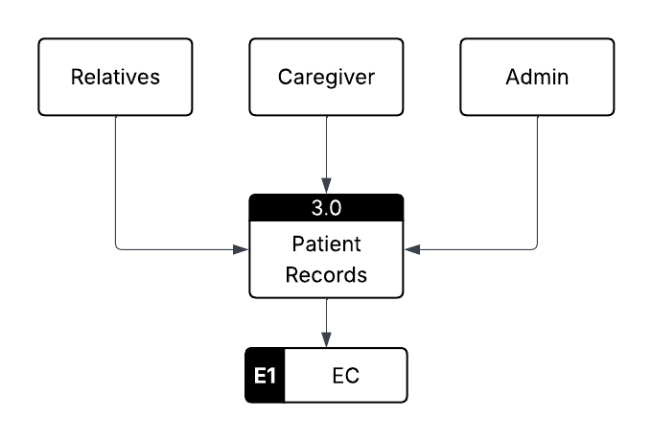
Figure . Level 0 Data Flow Diagram
This Level 0 DFD shows how the Patient Records (3.0) process works. The Relatives, Caregiver, and Admin are the main users who can give or get information about patients. They send patient details to the system, which helps keep all records complete and updated. The information is then stored in the EC (E1) data store, where it can be safely kept and used when needed.
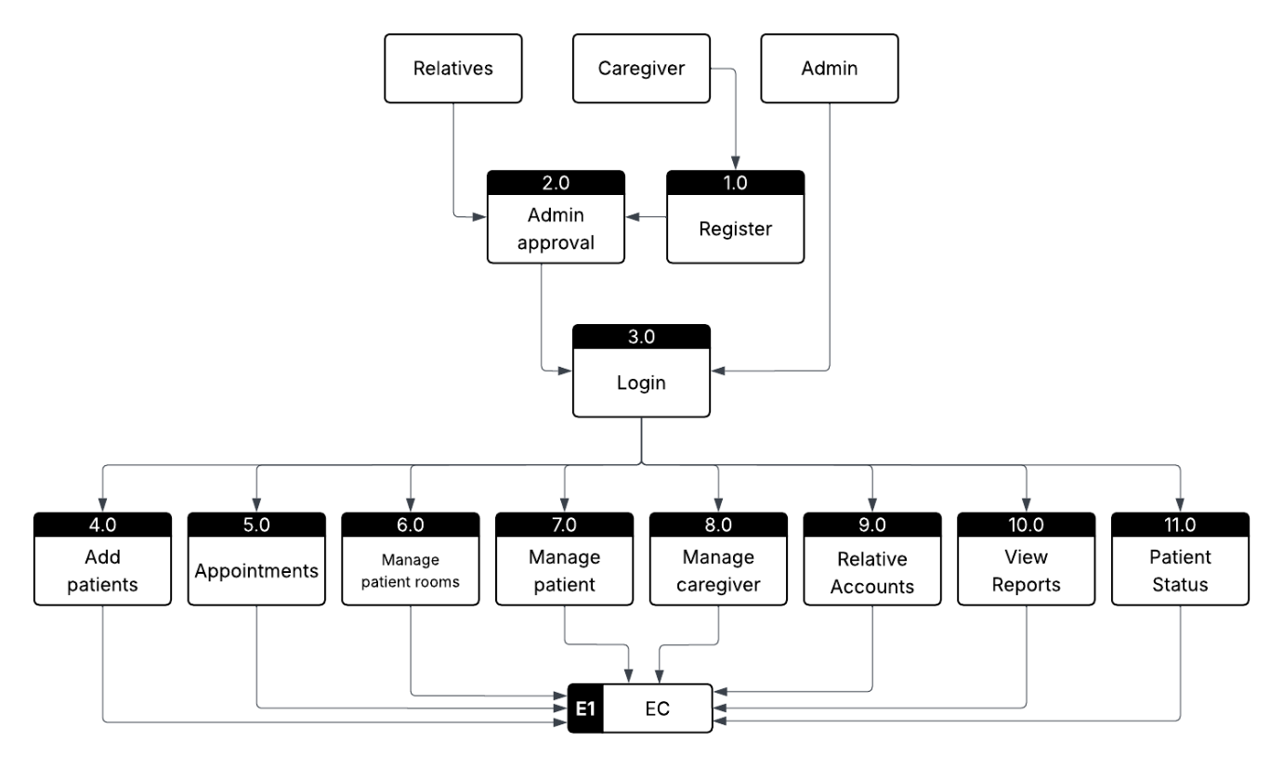
Figure . Level 1 Data Flow Diagram

Appendix D: User Survey Form and Summary
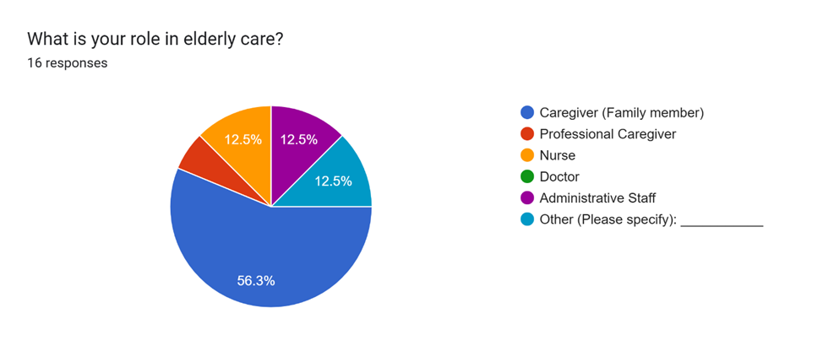
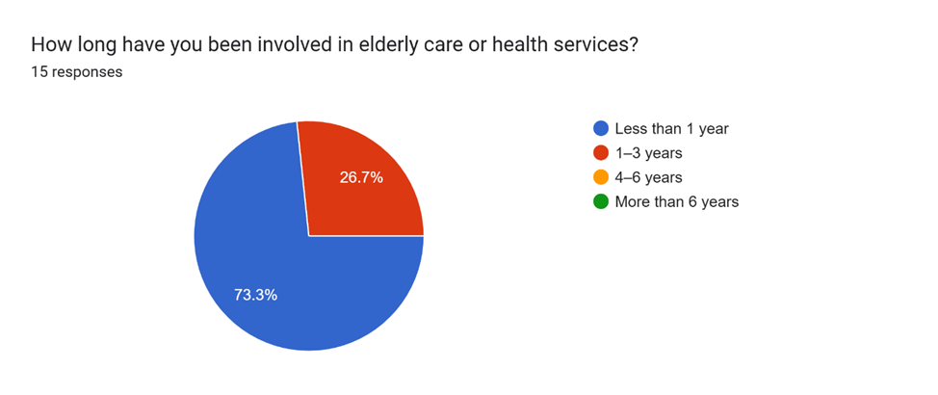
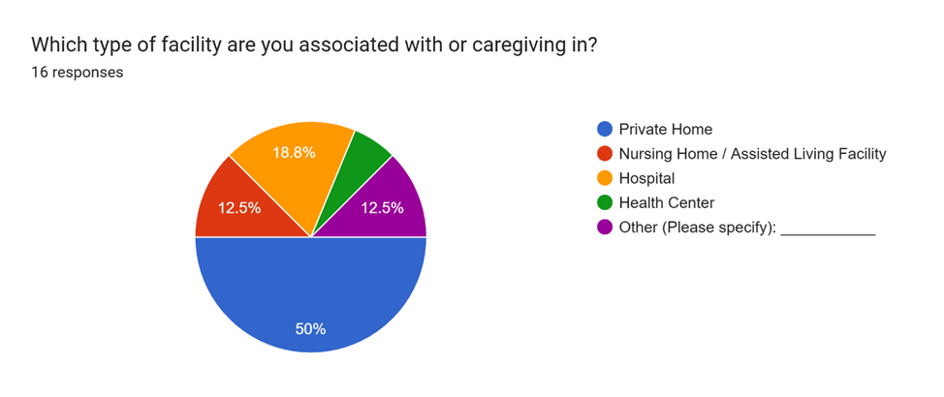
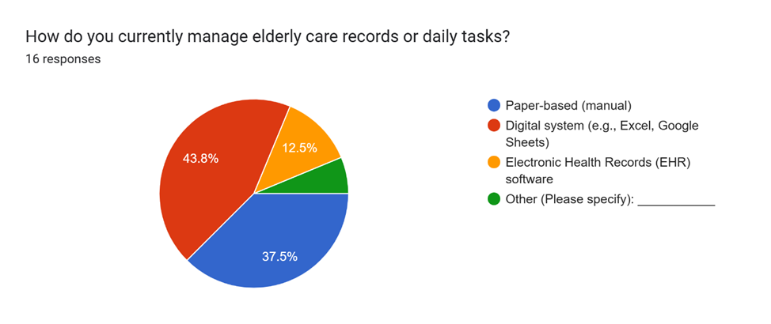
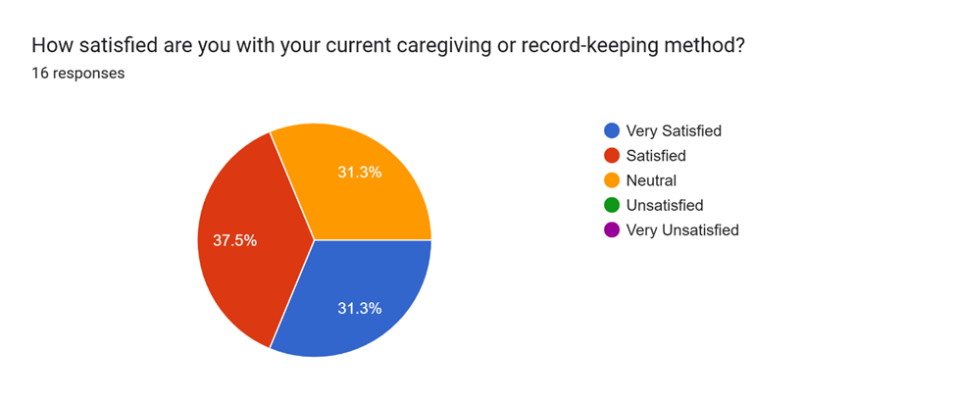
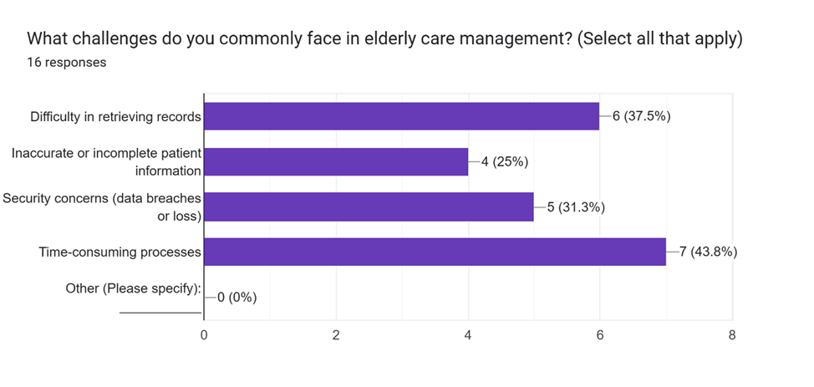
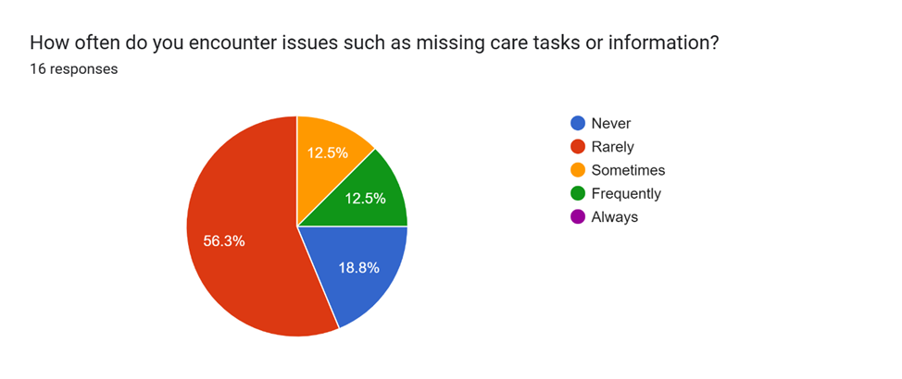
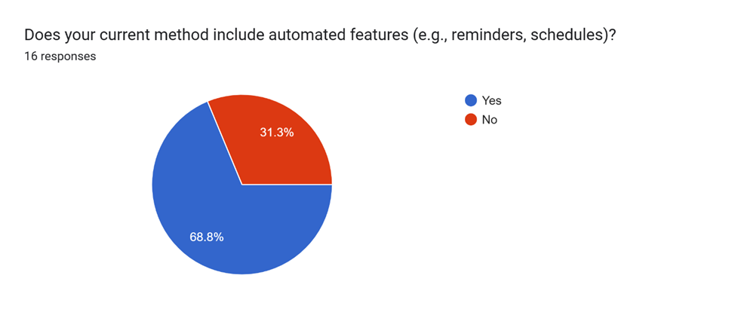
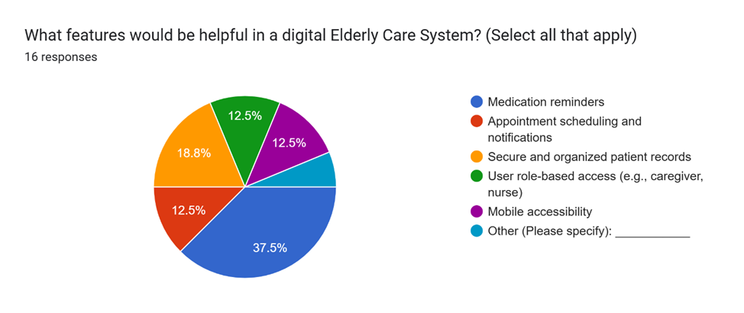
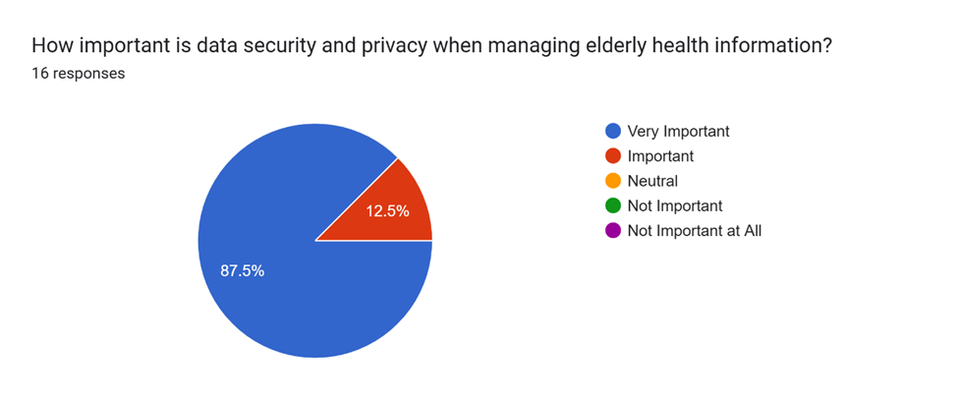
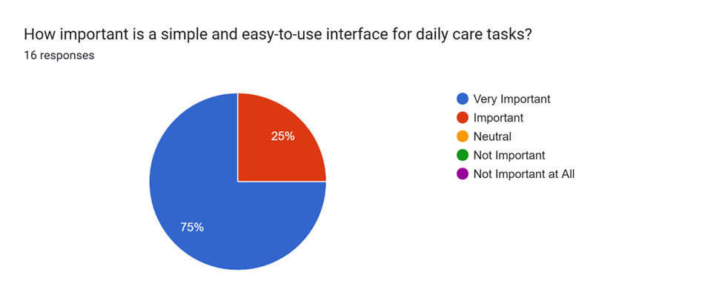
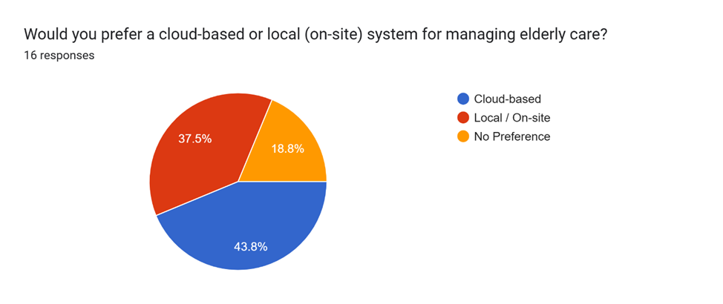
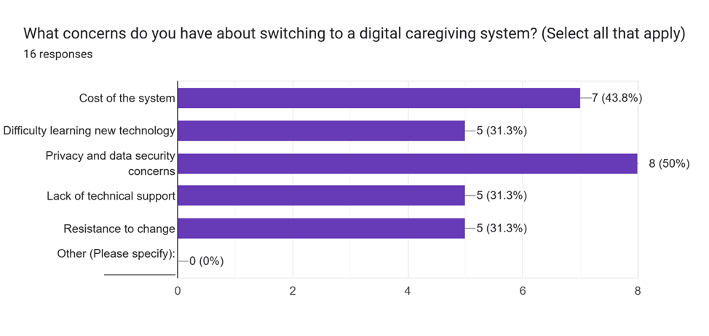
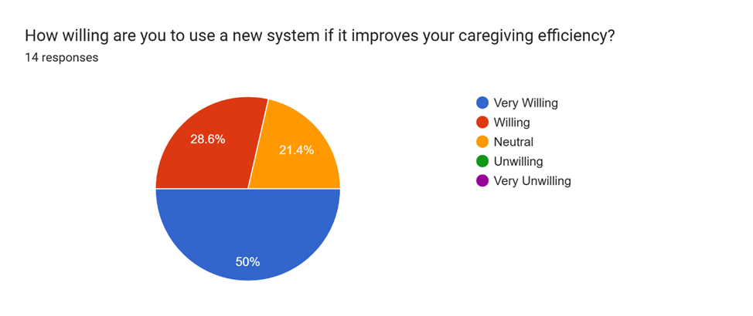
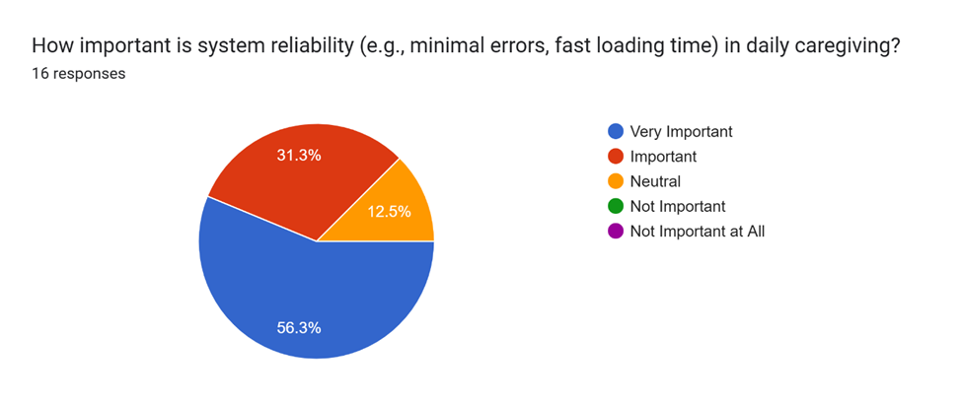
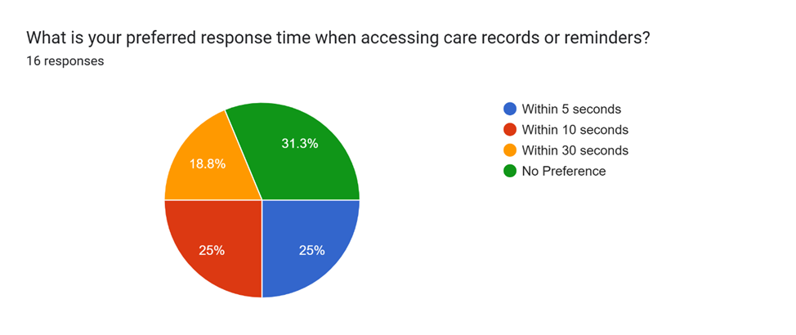
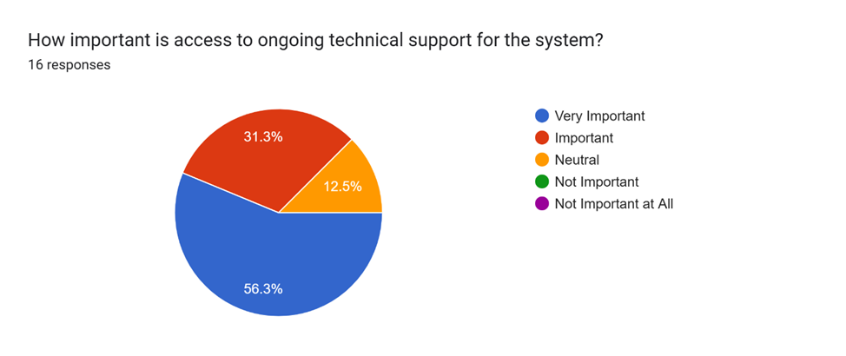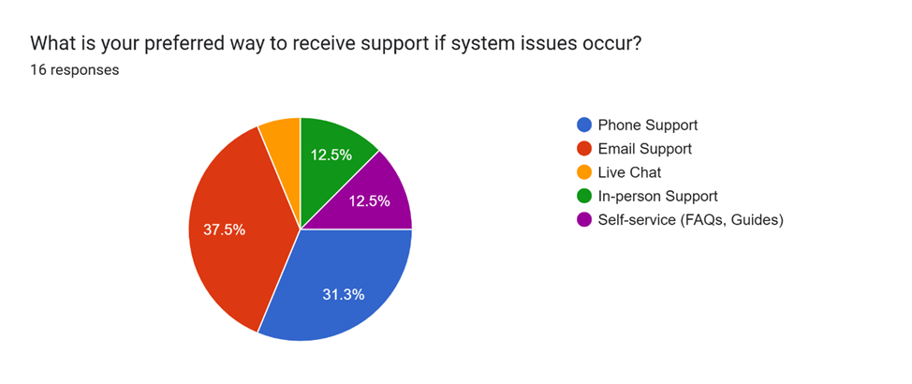
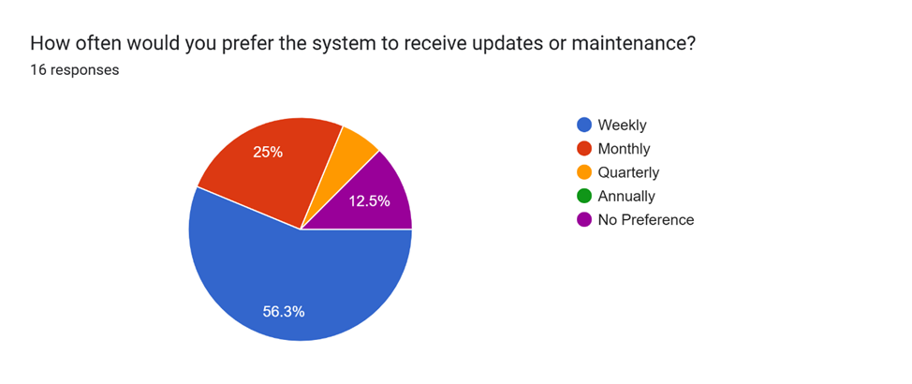
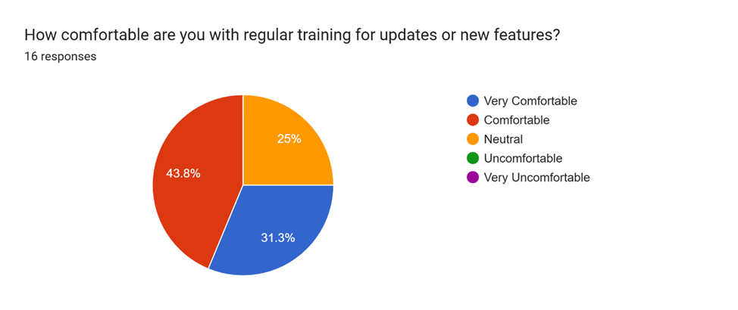

Appendix E: Sample Cover Page
PHINMA University of Iloilo
CITE Department
Elderly Care
A Capstone Project

Presented to the Faculty of the College of Information Technology Education

In Partial Fulfillment of the Requirements
For the degree Bachelor of Science in Information Technology

By:
Rhea O. Bengan
Danilyn C. Tuala
Cohryn Grace L. Galas
Baby Jean Lumacad

March 2025
Appendix F:Grammarian CV
Name:

Personal Information

Educational Background

Skills

Experience

Seminars and Trainings

Character References
Client Partner

[Your Company/Team Name]
[Your Address]
[City, State, Zip Code]
[Email Address]
[Phone Number]
[Date]
[Client’s Name]
[Client’s Position]
[Client’s Company/Organization Name]
[Client’s Address]
[City, State, Zip Code]
Dear [Client’s Name],
Subject: Proposal for Memorandum of Agreement to Use the Smart Inventory System
We are pleased to present to you our proposed Smart Inventory System, designed to streamline and improve the efficiency of your inventory management process through automation, real-time tracking, and accurate data handling.
To formalize the use and implementation of this system within your organization, we propose the execution of a Memorandum of Agreement (MOA) that outlines the responsibilities, terms, and conditions for both parties. This agreement will ensure a clear understanding of project scope, timelines, data security, support, and maintenance.
The Smart Inventory System is expected to provide the following benefits to your organization:
● Enhanced inventory accuracy and reduced errors
● Faster processing and tracking of inventory transactions
● Real-time updates and reporting
● User-friendly interface suitable for your staff
We are committed to supporting your team through the entire implementation process, including training and technical assistance to maximize the system’s benefits.
We look forward to discussing this proposal further and working together to enhance your inventory management system. Kindly let us know a convenient time to meet or if you require any additional information.
Thank you for your consideration.
Sincerely,
[Your Name]
[Your Position]
[Your Company/Team Name]

Moa
[Your Company Letterhead or Name]
Memorandum of Agreement (MOA)
Between
Tech Solutions Inc.
And
[Student’s Name]

Date: July 28, 2025

Purpose:
This agreement is entered into by and between Tech Solutions Inc., located at 123 Innovation Drive, Cityville, and [Student’s Name], a student from [School Name], to collaborate on the student’s capstone project entitled “Smart Inventory System.”

Scope.of.Agreement:
Tech Solutions Inc. agrees to provide support and resources including data access, guidance, and mentorship to assist the student in developing the project. The student agrees to perform research, development, and testing as required to complete the capstone project.

Client.Approval:
By signing this document, Tech Solutions Inc. acknowledges approval and support of the student’s proposed capstone project. The company commits to timely cooperation and to provide relevant information as needed for the project’s success.

Signatures:

[Client Representative Name]
Project Manager
Tech Solutions Inc.
Date: _______________

[Student’s Name]
Capstone Project Student
Date: _______________

